Lesson 11: Different Partial Quotients
- Let’s use what we know about multiplication and place value to find quotients.

Warm-up: Notice and Wonder: Ways to Record
What do you notice? What do you wonder?
Clare’s strategy:
Jada’s strategy:
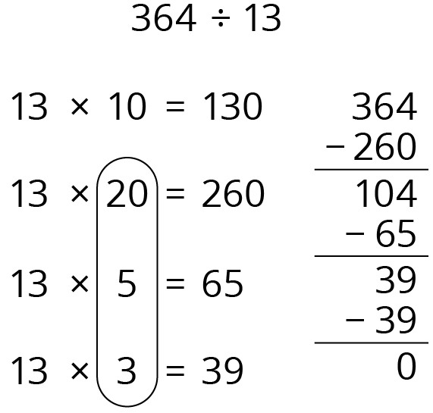
130÷13=10130÷13=1065÷13=0539÷13=03 364÷13¯ =28000¯

11.1: Division Expressions
Take turns:
- Choose a set of expressions that, when added together, is equal to $308÷14$. Not all expressions will be used.
- Explain to your partner how you know that your cards represent a sum that is equal to $308÷14$.
- (Pause for teacher directions.)
- Choose one of the sets of expressions whose sum is equal to $308÷14$ and use it to find the value of $308÷14$.

11.2: Choose Your Own Partial Quotients
For each expression, choose one of the partial quotients and, beginning with that expression, find the value of the quotient.
- $360÷15$
  - $150÷15$
  - $300÷15$
  - $60÷15$
- $945÷45$
  - $45÷45$
  - $450÷45$
  - $900÷45$
- $992÷31$
  - $62÷31$
  - $341÷31$
  - $310÷31$
- How did you decide which partial quotient to use to begin finding the quotient? Did you change your mind with any of the problems?
© CC BY 2021 Illustrative Mathematics®

