Unit 3 Lesson 17: Make 10 to Add

WU How Many Do You See: Double 10-frames (Warm up)

Student Task Statement
How many do you see?
How do you see them?
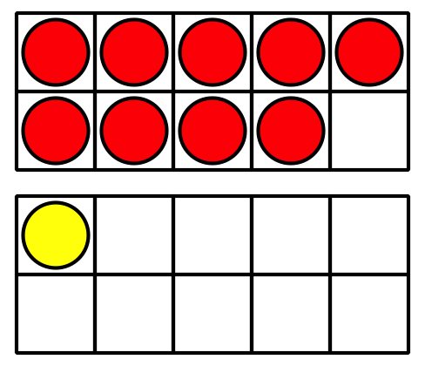
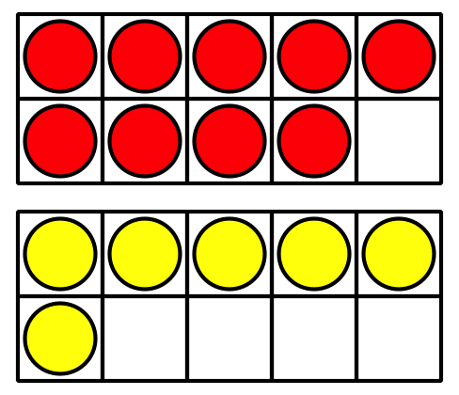
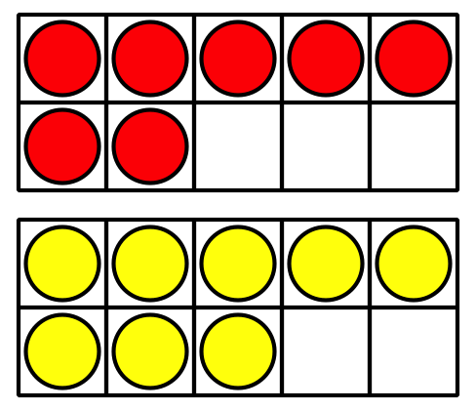

1 The 9 Plus Game

Student Task Statement
- Put out 9 counters.
- Pick a number card and add that many counters.
- Write an equation to represent the counters.
Can you write more than one?
Equations:
Round 1: ________________________________
Round 2: ________________________________
Round 3: ________________________________
Round 4: ________________________________
Round 5: ________________________________

2 Clare’s Birds

Student Task Statement
- Clare draws some birds.
She draws 3 birds in a nest and 9 birds flying.
How many birds did she draw?
Show your thinking using drawings, numbers, or words.
- Equation: ________________________________
- Clare draws birds that like warm weather.
She draws 6 toucans and 8 parrots.
How many birds did she draw?
Show your thinking using drawings, numbers, or words.
- Equation: ________________________________
- Clare draws birds that like cold weather.
She draws 7 penguins and 5 owls.
How many birds did she draw?
Show your thinking using drawings, numbers, or words.
- Equation: ________________________________
© CC BY 2021 Illustrative Mathematics®

