Unit 2 Lesson 6: Compare Methods for Subtraction

WU True or False: How many Tens? How many Ones? (Warm up)

Student Task Statement
Decide if each statement is true or false. Be prepared to explain your reasoning.
- $64=60+4$
- $64=50+14$
- $64=30+24$

1 Different Ways to Decompose

Student Task Statement
Diego and Elena drew base-ten diagrams to find the value of $82−9$.
Diego
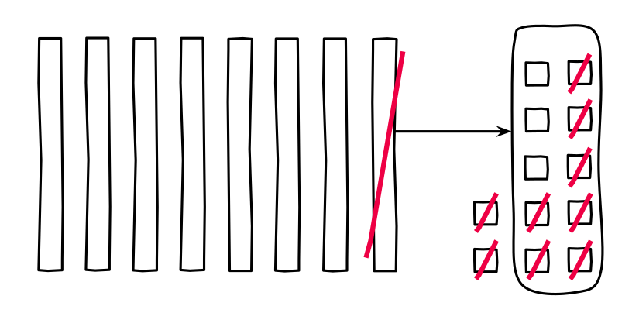
Elena
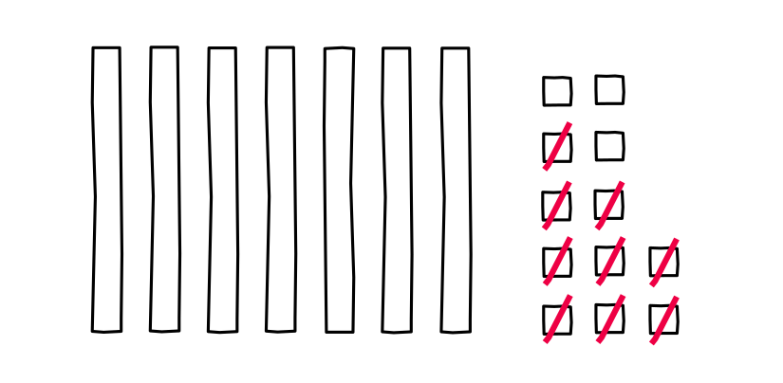
- Compare Deigo’s work to Elena’s.
  - What is the same?
  - What is different?
- Tyler used equations to show his thinking.
- $82−9$
$82=70+12$
$12−9=3$
$70+3=73$
- Diego says Tyler’s work matches his diagram.
Elena says Tyler’s work matches her diagram.
- Who do you agree with? Explain.

2 Introduce Target Numbers, Subtract Tens or Ones

Student Task Statement
© CC BY 2021 Illustrative Mathematics®

