Unit 8 Lesson 6: All Kinds of Attributes

WU How Many Do You See: Dot after Dot (Warm up)

Student Task Statement
How many do you see? How do you see them?
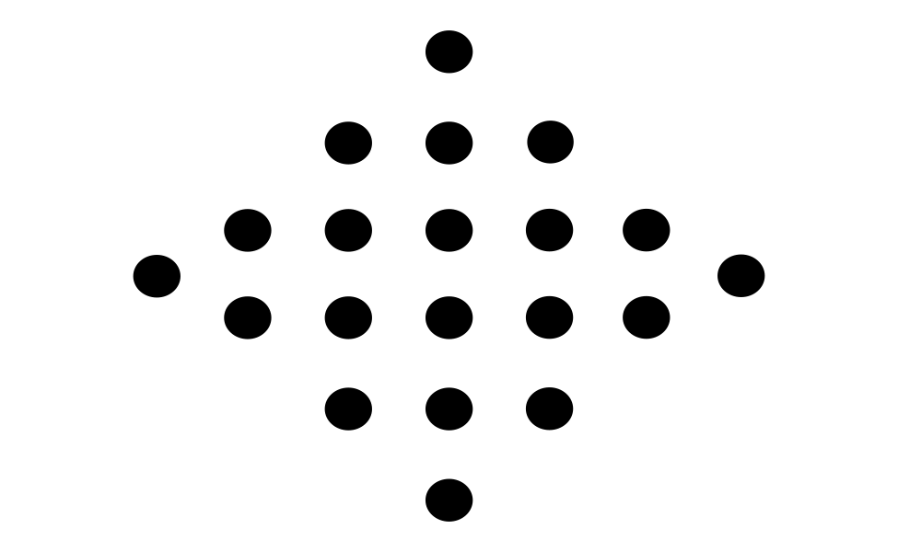

1 You’re Gonna Draw It: It’s Symmetric

Student Task Statement
- Here is a pair of parallel segments that have the same length.
- 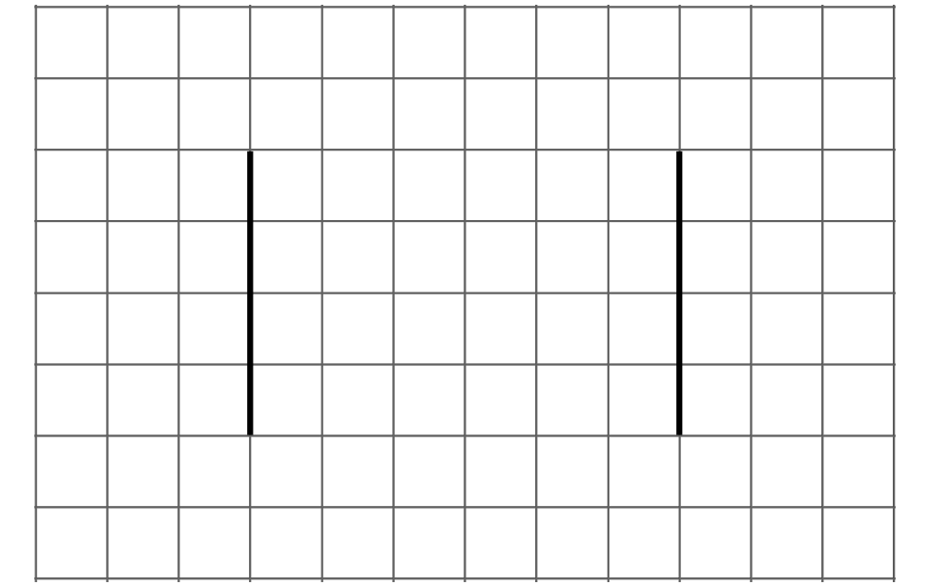
- Add one or more segments to create a figure with only 1 line of symmetry.
- Here are two more pairs of parallel segments. Add more segments to make:
  - a figure with 2 lines of symmetry
  - a figure with no lines of symmetry
If you have time: Here are some other pairs of parallel lines. Add more segments to create a figure with 1 line of symmetry.
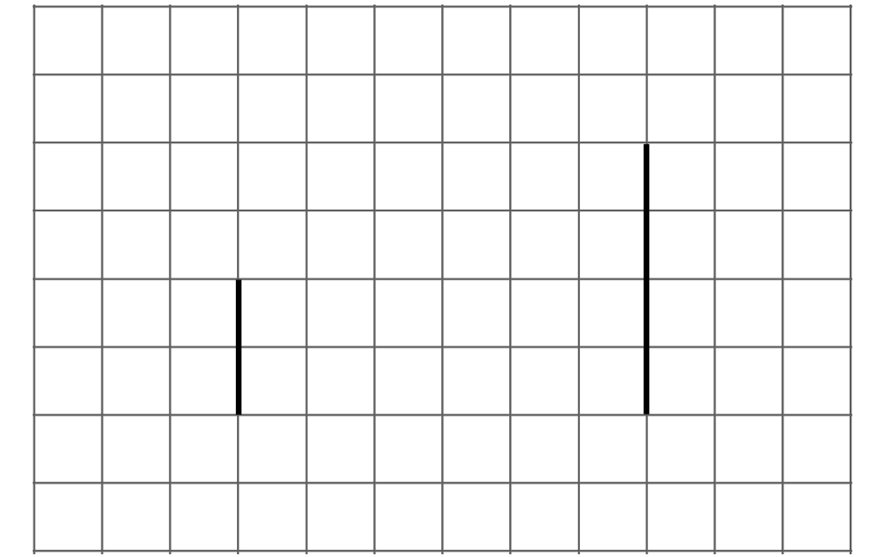
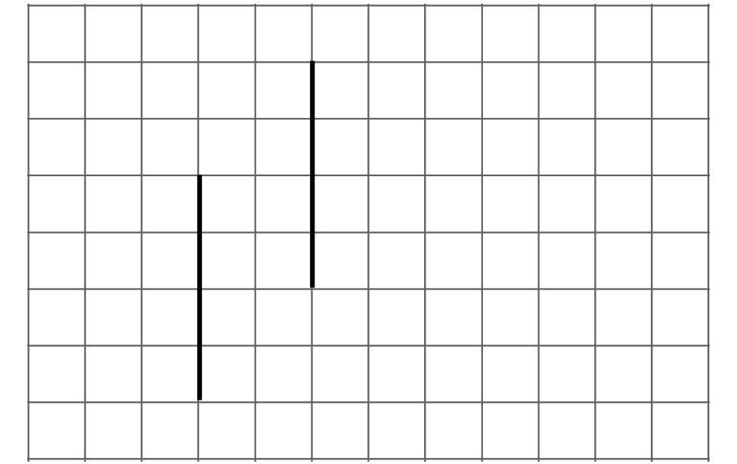

2 Hidden Shapes

Student Task Statement
Here is a field of dots.
Can you connect the dots to create each of the following shapes? If so, draw the shapes. If not, be prepared to explain your reasoning.
- A triangle with only one line of symmetry
- A quadrilateral with only one line of symmetry
- A quadrilateral with two pairs of parallel sides
- A quadrilateral with one pair of perpendicular sides
- A rectangle
- A six-sided shape with only one line of symmetry

Images for Activity Synthesis
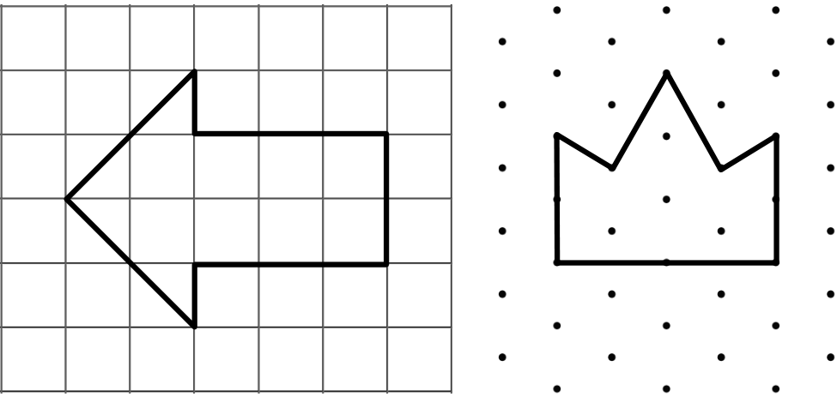
© CC BY 2021 Illustrative Mathematics®

