Unit 5 Lesson 12: Dividing Decimals by Whole Numbers

1 Number Talk: Dividing by 4 (Warm up)

Student Task Statement
Find each quotient mentally.
$80÷4$
$12÷4$
$1.2÷4$
$81.2÷4$

2 Using Diagrams to Represent Division

Student Task Statement
To find $53.8÷4$ using diagrams, Elena began by representing 53.8.
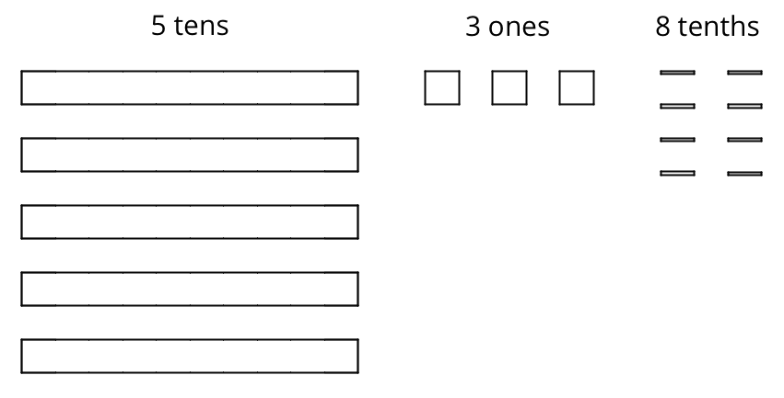
She placed 1 ten into each group, unbundled the remaining 1 ten into 10 ones, and went on distributing the units.
This diagram shows Elena’s initial placement of the units and the unbundling of 1 ten.
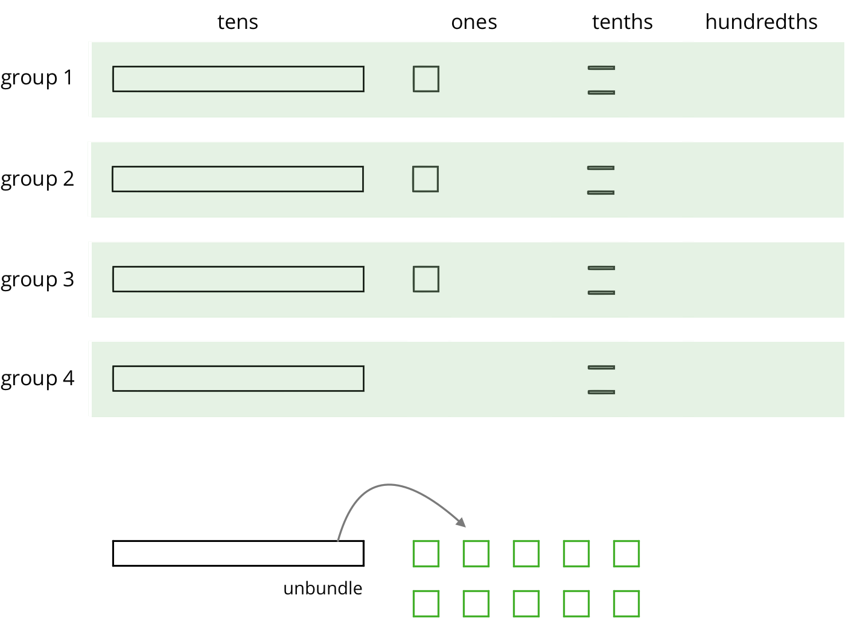
- Complete the diagram by continuing the division process. How would you use the available units to make 4 equal groups?
- As the units get placed into groups, show them accordingly and cross out those pieces from the bottom. If you unbundle a unit, draw the resulting pieces.
- What value did you find for $53.8÷4$? Be prepared to explain your reasoning.
- Use long division to find $53.8÷4$. Check your answer by multiplying it by the divisor 4.
- Use long division to find $77.4÷5$. If you get stuck, you can draw diagrams or use another method.

3 Dividends and Divisors

Images for Launch
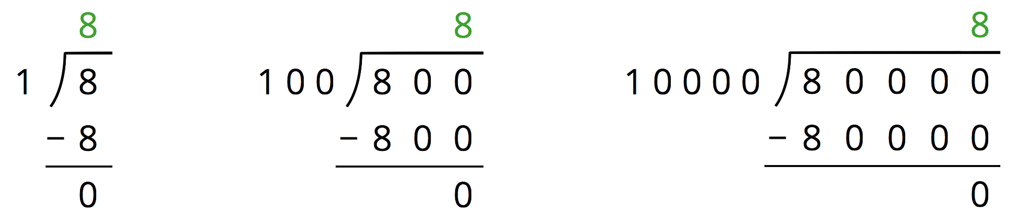

Student Task Statement
Analyze the dividends, divisors, and quotients in the calculations, and then answer the questions.
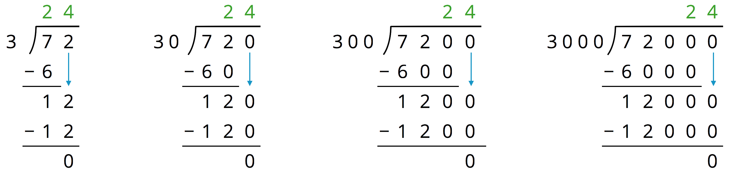
- Complete each sentence. In the calculations shown:
  - Each dividend is ______ times the dividend to the left of it.
  - Each divisor is ______ times the divisor to the left of it.
  - Each quotient is _____________________ the quotient to the left of it.
- Suppose we are writing a calculation to the right of $72,​000÷3,​000$. Which expression has a quotient of 24? Be prepared to explain your reasoning.
  - $72,​000÷30,​000$
  - $720,​000÷300,​000$
  - $720,​000÷30,​000$
  - $720,​000÷3,​000$
- Suppose we are writing a calculation to the left of $72÷3$. Write an expression that would also give a quotient of 24. Be prepared to explain your reasoning.
- Decide which of the following expressions would have the same value as $250÷10$. Be prepared to share your reasoning.
  - $250÷0.1$
  - $25÷1$
  - $2.5÷1$
  - $2.5÷0.1$
  - $2,500÷100$
  - $0.25÷0.01$
© CC BY Open Up Resources. Adaptations CC BY IM.

