Unit 5 Lesson 9: Multiplying Rational Numbers

1 Before and After (Warm up)

Student Task Statement
Where was the girl:
- 5 seconds after this picture was taken? Mark her approximate location on the picture.
- 5 seconds before this picture was taken? Mark her approximate location on the picture.

2 Backwards in Time

Student Task Statement
A traffic safety engineer was studying travel patterns along a highway. She set up a camera and recorded the speed and direction of cars and trucks that passed by the camera. Positions to the east of the camera are positive, and to the west are negative.
- Here are some positions and times for one car:
- position (feet) | - -180 | - -120 | - -60 | - 0 | - 60 | - 120
- time (seconds) | - -3 | - -2 | - -1 | - 0 | - 1 | - 2
  - In what direction is this car traveling?
  - What is its velocity?

  - What does it mean when the time is zero?
  - What could it mean to have a negative time?
- Here are the positions and times for a different car whose velocity is -50 feet per second:
- position (feet) |  |  |  | - 0 | - -50 | - -100
- time (seconds) | - -3 | - -2 | - -1 | - 0 | - 1 | - 2
  - Complete the table with the rest of the positions.
  - In what direction is this car traveling? Explain how you know.
- Complete the table for several different cars passing the camera.
 | - velocity  (meters per  second) | - time after passing  the camera  (seconds) | - ending  position  (meters) | - equation
- car C | - +25 | - +10 | - +250 | - $25⋅10=250$
- car D | - -20 | - +30
- car E | - +32 | - -40
- car F | - -35 | - -20
- car G | - -15 | - -8

  - If a car is traveling east when it passes the camera, will its position be positive or negative 60 seconds before it passes the camera?
  - If we multiply a positive number and a negative number, is the result positive or negative?

  - If a car is traveling west when it passes the camera, will its position be positive or negative 60 seconds before it passes the camera?
  - If we multiply two negative numbers, is the result positive or negative?

3 Cruising (Optional)

Student Task Statement
Around noon, a car was traveling -32 meters per second down a highway. At exactly noon (when time was 0), the position of the car was 0 meters.
- Complete the table.
- time (s) | - -10 | - -7 | - -4 | - -1 | - 2 | - 5 | - 8 | - 11
- position (m)
- Graph the relationship between the time and the car's position.
- 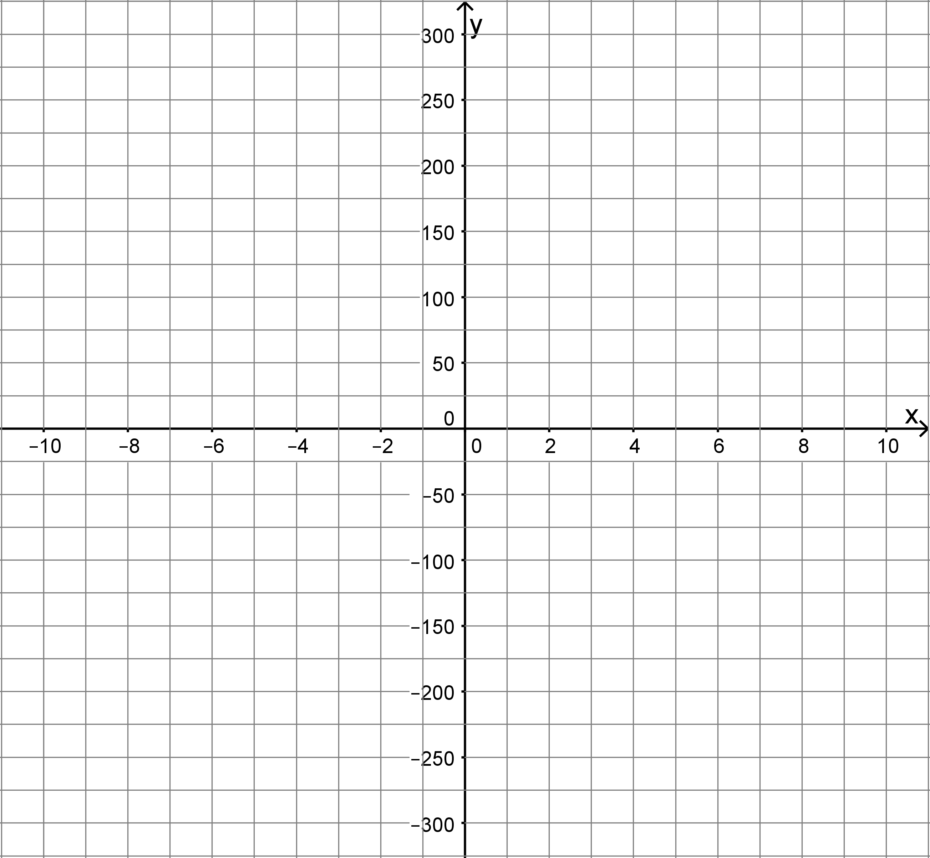
- What was the position of the car at -3 seconds?
- What was the position of the car at 6.5 seconds?

4 Rational Numbers Multiplication Grid (Optional)

Student Task Statement
- Complete the shaded boxes in the multiplication square.
- 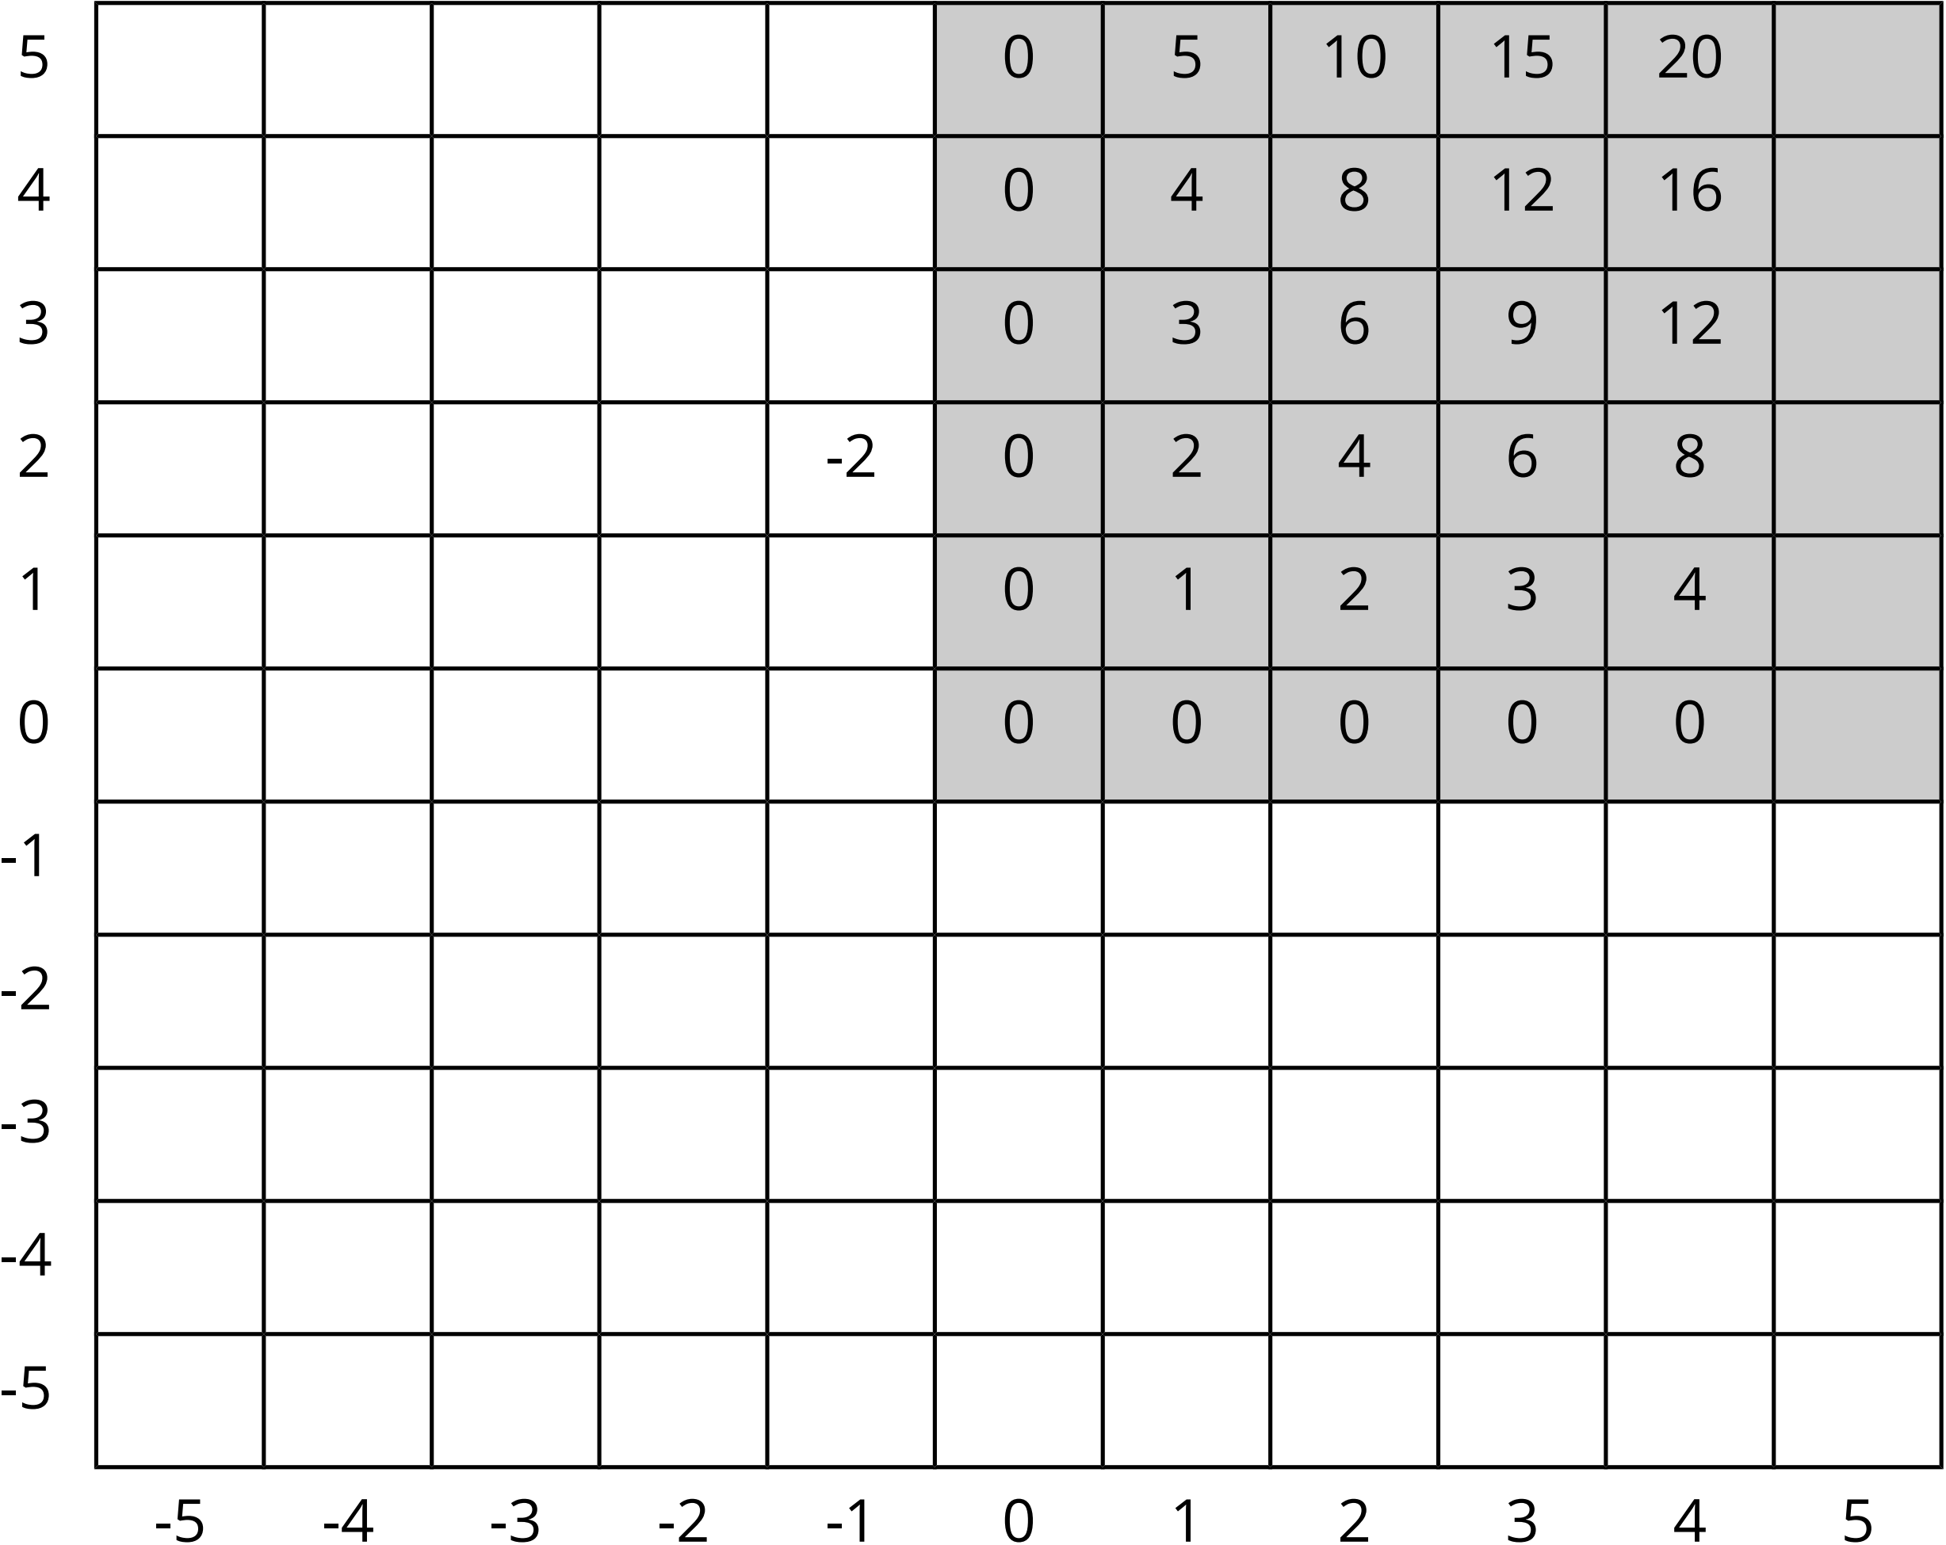
- Look at the patterns along the rows and columns. Continue those patterns into the unshaded boxes.
- Complete the whole table.
- What does this tell you about multiplication with negative numbers?

Activity Synthesis
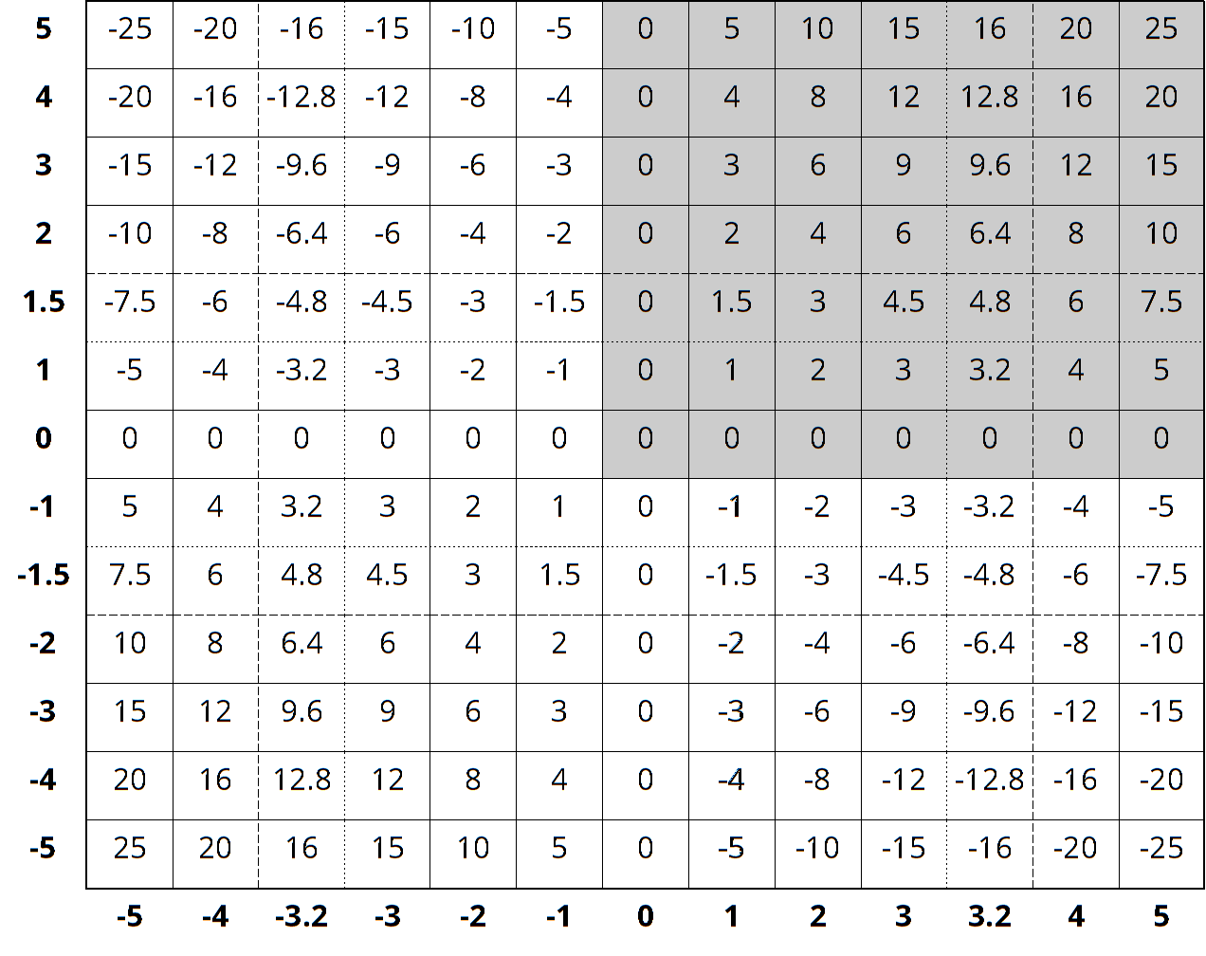
© CC BY Open Up Resources. Adaptations CC BY IM.

