Lesson 22: Observing More Patterns in Scatter Plots
Let’s look for other patterns in data.

22.1: Notice and Wonder: Clustering
What do you Notice? What do you Wonder?
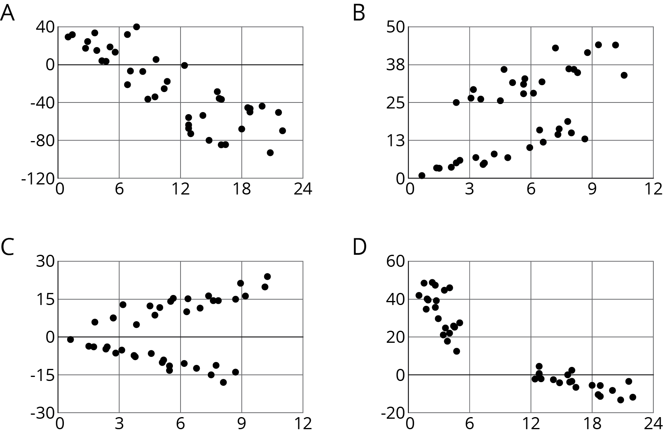

22.2: Scatter Plot City
Your teacher will give you a set of cards. Each card shows a scatter plot.
- Sort the cards into categories and describe each category.
- Explain the reasoning behind your categories to your partner. Listen to your partner’s reasoning for their categories.
- Sort the cards into two categories: positive associations and negative associations. Compare your sorting with your partner’s and discuss any disagreements.
- Sort the cards into two categories: linear associations and non-linear associations. Compare your sorting with your partner’s and discuss any disagreements.

22.3: Animal Brains
Is there an association between the weight of an animal’s body and the weight of the animal’s brain?
Use the data in the table to make a scatter plot. Are there any outliers?
animal | body weight (kg) | brain weight (g)
cow | 465 | 423
grey wolf | 36 | 120
goat | 28 | 115
donkey | 187 | 419
horse | 521 | 655
potar monkey | 10 | 115
cat | 3 | 26
giraffe | 529 | 680
gorilla | 207 | 406
human | 62 | 1,320
rhesus monkey | 7 | 179
kangaroo | 35 | 56
sheep | 56 | 175
jaguar | 100 | 157
chimpanzee | 52 | 440
pig | 192 | 180
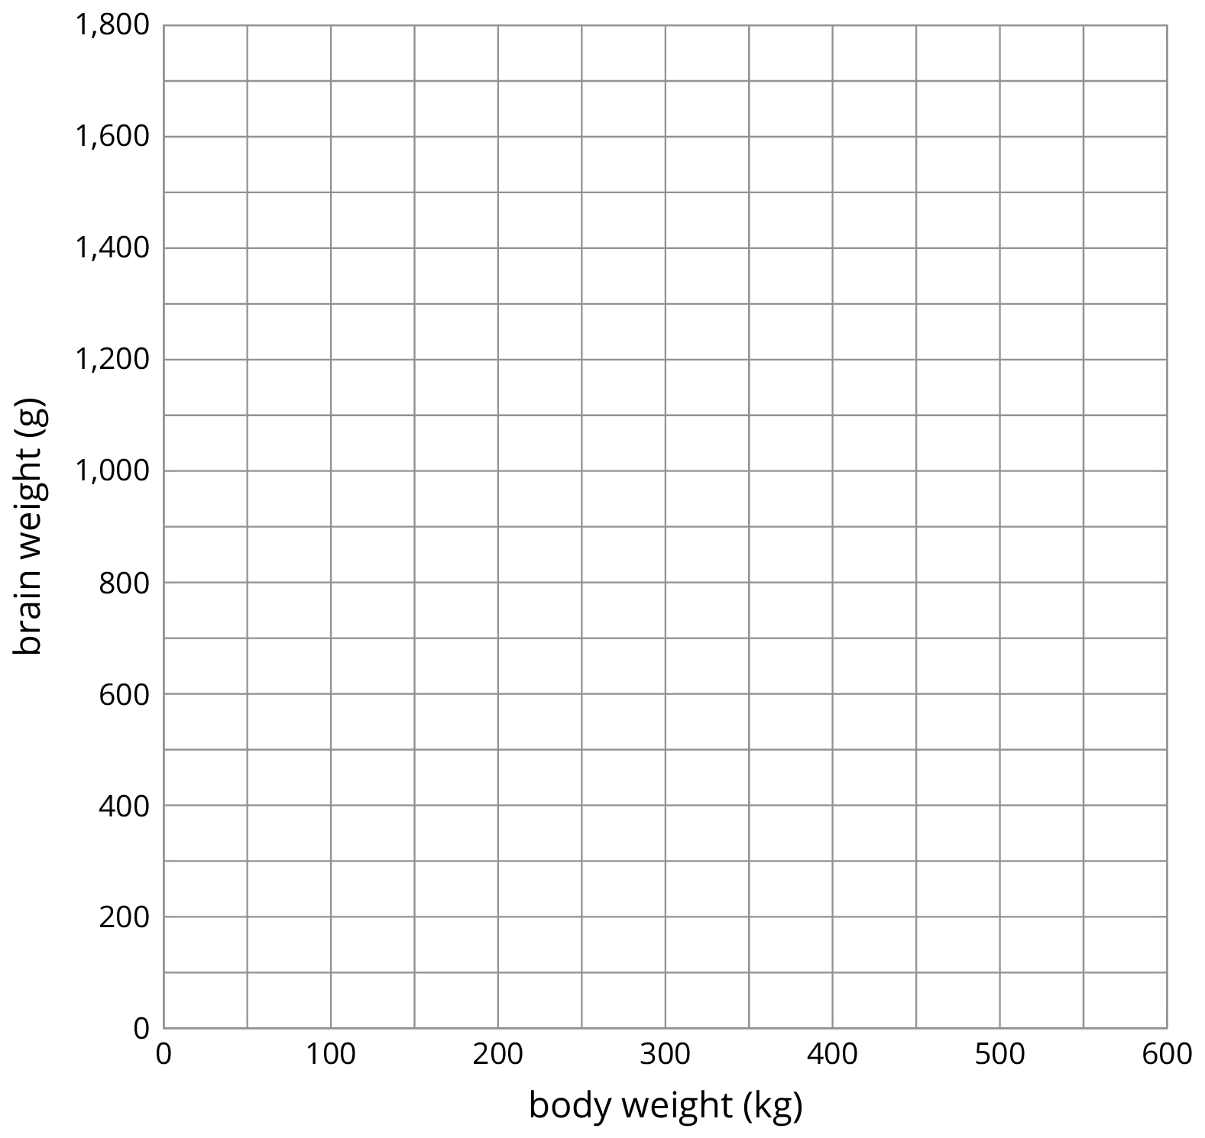
- After removing the outliers, does there appear to be an association between body weight and brain weight? Describe the association in a sentence.
- Using a piece of pasta and a straightedge, fit a line to your scatter plot, and estimate its slope. What does this slope mean in the context of brain and body weight?
- Does the fitted line help you identify more outliers?

Are you ready for more?
Use one of the suggestions or find another set of data that interested you to look for associations between the variables.
- Number of wins vs number of points per game for your favorite sports team in different seasons
- Amount of money grossed vs critic rating for your favorite movies
- Price of a ticket vs stadium capacity for popular bands on tour
After you have collected the data,
- Create a scatter plot for the data.
- Are any of the points very far away from the rest of the data?
- Would a linear model fit the data in your scatter plot? If so, draw it. If not, explain why a line would be a bad fit.
- Is there an association between the two variables? Explain your reasoning.

Lesson 22 Summary
Sometimes a scatter plot shows an association that is not linear:
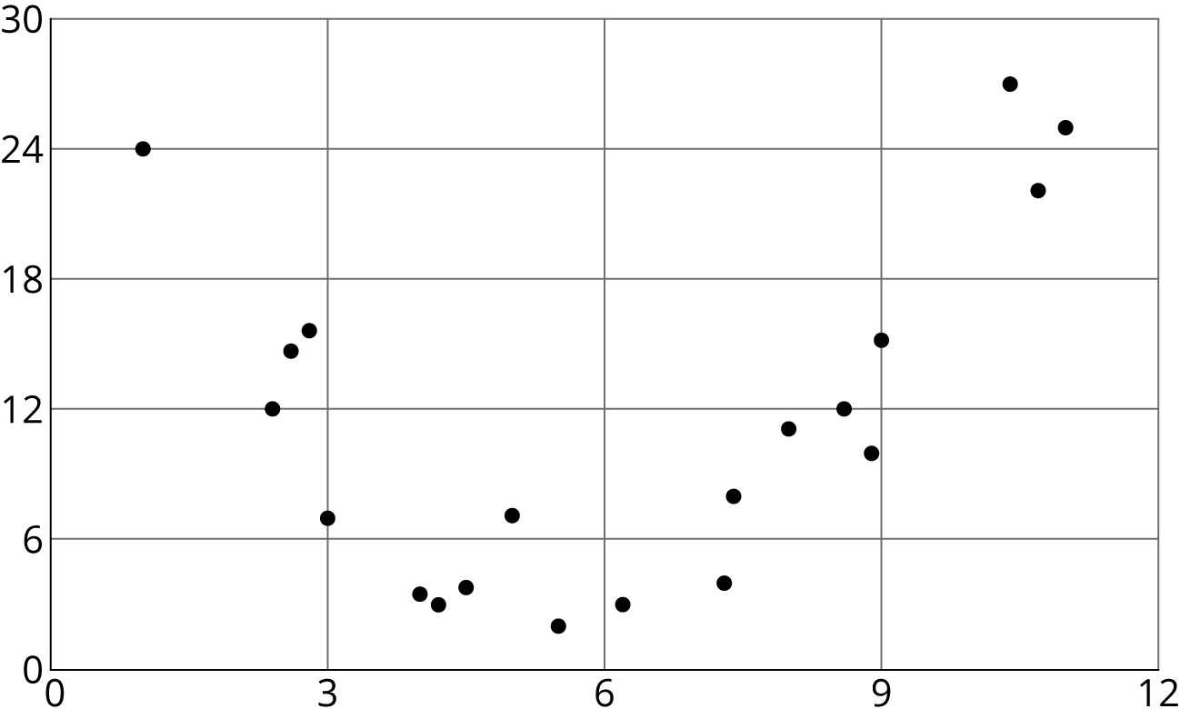
We call such an association a non-linear association. In later grades, you will study equations that can be models for non-linear associations.
Sometimes in a scatter plot we can see separate groups of points.
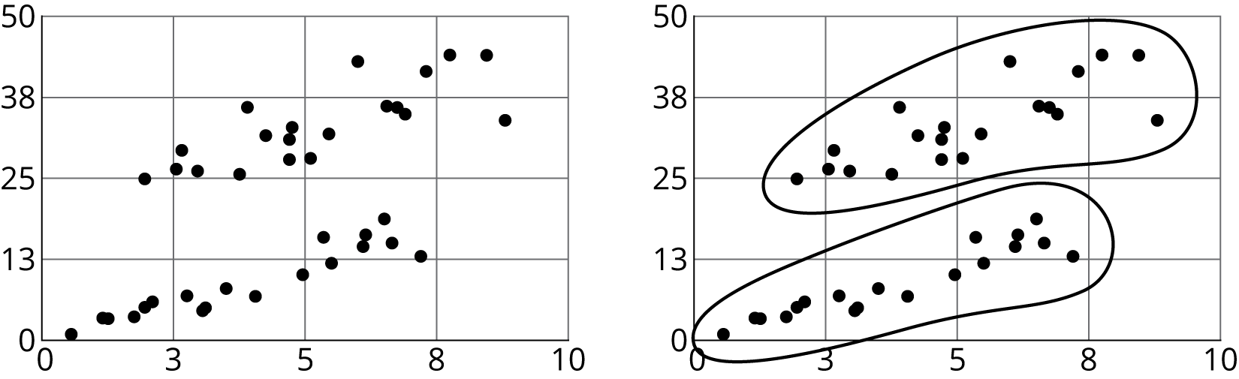
We call these groups clusters.
People often collect data in two variables to investigate possible associations between two numerical variables and use the connections that they find to predict more values of the variables. Data analysis usually follows these steps:
- Collect data.
- Organize and represent the data, and look for an association.
- Identify any outliers and try to explain why these data points are exceptions to the trend that describes the association.
- Find n equation that fits the data well.
Although computational systems can help with data analysis by graphing the data, finding an equation that might fit the data, and using that equation to make predictions, it is important to understand the process and think about what is happening. A computational system may find an equation that does not make sense or use a line when the situation suggests that a different model would be more appropriate.
© CC BY Open Up Resources. Adaptations CC BY IM.

