Unit 5 Lesson 6: Red and Yellow Apples

WU Act It Out: All About Apples (Warm up)

Student Task Statement
Mai was picking apples at the orchard.
Mai picked 5 yellow apples and 2 red apples.
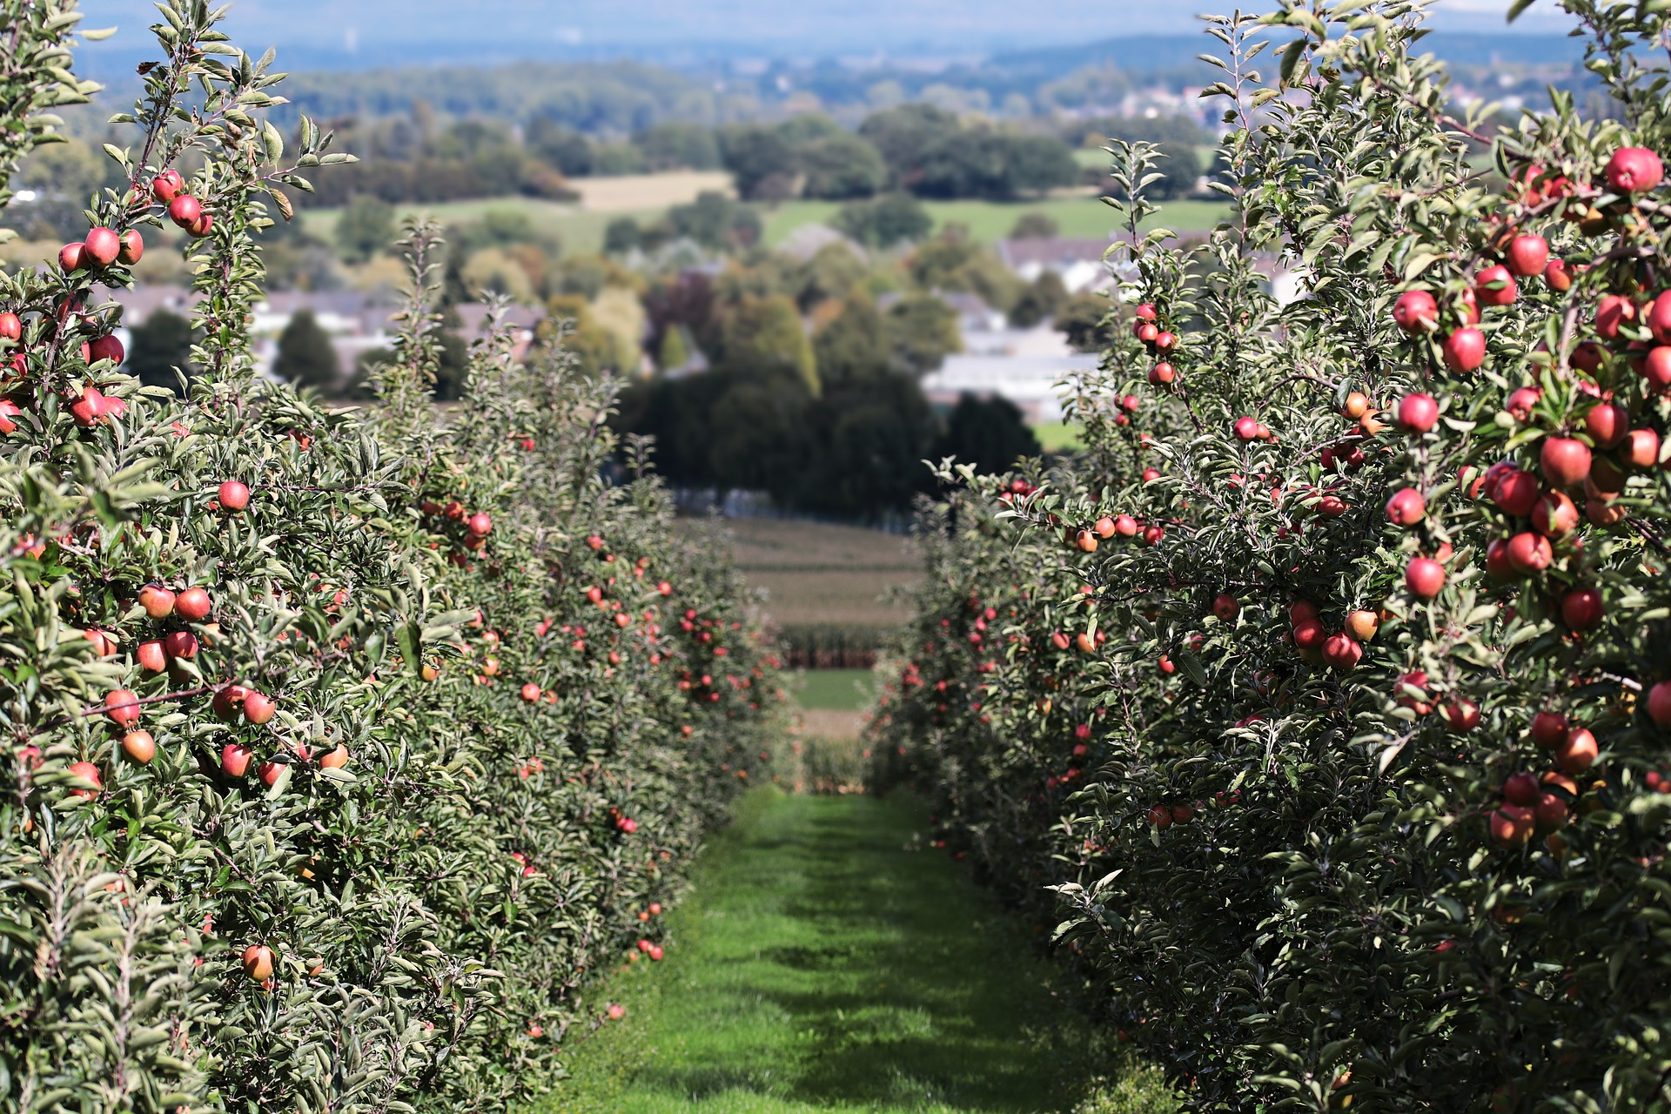

1 Two Problems about Apples

Student Task Statement
- Mai was picking apples at the orchard.
- Mai picked 5 yellow apples and 2 red apples.
- Lin picked 8 apples at the orchard.
- Some of the apples were yellow.
- The rest of the apples were red.
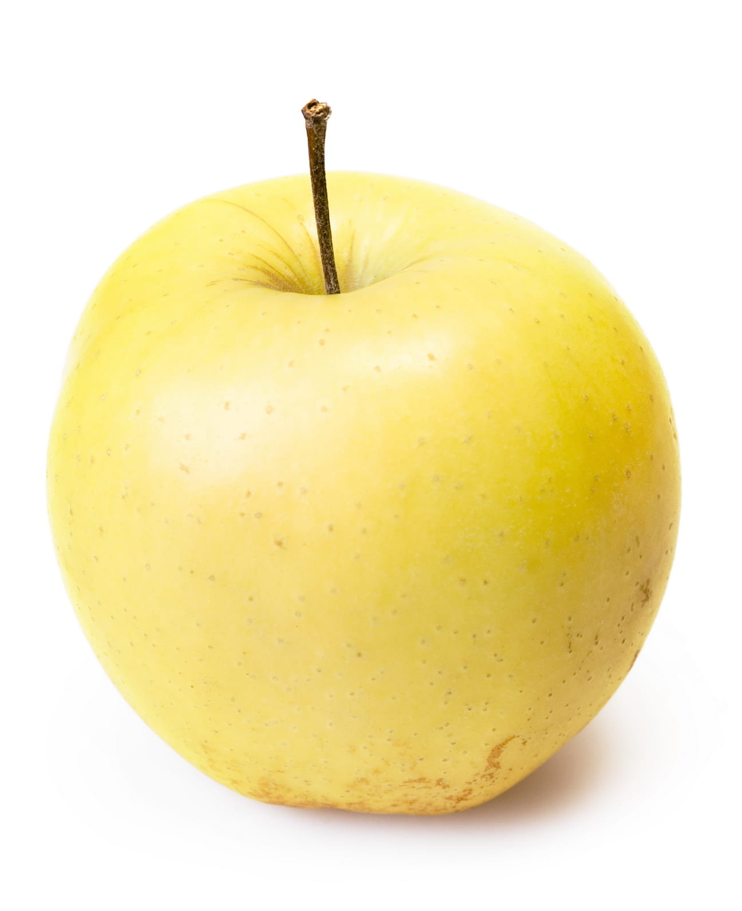
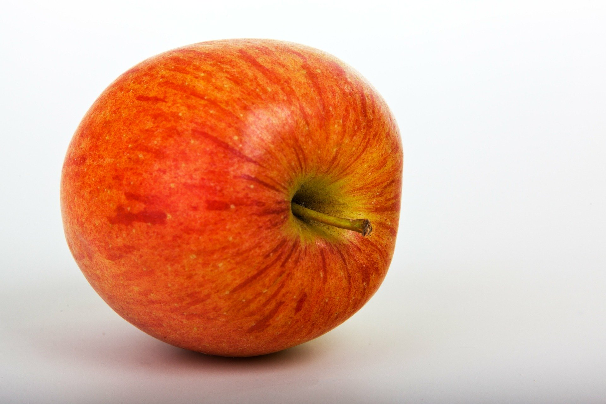

2 Yellow Apples and Red Apples

Student Task Statement
Lin picked 8 apples at the orchard.
Some of the apples were yellow.
The rest of the apples were red.

3 Centers: Choice Time

Student Task Statement
Choose a center.
What’s Behind My Back?
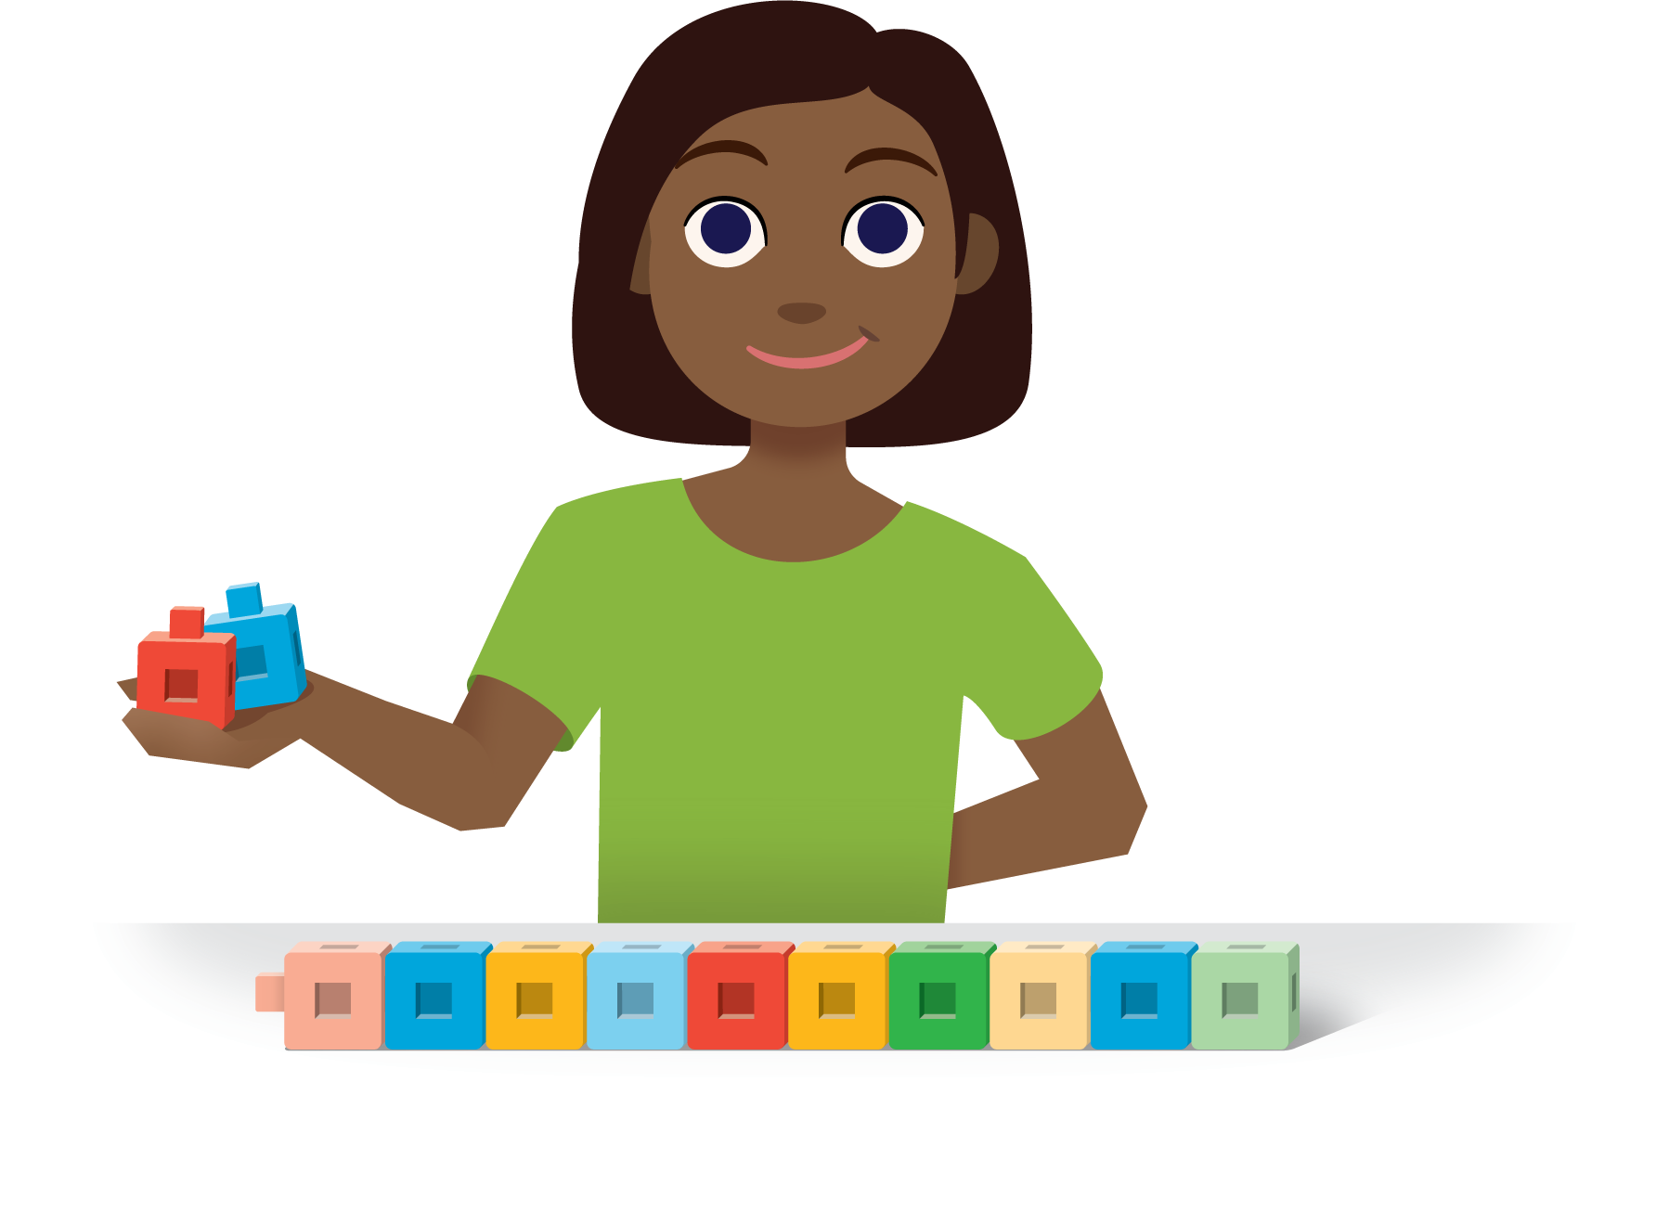
5-frames
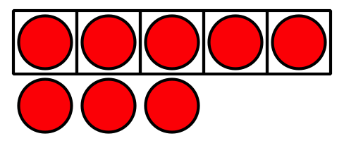
Make or Break Apart Numbers
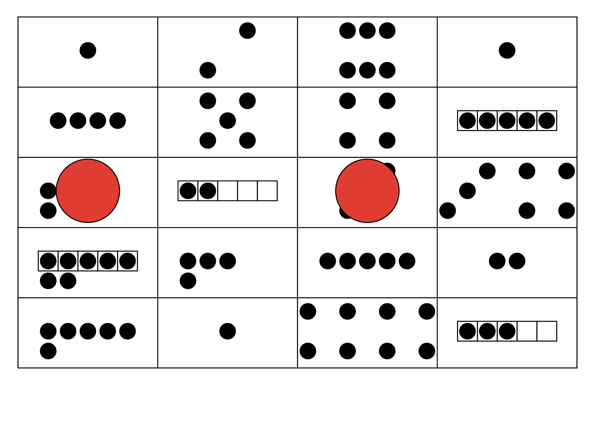
© CC BY 2021 Illustrative Mathematics®

