Unit 7 Lesson 11: Compare and Sort Solid Shapes

WU What Do You Know About Cylinders? (Warm up)

Student Task Statement

1 Compare Solid Shapes

Student Task Statement
alike | different
____________________ | ____________________
____________________ | ____________________
____________________ | ____________________

2 Sort Solid Shapes

Student Task Statement
_____________________
_______________
_____________________
_______________

3 Introduce Geoblocks, Feel and Guess

Student Task Statement
Choose a center.
Geoblocks
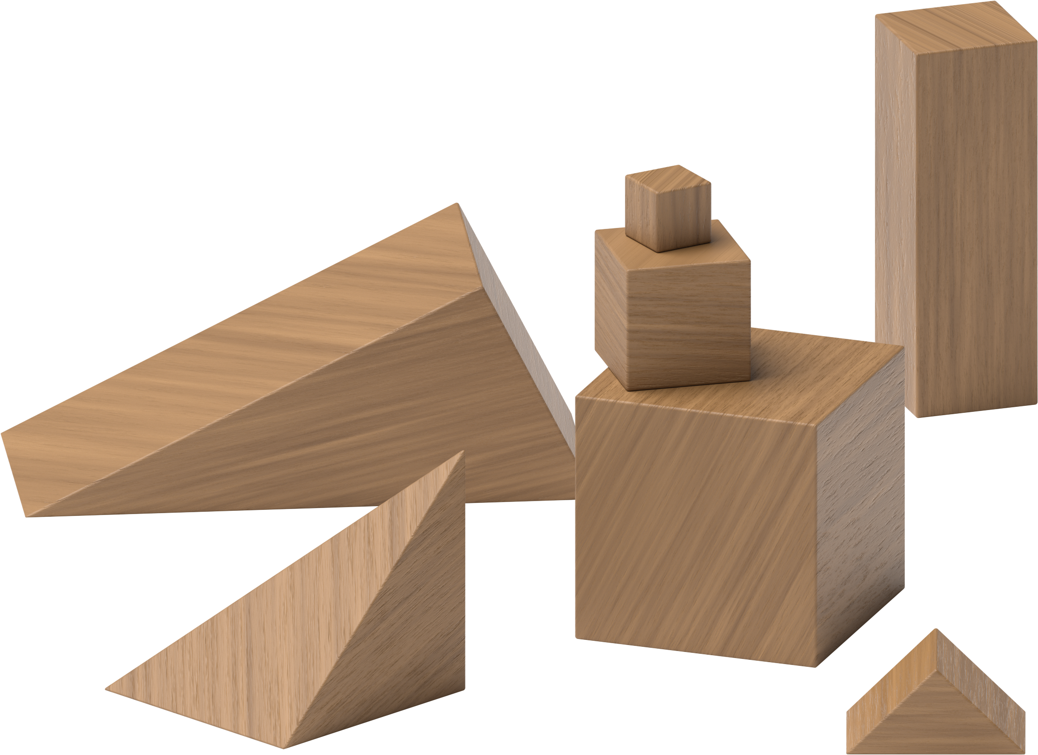
Counting Collections
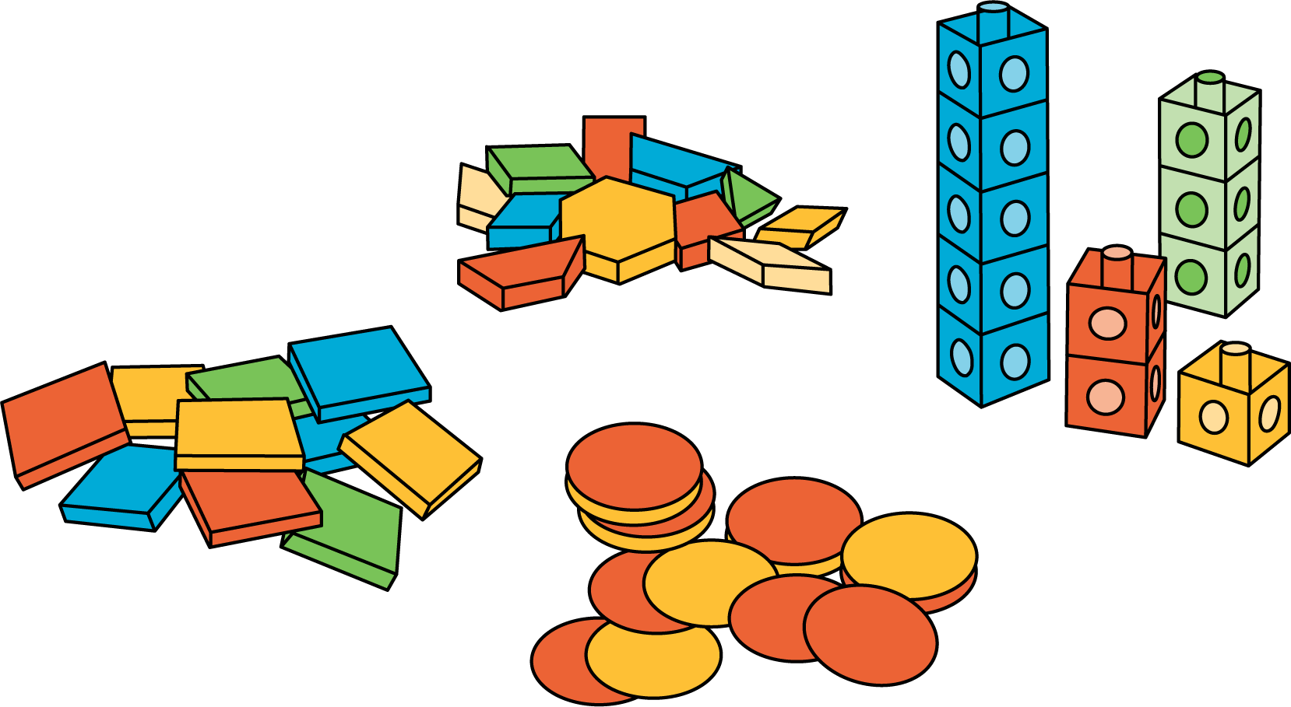
Match Mine
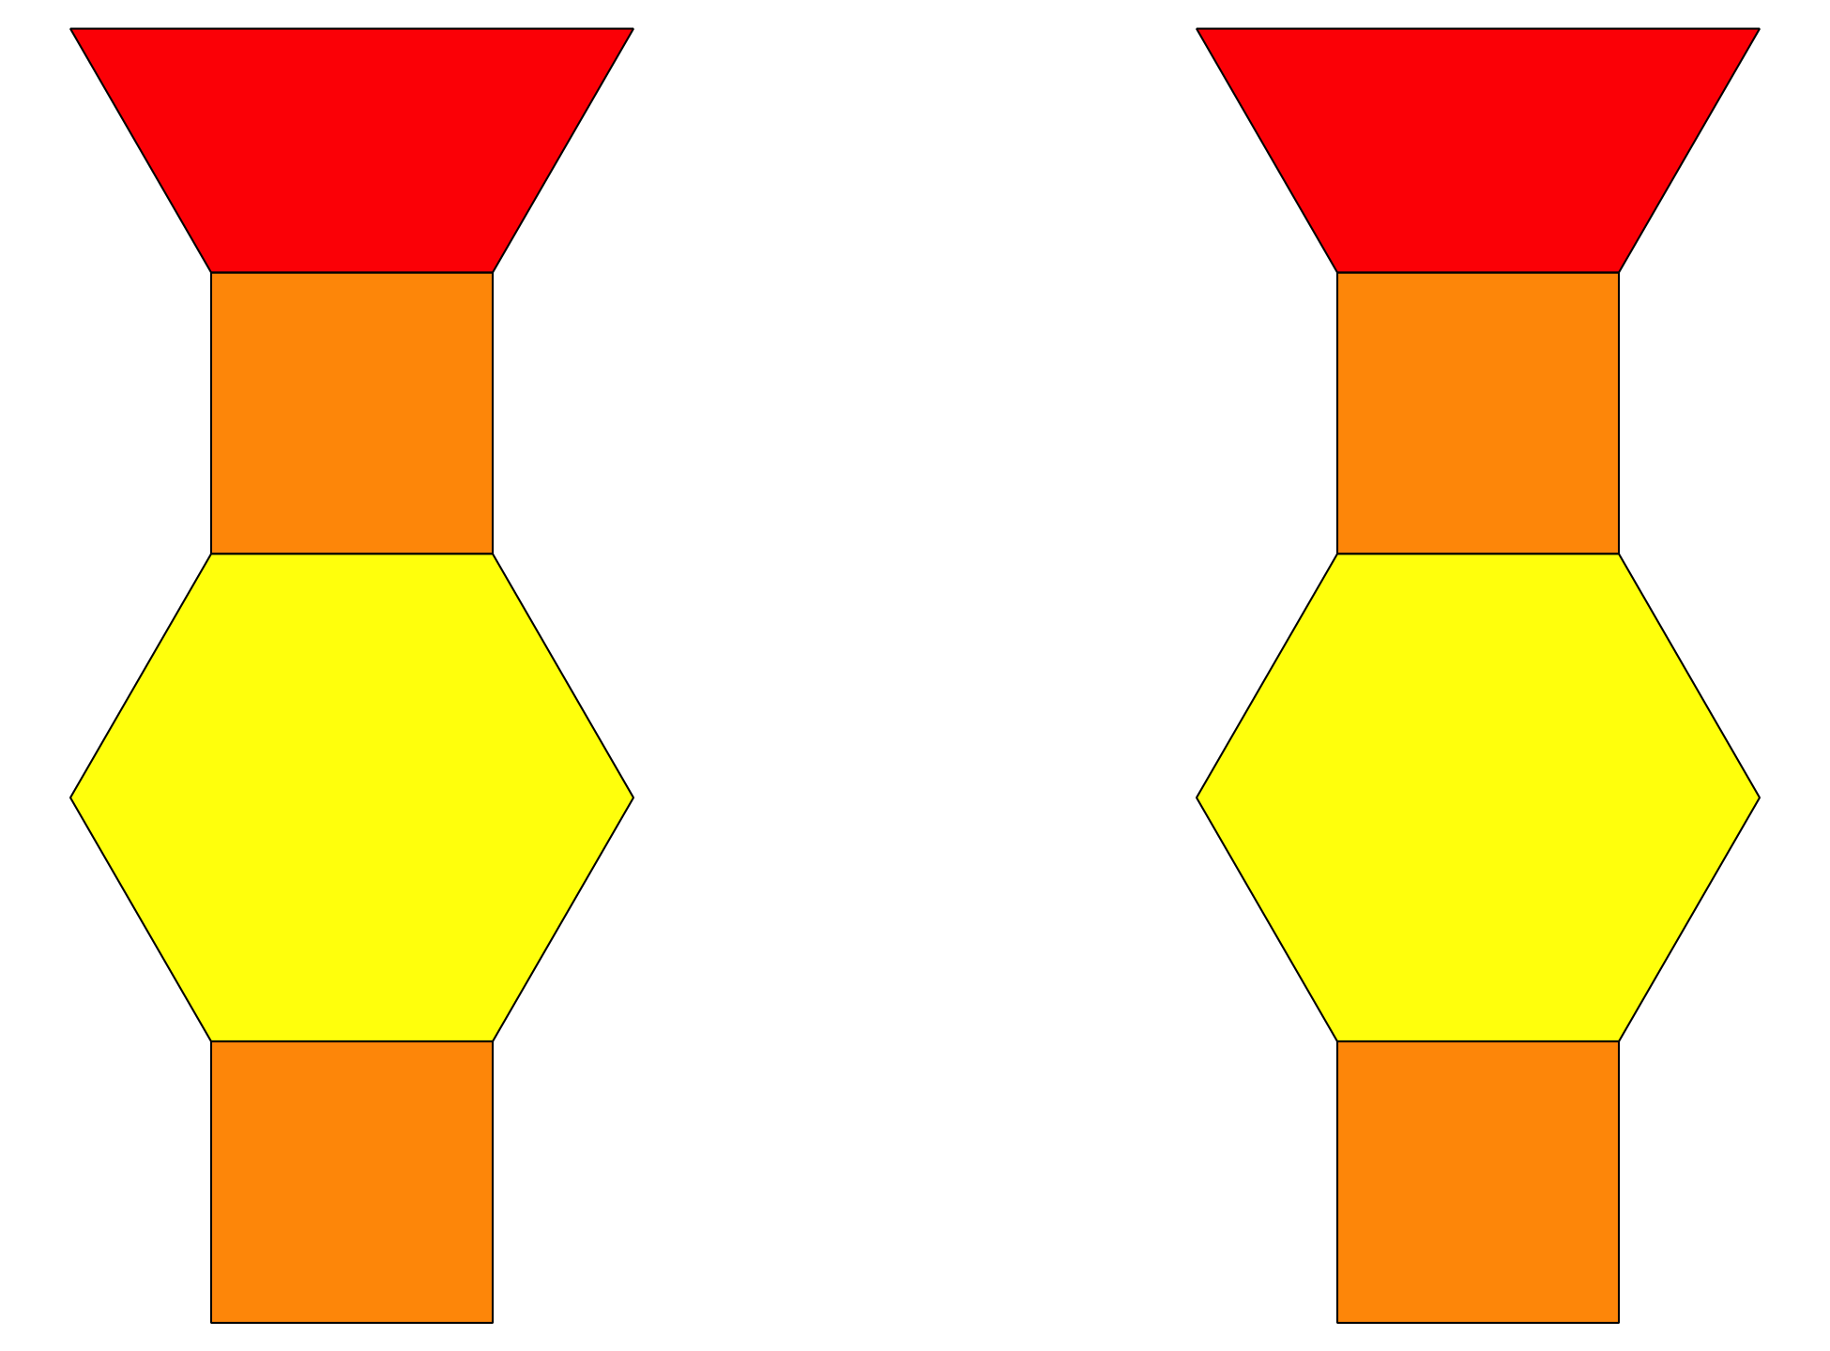
Shake and Spill
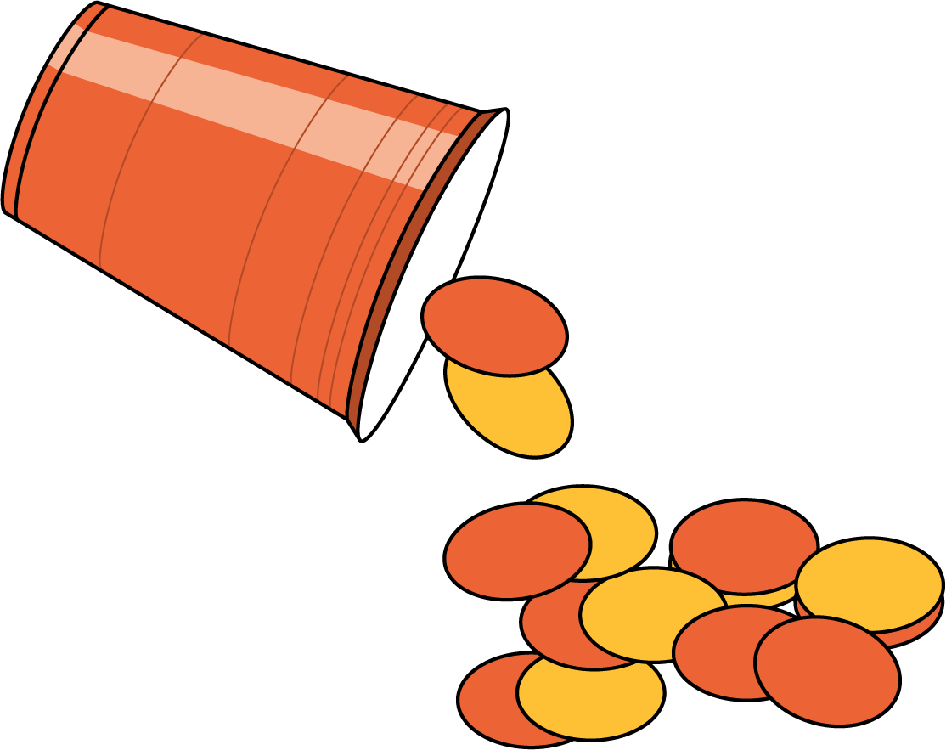
© CC BY 2021 Illustrative Mathematics®

