Lesson 22 Practice Problems
- The following quadratic expressions all define the same function.
- $\left(x+5\right)\left(x+3\right)$
- $x^{2}+8x+15$
- ${\left(x+4\right)}^{2}−1$
- Select all of the statements that are true about the graph of this function.
  - The $y$-intercept is $\left(0,\text{-}15\right)$.
  - The vertex is $\left(\text{-}4,\text{-}1\right)$.
  - The $x$-intercepts are $\left(\text{-}5,0\right)$ and $\left(\text{-}3,0\right)$.
  - The $x$-intercepts are $\left(0,5\right)$ and $\left(0,3\right)$.
  - The $x$-intercept is $\left(0,15\right)$.
  - The $y$-intercept is $\left(0,15\right)$.
  - The vertex is $\left(4,\text{-}1\right)$.
- The following expressions all define the same quadratic function.
- $\left(x−4\right)\left(x+6\right)$
- $x^{2}+2x−24$
- ${\left(x+1\right)}^{2}−25$
  - What is the $y$-intercept of the graph of the function?
  - What are the $x$-intercepts of the graph?
  - What is the vertex of the graph?
  - Sketch a graph of the function without graphing technology. Make sure the $x$-intercepts, $y$-intercept, and vertex are plotted accurately.
- 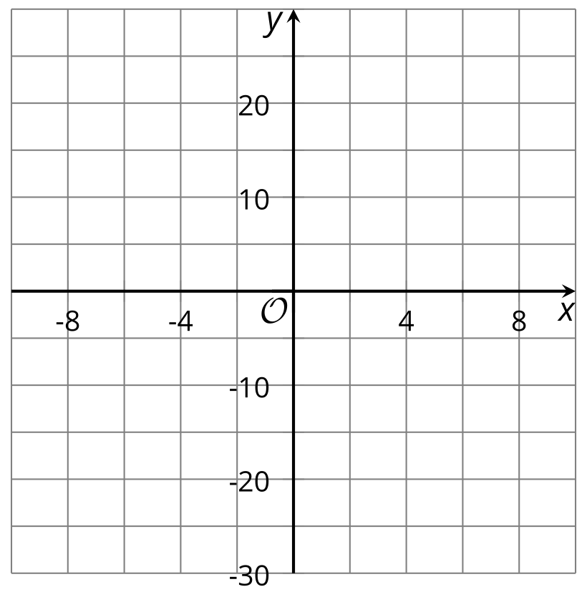
- Here is one way an expression in standard form is rewritten into vertex form.
- $\begin{matrix} & x^{2}−7x+6 & & \text{original expression} \\ & x^{2}−7x+{\left(\text{-}\frac{7}{2}\right)}^{2}+6−{\left(\text{-}\frac{7}{2}\right)}^{2} & & \text{step 1} \\ & {\left(x−\frac{7}{2}\right)}^{2}+6−\frac{49}{4} & & \text{step 2} \\ & {\left(x−\frac{7}{2}\right)}^{2}+\frac{24}{4}−\frac{49}{4} & & \text{step 3} \\ & {\left(x−\frac{7}{2}\right)}^{2}−\frac{25}{4} & & \text{step 4}\end{matrix}$
  - In step 1, where did the number $\text{-}\frac{7}{2}$ come from?
  - In step 1, why was ${\left(\text{-}\frac{7}{2}\right)}^{2}$ added and then subtracted?
  - What happened in step 2?
  - What happened in step 3?
  - What does the last expression tell us about the graph of a function defined by this expression?
- Rewrite each quadratic expression in vertex form.
  - $d\left(x\right)=x^{2}+12x+36$
  - $f\left(x\right)=x^{2}+10x+21$
  - $g\left(x\right)=2x^{2}−20x+32$

  - Give an example that shows that the sum of two irrational numbers can be rational.
  - Give an example that shows that the sum of two irrational numbers can be irrational.
- (From Unit 7, Lesson 21.)

  - Give an example that shows that the product of two irrational numbers can be rational.
  - Give an example that shows that the product of two irrational numbers can be irrational.
- (From Unit 7, Lesson 21.)
- Select all the equations with irrational solutions.
  - $36=x^{2}$
  - $x^{2}=\frac{1}{4}$
  - $x^{2}=8$
  - $2x^{2}=8$
  - $x^{2}=0$
  - $x^{2}=40$
  - $9=x^{2}−1$
- (From Unit 7, Lesson 15.)

  - What are the coordinates of the vertex of the graph of the function defined by $f\left(x\right)=2{\left(x+1\right)}^{2}−4$?
  - Find the coordinates of two other points on the graph.
  - Sketch the graph of $f$.
  - 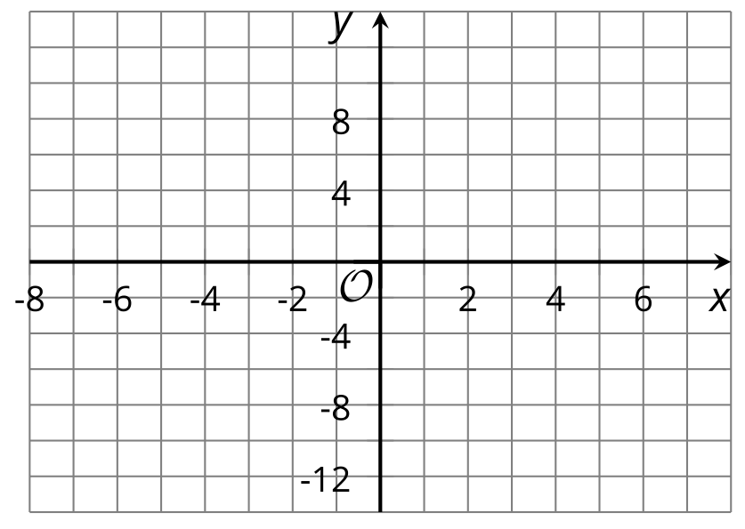
- (From Unit 6, Lesson 16.)
- How is the graph of the equation $y={\left(x−1\right)}^{2}+4$ related to the graph of the equation $y=x^{2}$?
  - The graph of $y={\left(x−1\right)}^{2}+4$ is the same as the graph of $y=x^{2}$ but is shifted 1 unit to the right and 4 units up.
  - The graph of $y={\left(x−1\right)}^{2}+4$ is the same as the graph of $y=x^{2}$ but is shifted 1 unit to the left and 4 units up.
  - The graph of $y={\left(x−1\right)}^{2}+4$ is the same as the graph of $y=x^{2}$ but is shifted 1 unit to the right and 4 units down.
  - The graph of $y={\left(x−1\right)}^{2}+4$ is the same as the graph of $y=x^{2}$ but is shifted 1 unit to the left and 4 units down.
- (From Unit 6, Lesson 17.)
© CC BY 2019 by Illustrative Mathematics®

