Lesson 5 Practice Problems
- Noah says, “I constructed 2 perpendicular bisectors of triangle $ABC$. That means the point where they intersect is the circumcenter!” Andre responds, “No, we still need to check the third perpendicular bisector to make sure it intersects at the same point.”
- Do you agree with either of them? Explain or show your reasoning.
- The dotted line is the perpendicular bisector of side $AB$. The distance between points $E$ and $A$ is 7 units. What is the distance between points $E$ and $B$? Explain or show your reasoning.
- 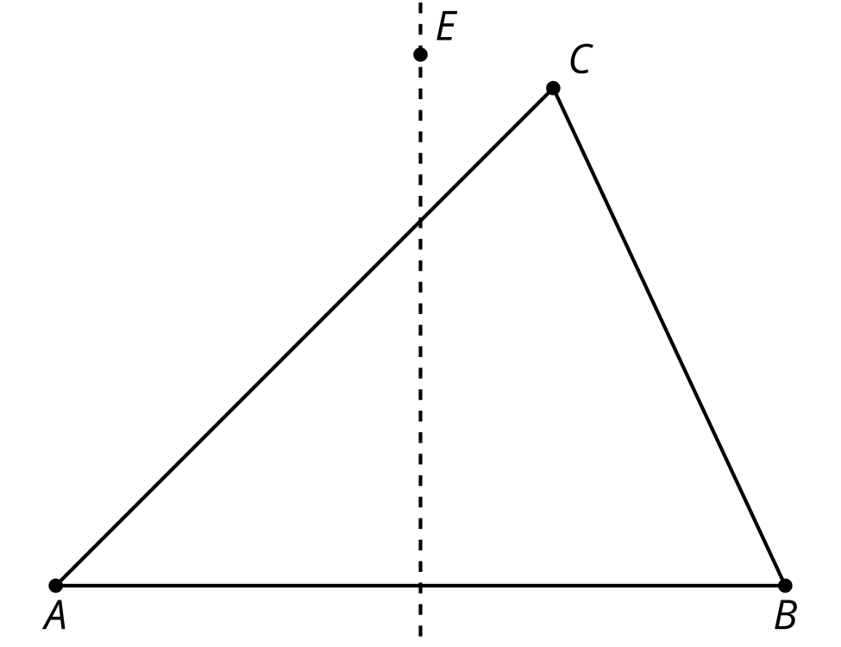
- Construct the circumcenter of each triangle. Then, based on the locations of the circumcenters, classify each triangle as acute, right, or obtuse.

- triangle A
- 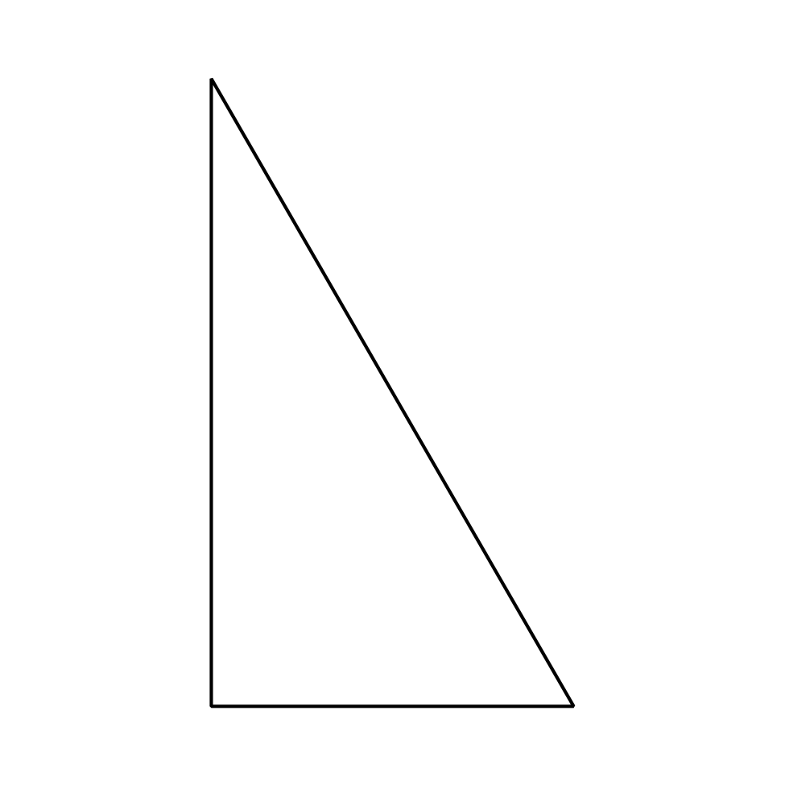

- triangle B
- 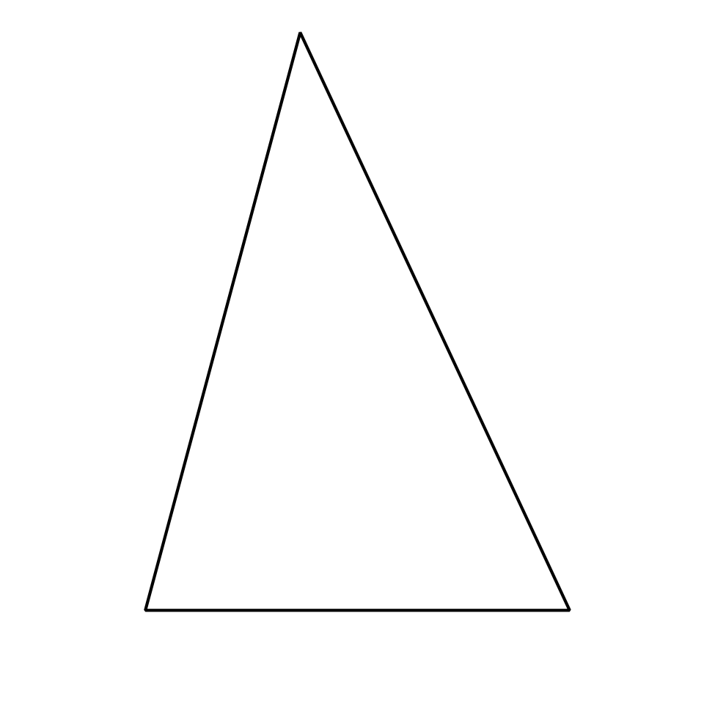
- Select all quadrilaterals that cannot be cyclic.
  - a square with side length $\sqrt{5}$ units
  - a 2 inch by 4 inch rectangle
  - a rhombus with side length 5 centimeters and angle measures 20 degrees and 160 degrees
  - quadrilateral $ABCD$ in which angle $A$ is 62 degrees, angle $B$ is 97 degrees, angle $C$ is 118 degrees, and angle $D$ is 83 degrees
  - quadrilateral $WXYZ$ in which angle $W$ is 45 degrees, angle $X$ is 135 degrees, angle $Y$ is 90 degrees, and angle $Z$ is 90 degrees
- (From Unit 7, Lesson 4.)
- A quadrilateral $ABCD$ has the given angle measures. Select the set of measurements which could come from a cyclic quadrilateral.
  - angle $A$ is 70$​^{∘}$, angle $B$ is 110$​^{∘}$, angle $C$ is 70$​^{∘}$, and angle $D$ is 110$​^{∘}$
  - angle $A$ is 60$​^{∘}$, angle $B$ is 50$​^{∘}$, angle $C$ is 120$​^{∘}$, and angle $D$ is 130$​^{∘}$
  - angle $A$ is 100$​^{∘}$, angle $B$ is 110$​^{∘}$, angle $C$ is 70$​^{∘}$, and angle $D$ is 80$​^{∘}$
  - angle $A$ is 70$​^{∘}$, angle $B$ is 45$​^{∘}$, angle $C$ is 110$​^{∘}$, and angle $D$ is 45$​^{∘}$
- (From Unit 7, Lesson 4.)
- What is the measure of angle $YXZ$?
- 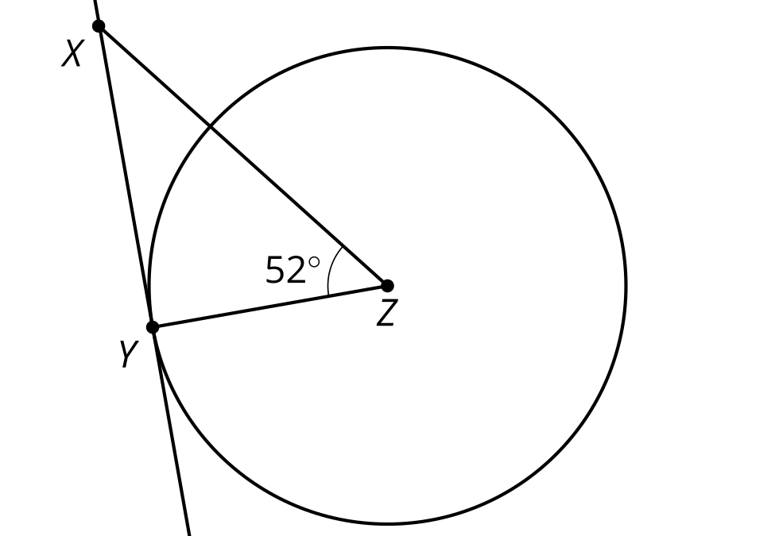
- (From Unit 7, Lesson 3.)
- The measure of angle $AOB$ is 56 degrees.
  - What is the measure of angle $ACB$?
  - What is the measure of the arc from $A$ to $B$ not passing through $C$?
- 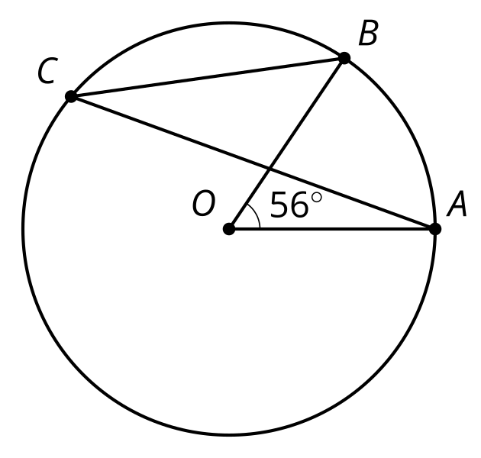
- (From Unit 7, Lesson 2.)
- A quadrilateral has vertices $A=\left(0,0\right),B=\left(2,4\right),C=\left(0,5\right),$ and $D=\left(\text{-}2,1\right)$. Select the most precise classification for quadrilateral $ABCD$.
  - quadrilateral
  - parallelogram
  - rectangle
  - square
- (From Unit 6, Lesson 14.)
© CC BY 2019 by Illustrative Mathematics®

