Lesson 8: Filling up the World's Largest Wagon
- Let’s solve more problems about volume.

Warm-up: Notice and Wonder: Toy Boxes
What do you notice? What do you wonder?
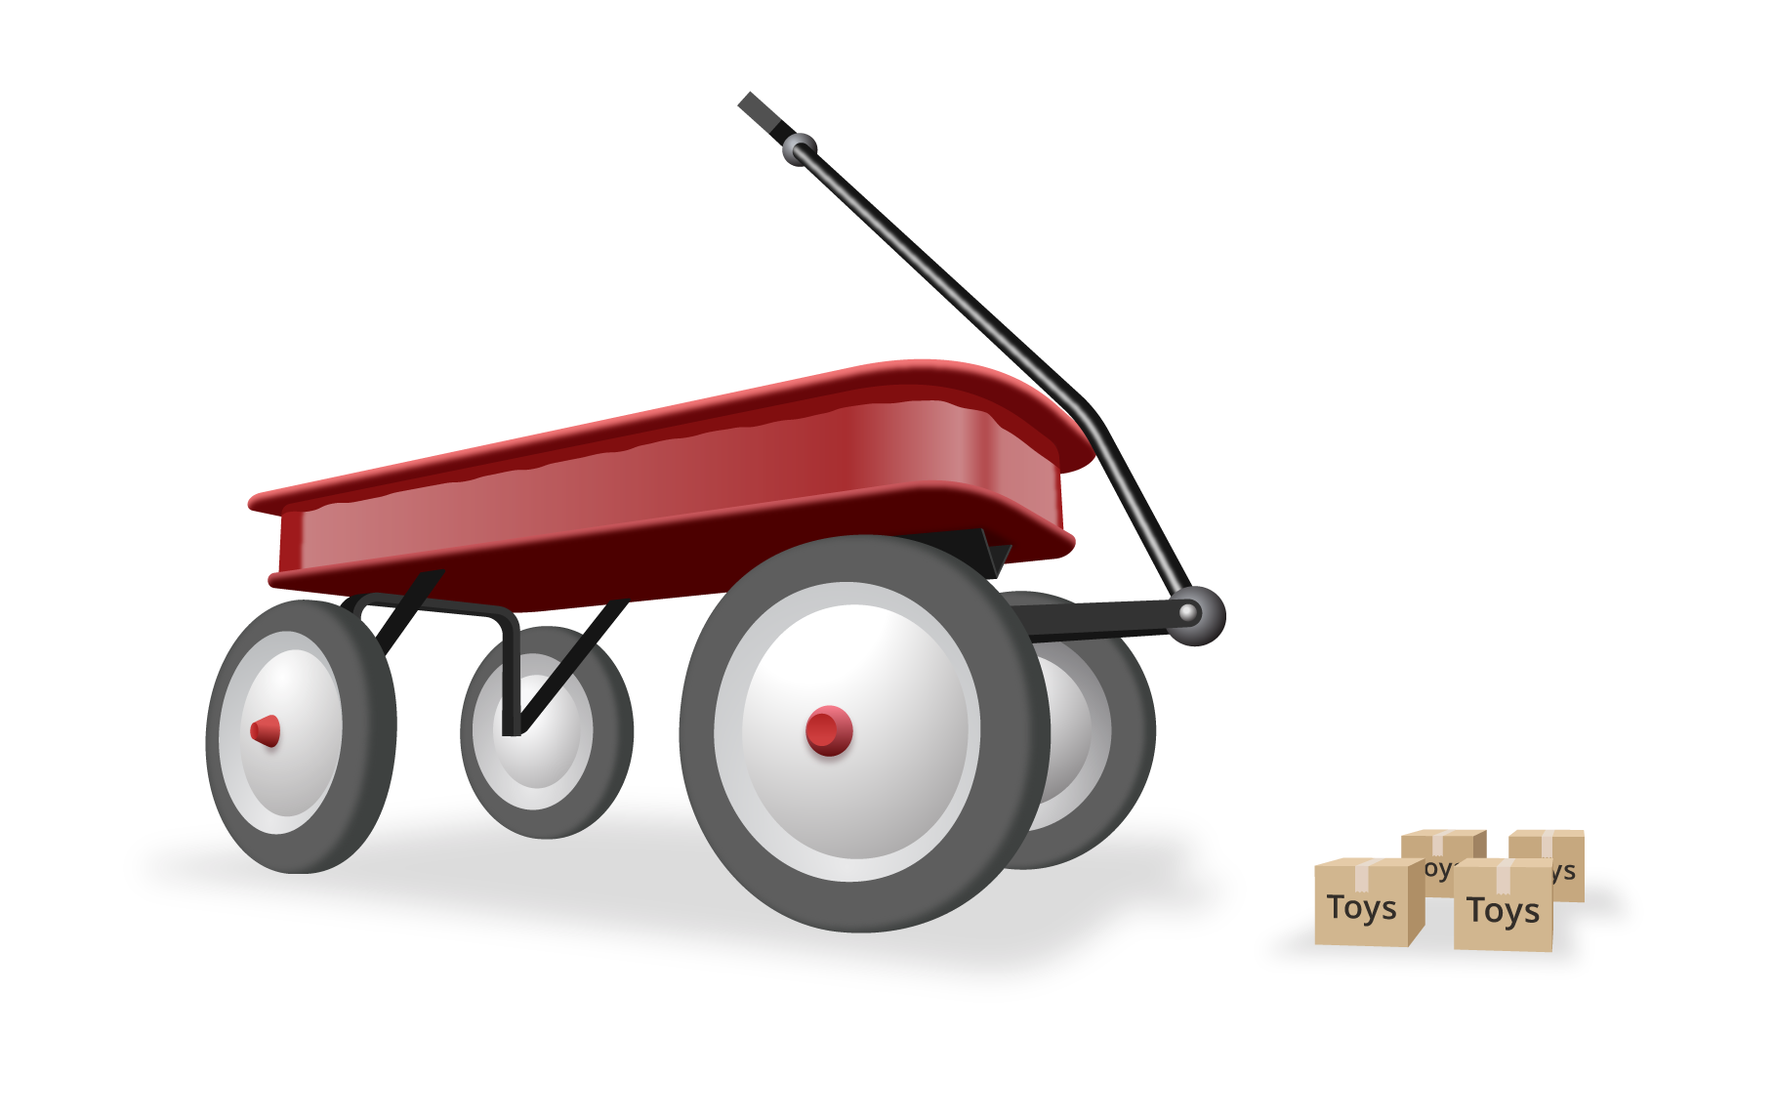

8.1: Sand Wagon
The Radio Flyer wagon is 27 feet long, 13 feet wide, and 2 feet deep.
- A 150-pound bag of sand will fill about 9 cubic feet. How many bags of sand will it take to fill the wagon with sand?
- A 150-pound bag of sand costs about $12. About how much will it cost to fill the wagon with sand? Explain or show your reasoning.
- How many pounds of sand does the Radio Flyer hold when it is full? Explain or show your reasoning.

8.2: More Boxes
The Radio Flyer wagon is 27 feet long 13 feet wide and 2 feet deep.
The wagon is being used to deliver 4,000 boxes that each have the side lengths 2 feet by 2 feet by 2 feet. How many trips will the wagon have to make? Explain or show your reasoning.
© CC BY 2021 Illustrative Mathematics®

