Lesson 12: An Algorithm Using Partial Quotients
- Let's make sense of an algorithm using partial quotients.

Warm-up: Notice and Wonder: Incomplete Solution
What do you notice? What do you wonder?
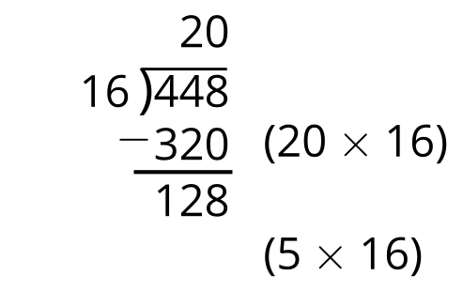

12.1: Elena’s Work
- Find the value of $448÷16$. Show your thinking. Organize it so it can be followed by others.
- (Pause for teacher directions.)
- This is Elena’s work. Describe the steps Elena took to find the value of $448÷16$.
- 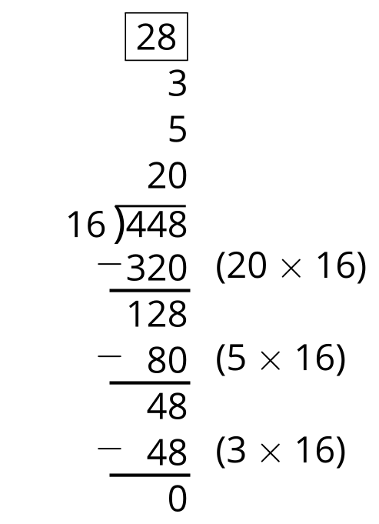

12.2: Complete the Solution
Use Elena’s strategy to complete the following problems:
1.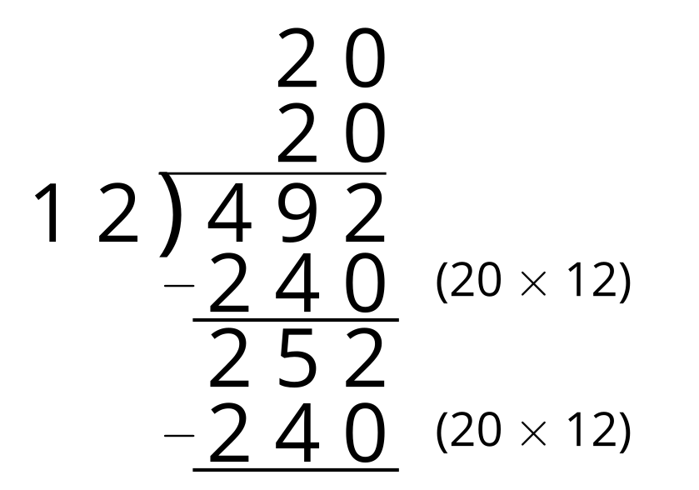
2.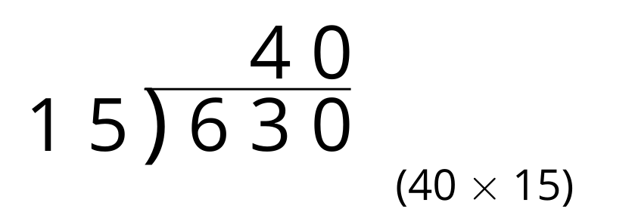
3.
© CC BY 2021 Illustrative Mathematics®

