Unit 3 Lesson 18: Patterns in Addition

WU How Many Do You See: More Double 10-frames (Warm up)

Student Task Statement
How many do you see?
How do you see them?
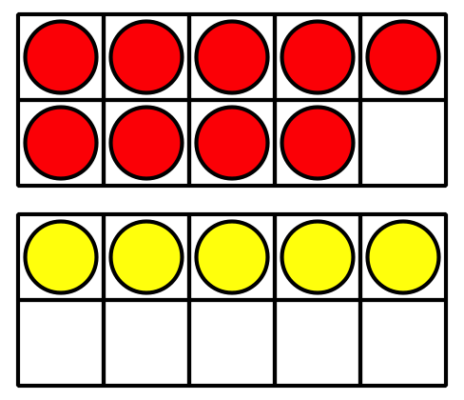
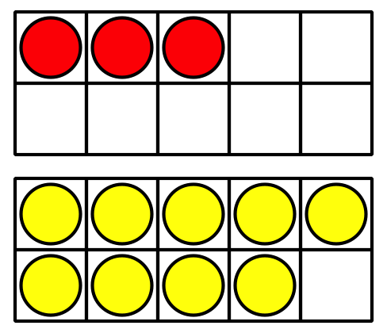
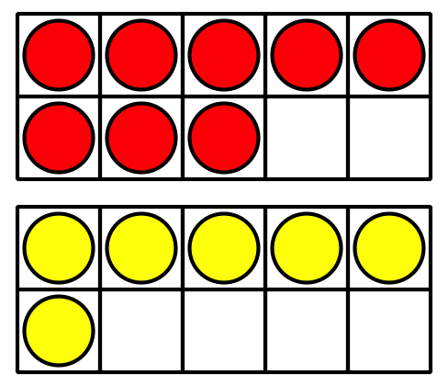

1 Expression Match

Student Task Statement
- Take out all the expression cards that have the number 10.
- Mix up the rest of the cards.
- Pick a card.
- Place the card under the expression with 10 that it is equal to.
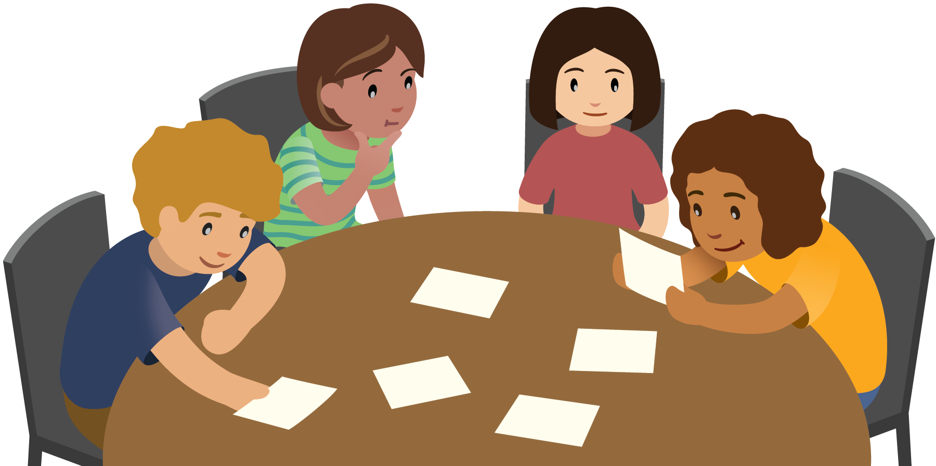

2 Compare and Connect: Gallery Walk

Student Task Statement

3 Centers: Choice Time

Student Task Statement
Choose a center.
Shake and Spill
Compare
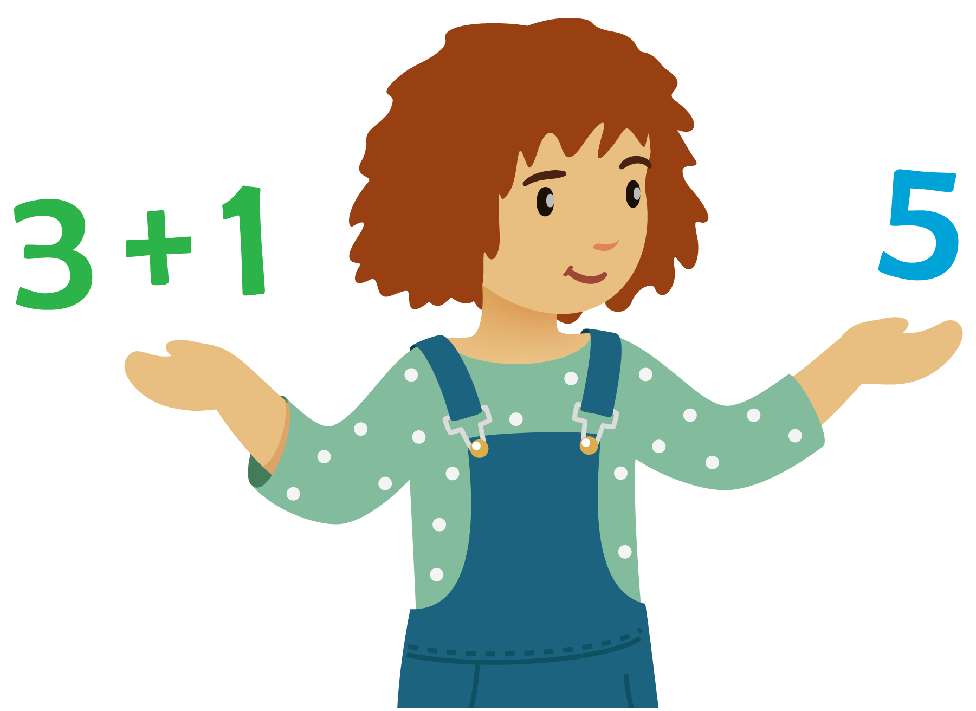
Number Puzzles
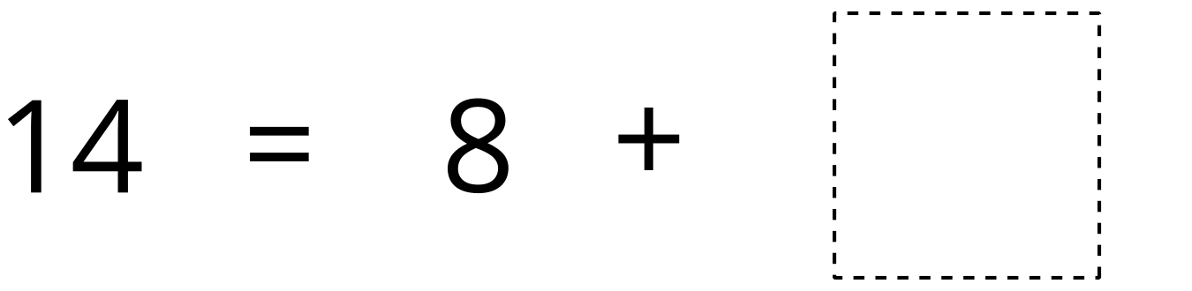
© CC BY 2021 Illustrative Mathematics®

