Unit 2 Lesson 7: Subtract Two Digits

WU How Many Do You See: Compose a Ten (Warm up)

Student Task Statement
How many do you see? How do you see them?
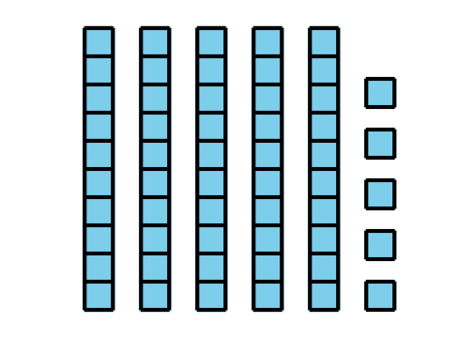
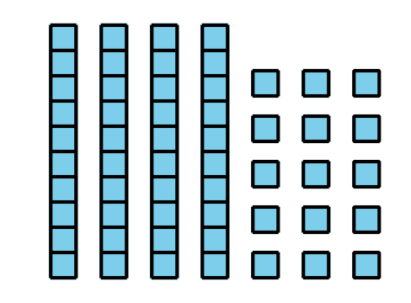
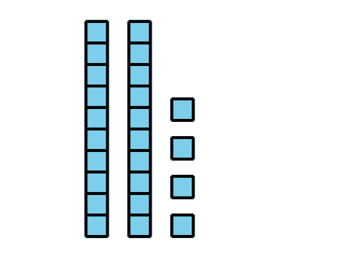
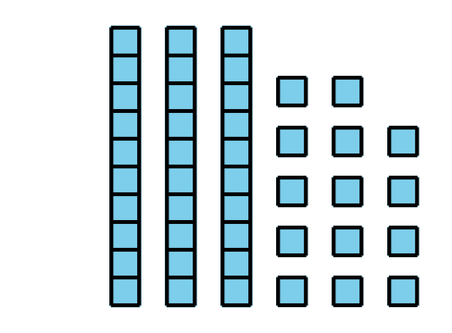

1 What's the Difference?

Student Task Statement
Find the value of each difference. Show your thinking. Use blocks if it helps.
- 46−28= _
- 93−54= _
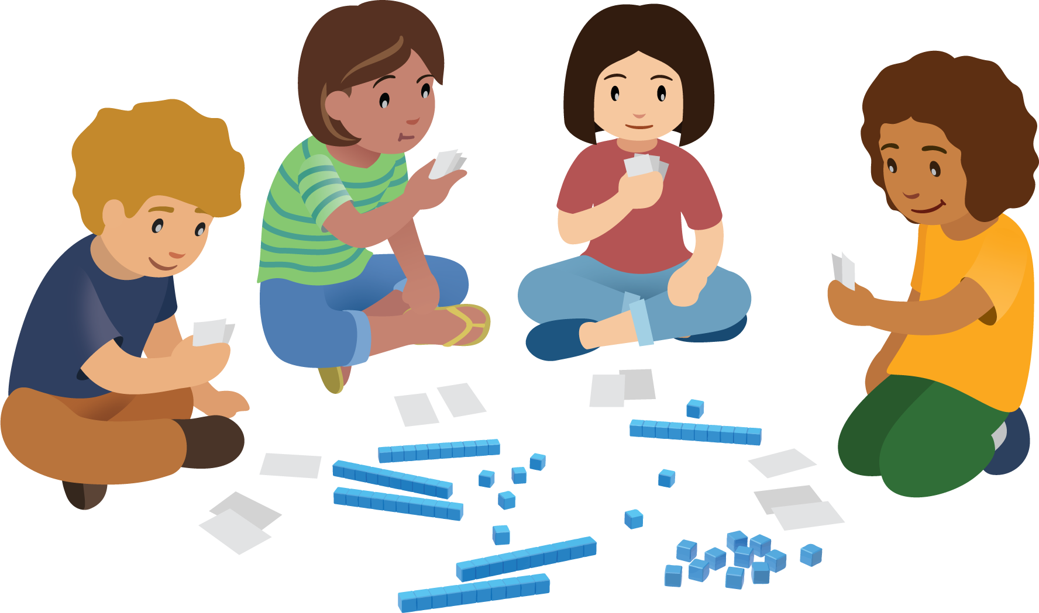

2 Use Blocks to Take Away

Student Task Statement
- Choose a player card. Mix up the other cards and put them face down.
- Player name: ________________________________
- Represent your starting number with base-ten blocks.
- Starting number: ____________________________
- Take turns picking a card. Read the card to the group.
- Listen for your player’s name. Use the blocks to show the change.
- Explain your thinking to your group.
- Write an equation to show the new number.
- Equation 1: ________________________________
- Equation 2: ________________________________
- My player now has ____________ tens and ____________ones.
- Ending number: _____________________________
- Share this number with your group.
- Write an equation to show the sum of the ending numbers in your group.
© CC BY 2021 Illustrative Mathematics®

