Lesson 20: Sticky Notes
- Let’s make a design using sticky notes.

Warm-up: Which One Doesn’t Belong: Sticky Notes
Which one doesn’t belong?
A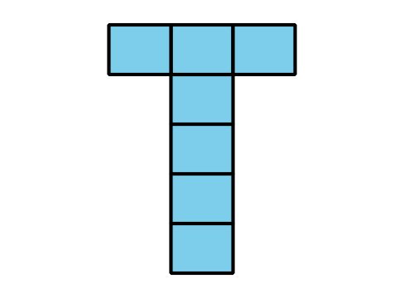
B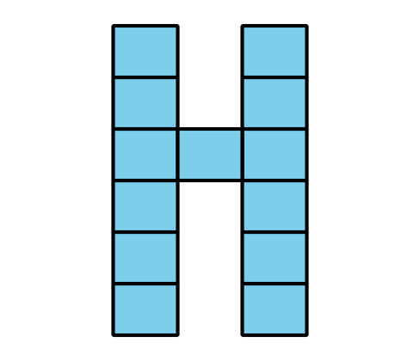
C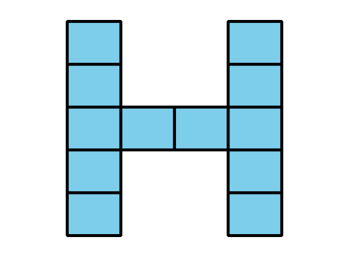
D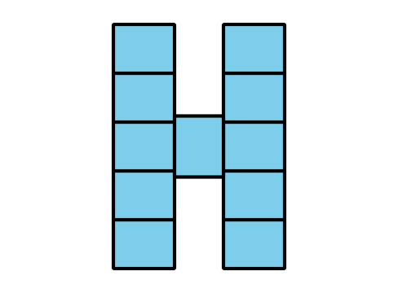

20.1: Estimation Exploration: Sticky Notes
- How many sticky notes will fit across the top or the side of the page?
- Record an estimate that is:
- too low | - about right | - too high
- What information do you need to help you make a better estimate?
- With the new information you have now, make a better estimate. Show or explain your reasoning.
- Write an expression that represents your estimate that shows how many sticky notes fit across or on the side of the paper.

20.2: Design Your Initial
Design your initial with sticky notes.
- Plan your design and determine the number of sticky notes that you need.
- Write at least two equations that show your design will fit on a piece of paper.
- Take turns sharing your design with your partner.
- Get the supplies and make your design.
© CC BY 2021 Illustrative Mathematics®

