Unit 8 Lesson 7: Ways to Find Unknown Length (Part 1)

WU Number Talk: Multiple Thirds (Warm up)

Student Task Statement
Find the value of each expression mentally.
- $6×\frac{1}{3}$
- $30×\frac{1}{3}$
- $60×\frac{2}{3}$
- $90×\frac{2}{3}$

1 All the Way Around

Student Task Statement
- Find the perimeter of each shape. Write an expression that shows how you find the perimeter.
- 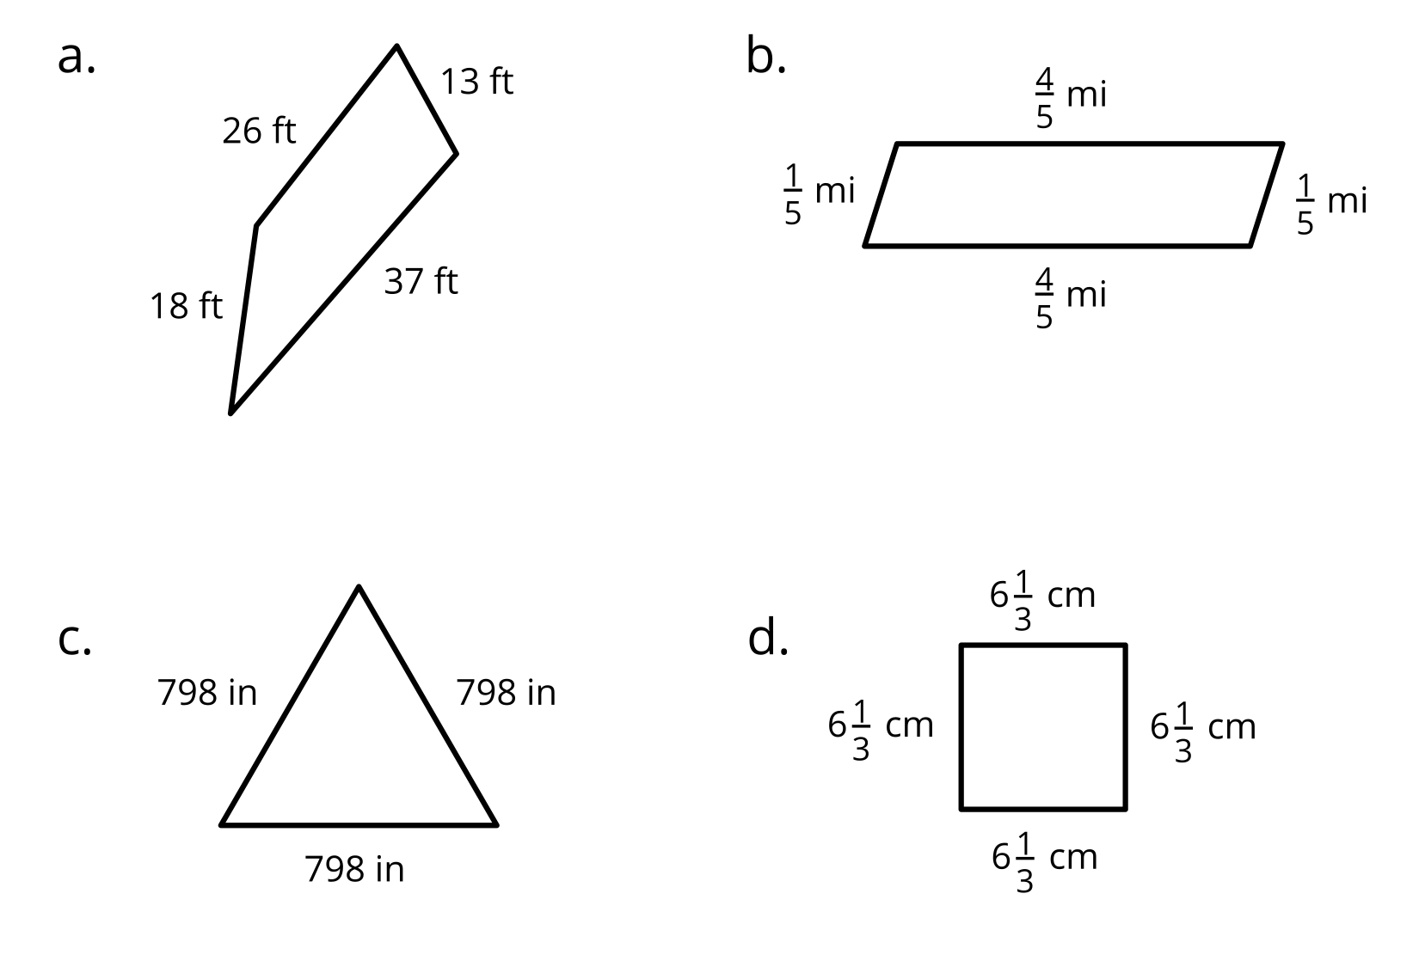
- Compare your expressions with your partners’ expressions. Make 1–2 observations.

2 Ponder Perimeter

Student Task Statement
Here are four shapes and what we know about them:
- A, B, and C have no lines of symmetry.
- A has no parallel sides.
- B has 1 pair of parallel sides.
- C has 2 pairs of parallel sides.
- D has 1 pair of parallel sides and 1 line of symmetry.
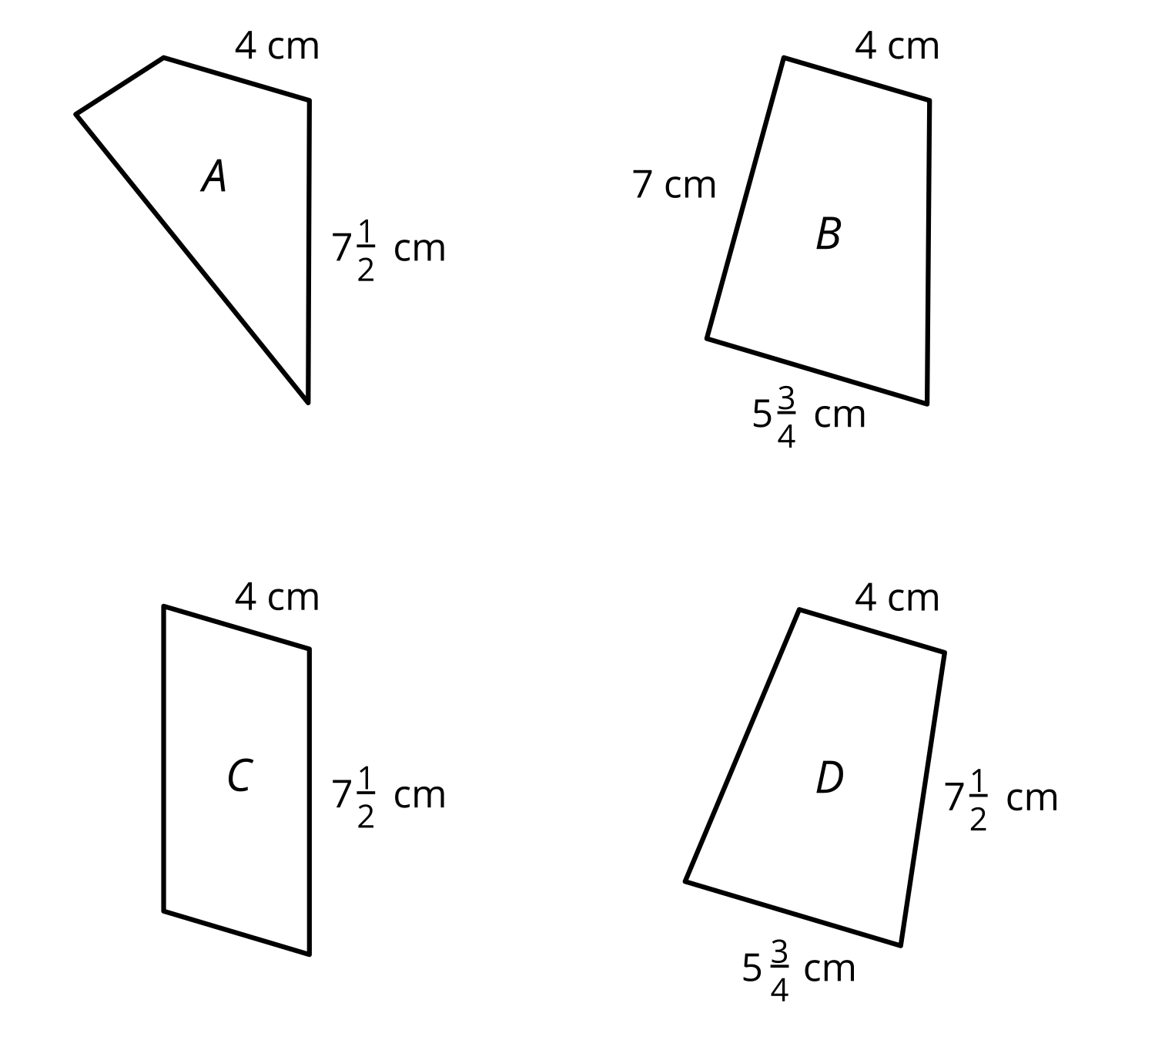
Mai says, “We can’t find the perimeter of any quadrilateral because each one is missing one or more side lengths.”
Andre disagrees. He says, “We can find the perimeters for C and D but not for A and B.”
- Do you agree with either one of them? Explain or show your reasoning.
- Find the perimeters that could be found, if any.

3 Perimeter Expressions (Optional)

Student Task Statement
Here are five shapes and what we know about them.
- Not all the sides are labeled.
- The lines of symmetry are shown.
- Only the triangle has no parallel sides.
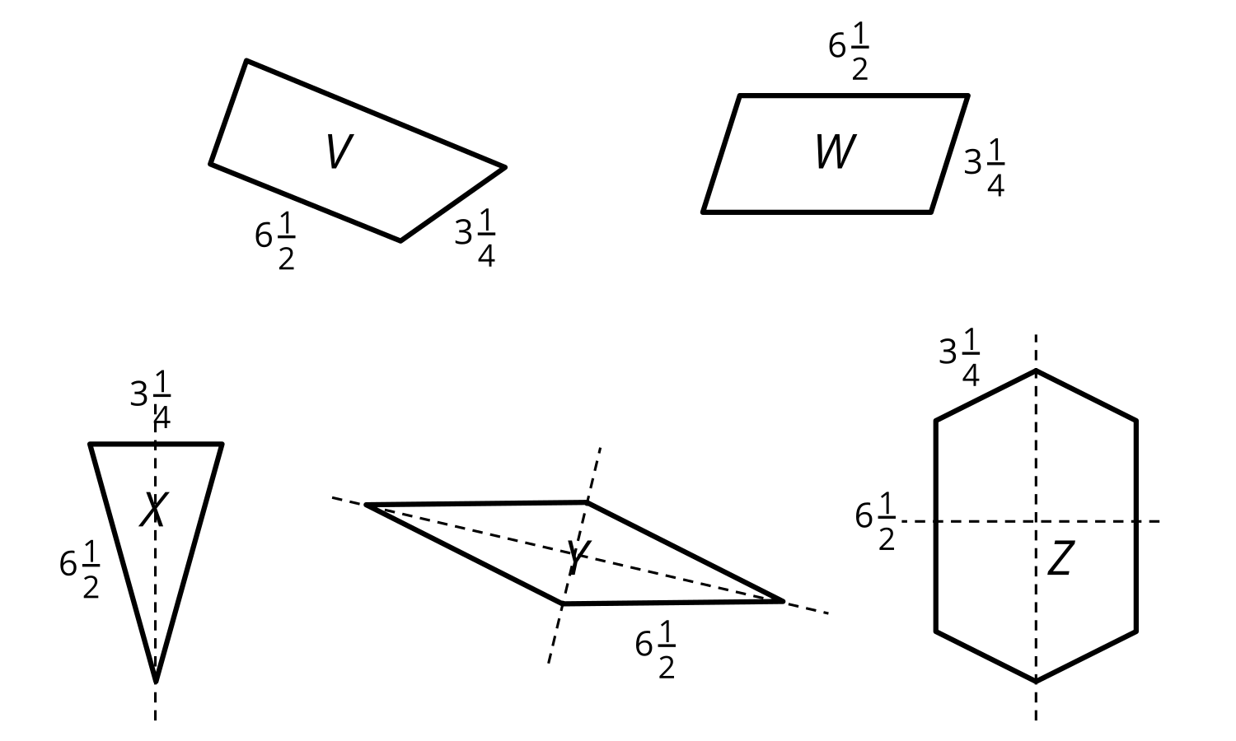
- For which shapes is it possible to find the perimeter? For which shapes is it not possible? Be prepared to explain how you know.
- Here are four expressions. Each one represents the perimeter of one shape. The $6\frac{1}{2}$ and $3\frac{1}{4}$ in each represent side lengths. Can you tell which expression represents which shape?
  - $\left(2×6\frac{1}{2}\right)+3\frac{1}{4}$
  - $4×6\frac{1}{2}$
  - $\left(2×6\frac{1}{2}\right)+\left(4×3\frac{1}{4}\right)$
  - $\left(2×6\frac{1}{2}\right)+\left(2×3\frac{1}{4}\right)$
© CC BY 2021 Illustrative Mathematics®

