Lesson 12: ¿Cuál es la historia?

Standards Alignments
Addressing | 2.NBT.A, 2.NBT.B.5, 2.OA.A.1

Teacher-facing Learning Goals
- See math in the world around them.
- Write story problems using expressions.

Student-facing Learning Goals
- Escribamos problemas-historia.

Lesson Purpose
The purpose of this lesson is for students to ask mathematical questions and write story problems based on a given expression.
In previous lessons, students solved story problems of all types, matched them with tape diagrams and equations, and wrote stories to match tape diagrams. In this lesson, students write story problems to match equations, ask mathematical questions based on pictures and about their environment, and write story problems based on their observations. The goal of the lesson synthesis is for students to discuss which story they liked the most of those that were shared.

Access for:

Students with Disabilities
- Action and Expression (Activity 2)

English Learners
- MLR8 (Activity 2)

Instructional Routines
Estimation Exploration (Warm-up)

Materials to Gather
- Connecting cubes: Activity 2
- Materials from a previous lesson: Activity 1

Materials to Copy
- Story Photos (groups of 2): Activity 2

Lesson Timeline
Warm-up | 10 min
Activity 1 | 15 min
Activity 2 | 20 min
Lesson Synthesis | 10 min
Cool-down | 5 min

Teacher Reflection Question
Which students had opportunities to share their math story problems and thinking during the whole-class discussion? How did you select these students?

Cool-down
(to be completed at the end of the lesson) 5min
¿Cuál puede ser la pregunta?

Standards Alignments
Addressing | 2.NBT.B.5, 2.OA.A.1

Student-facing Task Statement
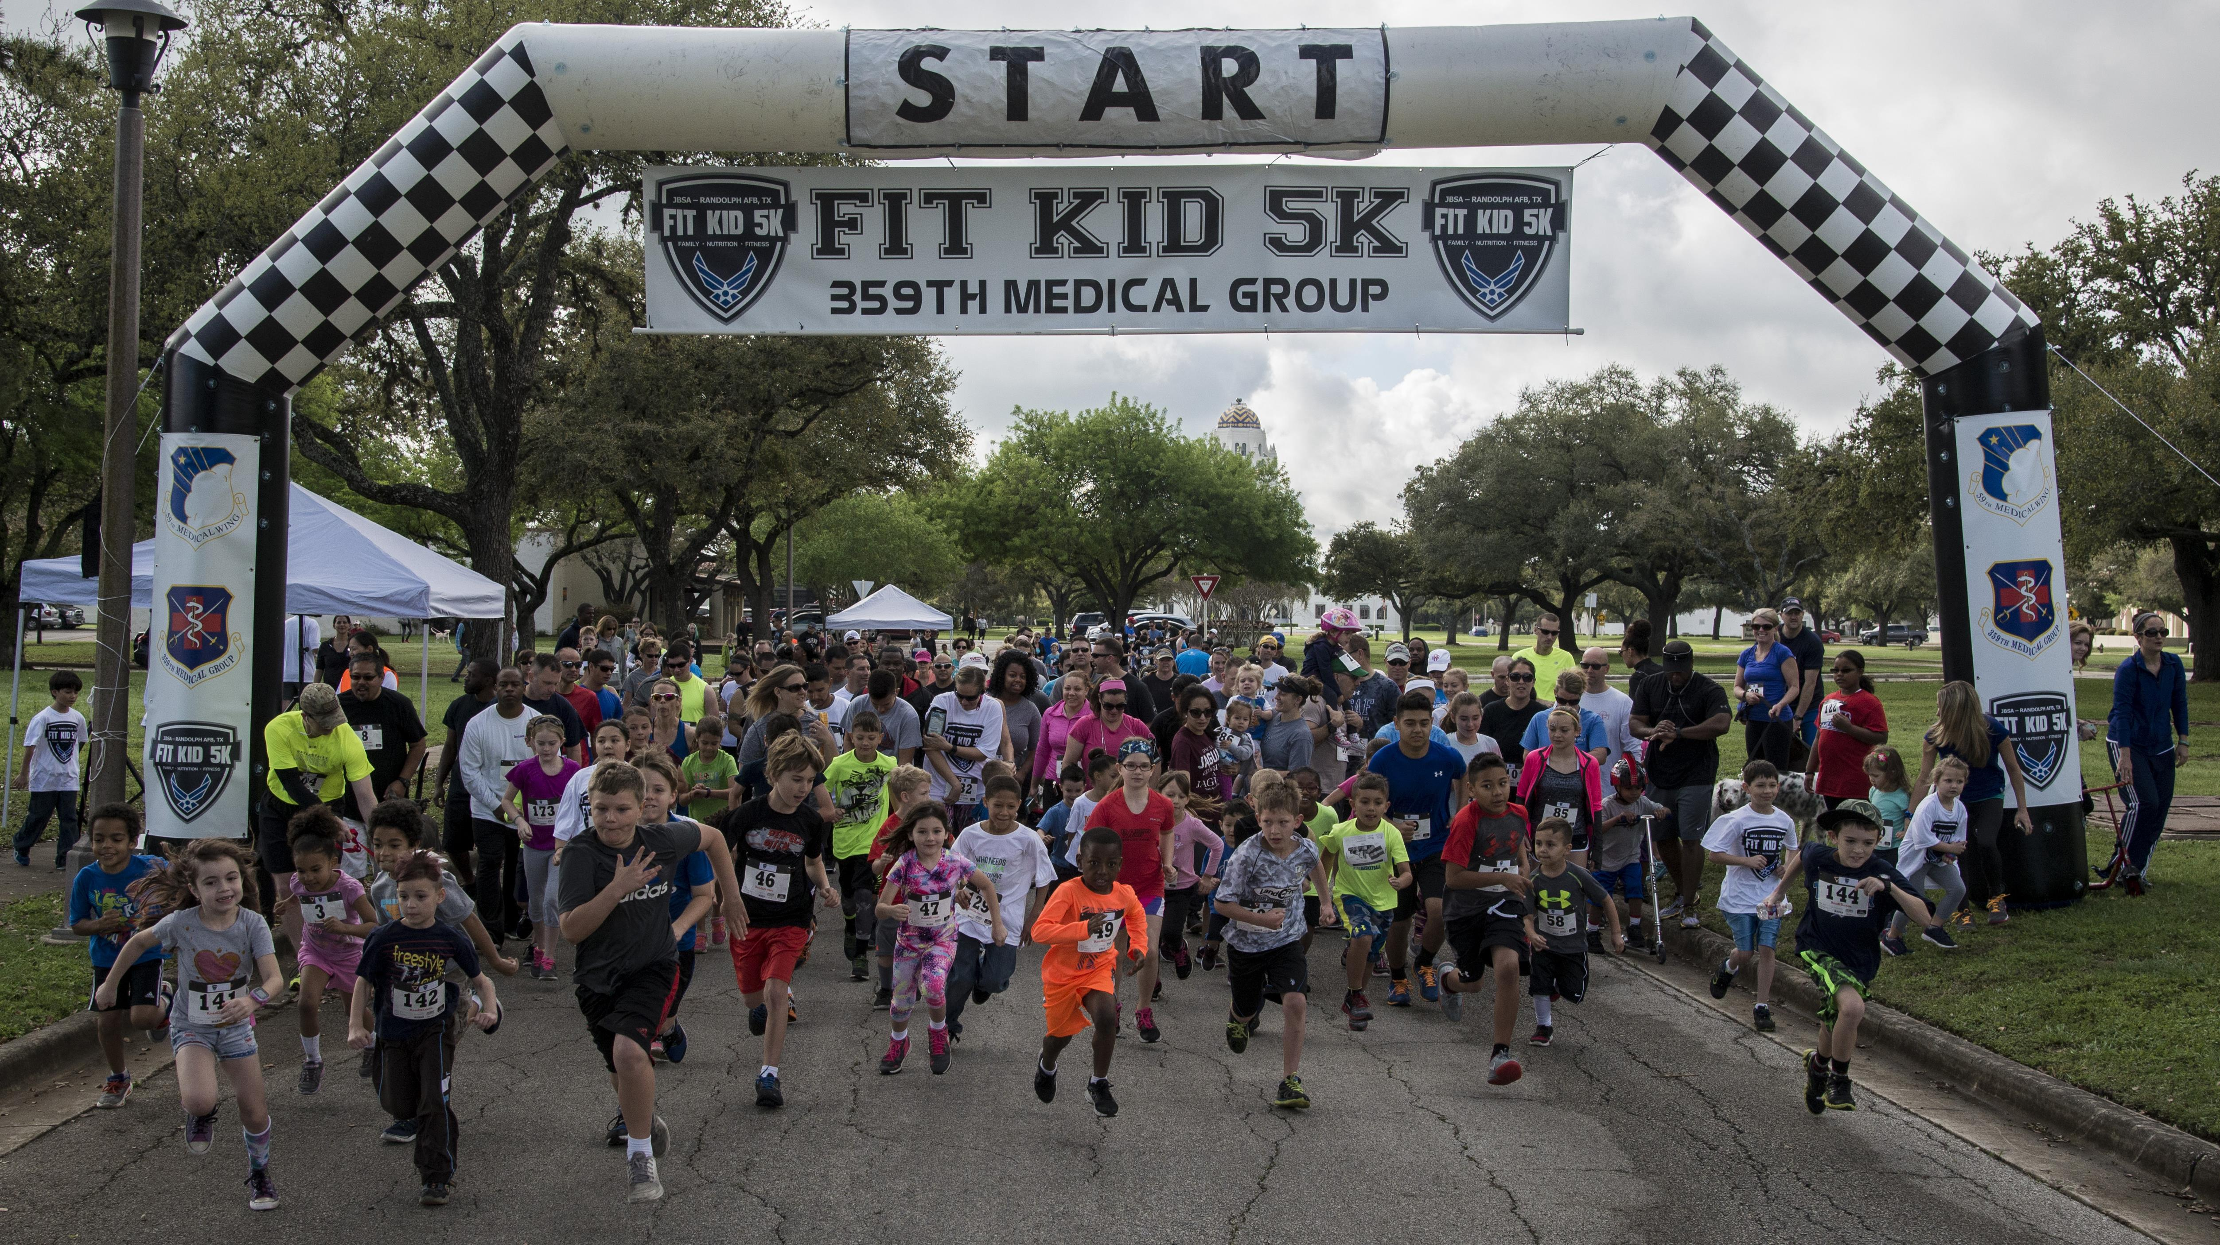
Tyler escribió la ecuación $24+37=61$ para responder una pregunta sobre la imagen.
Escribe un problema-historia que tenga una pregunta que se pueda responder con la ecuación de Tyler.

Student Responses
Sample response: There are 24 kids running. There are 37 more kids behind them walking. How many kids are there altogether in the race? There are 61 kids in the race.

