Unit 7 Lesson 12: Build Solid Shapes

WU Notice and Wonder: Sorted Shapes (Warm up)

Student Task Statement

1 Make Boxes

Student Task Statement

Activity Synthesis
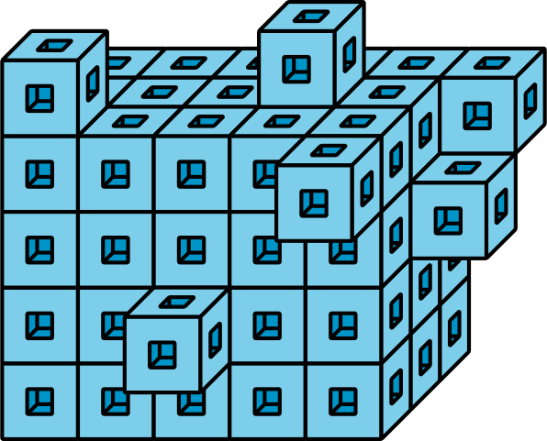

2 Introduce Build Shapes, Match the Solid Shape

Student Task Statement

3 Centers: Choice Time

Student Task Statement
Choose a center.
Build Shapes
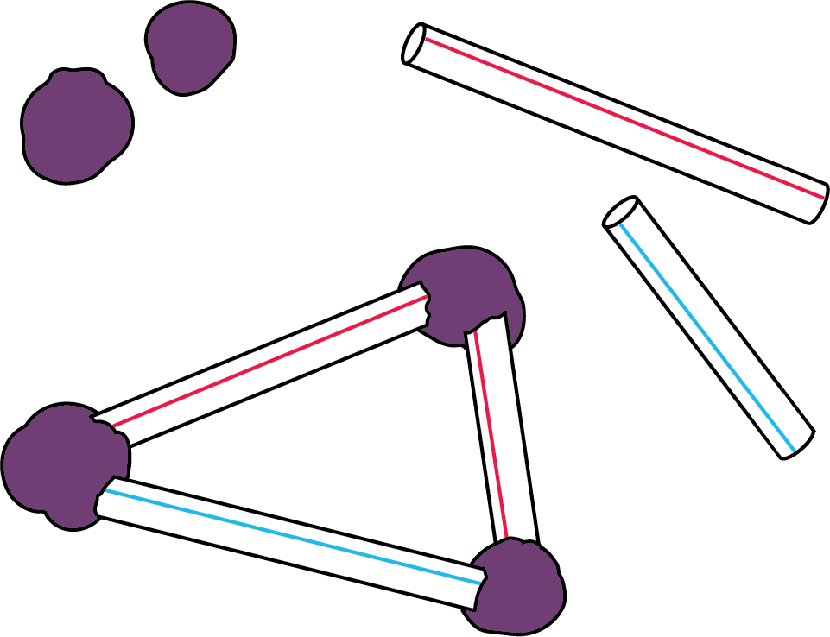
Geoblocks
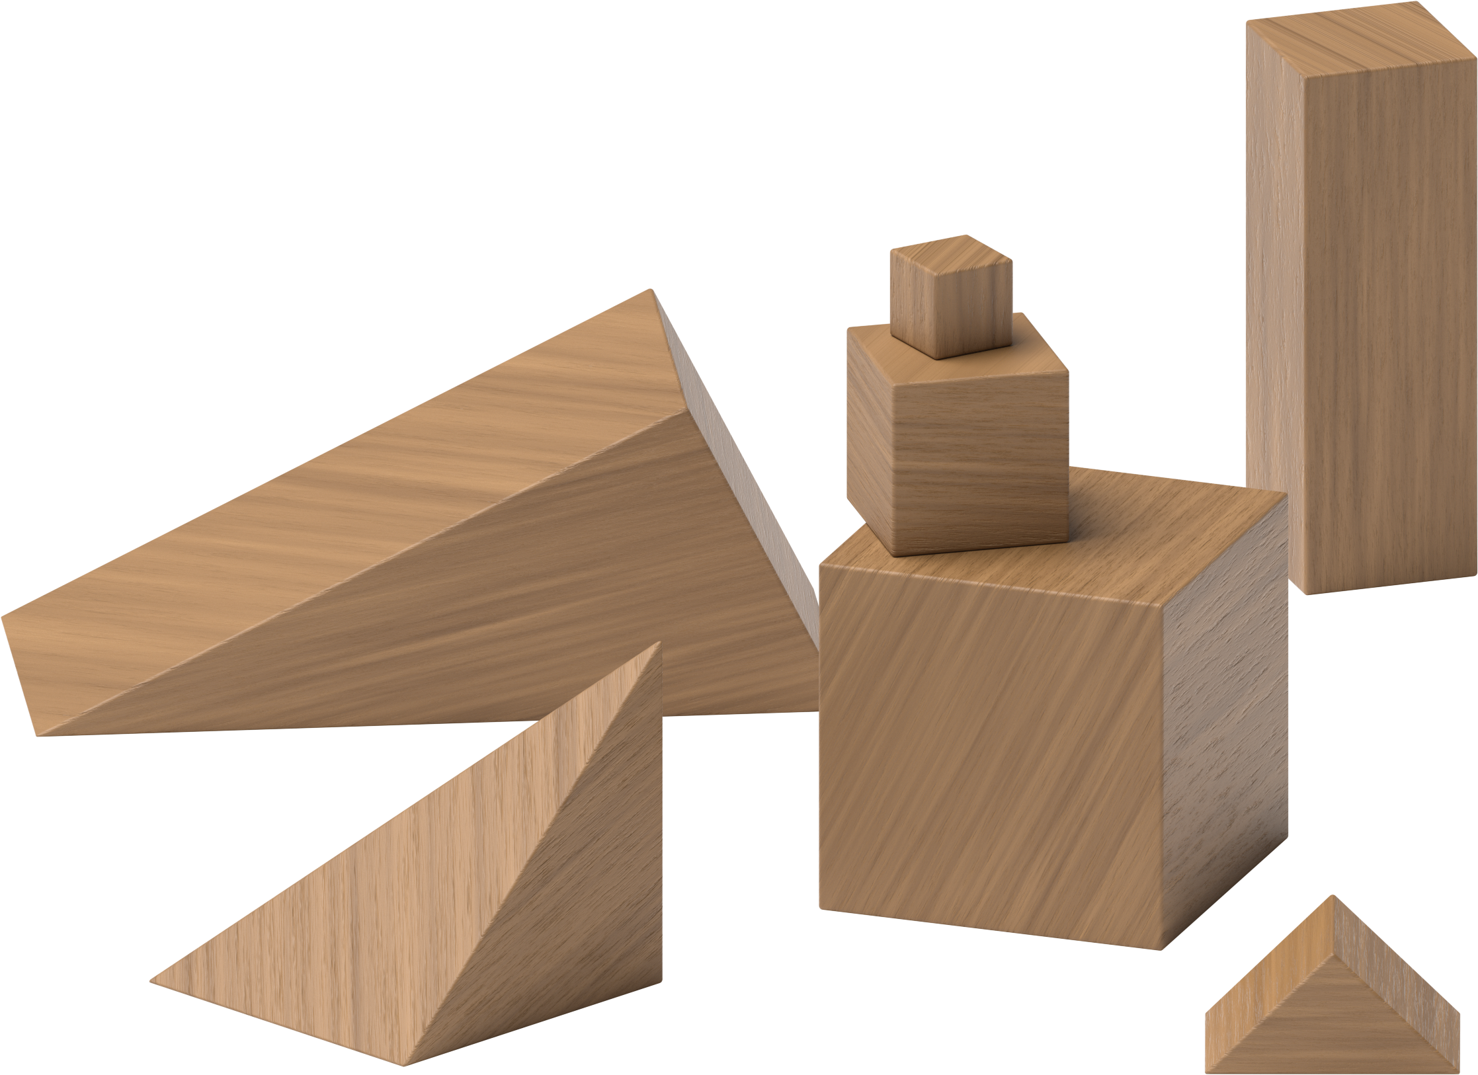
Counting Collections
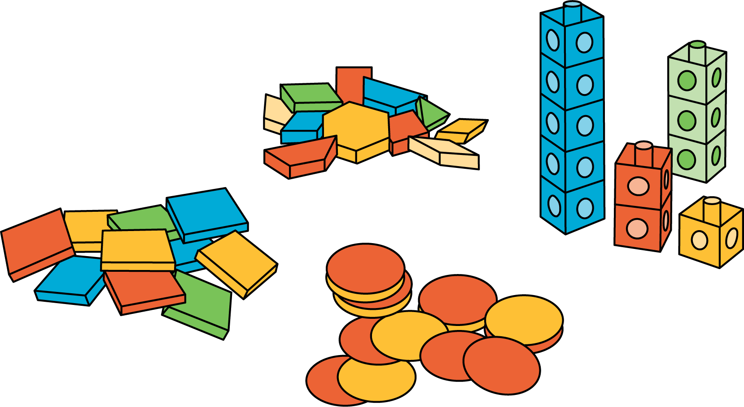
Match Mine
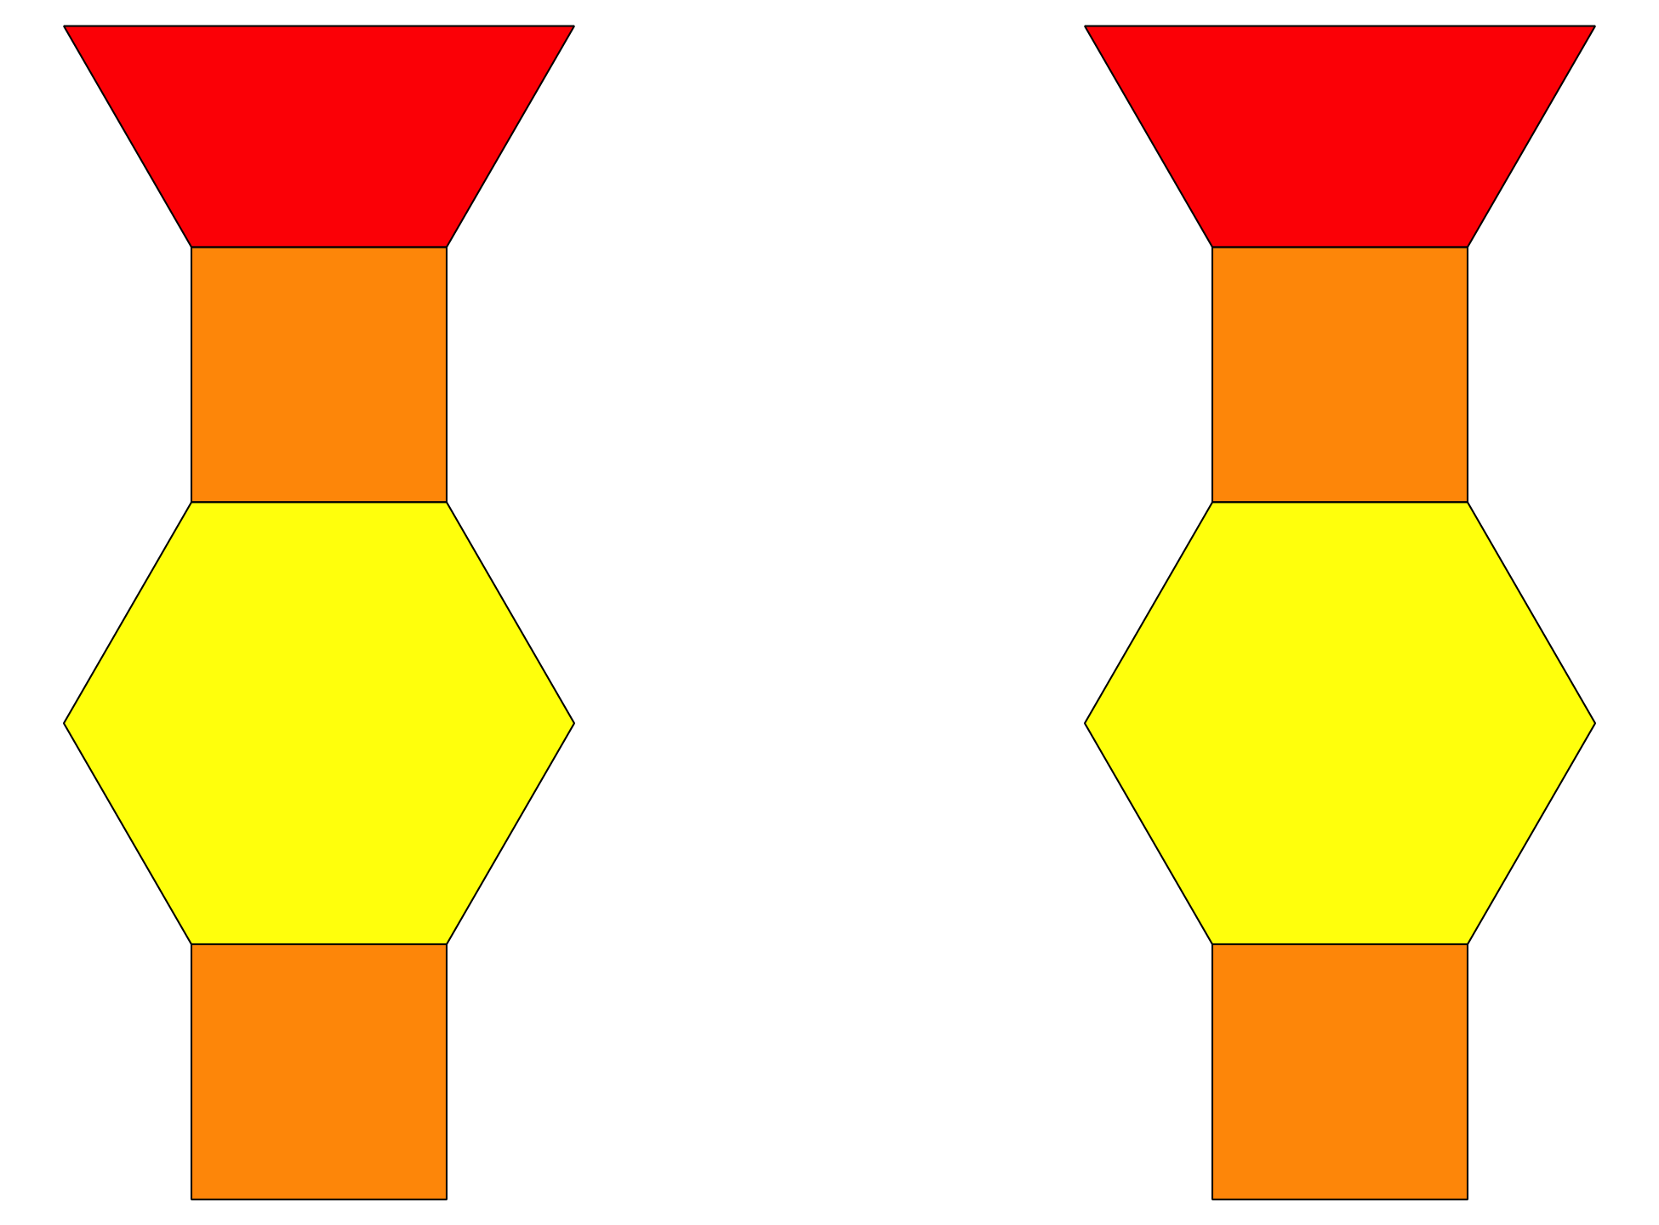
Shake and Spill
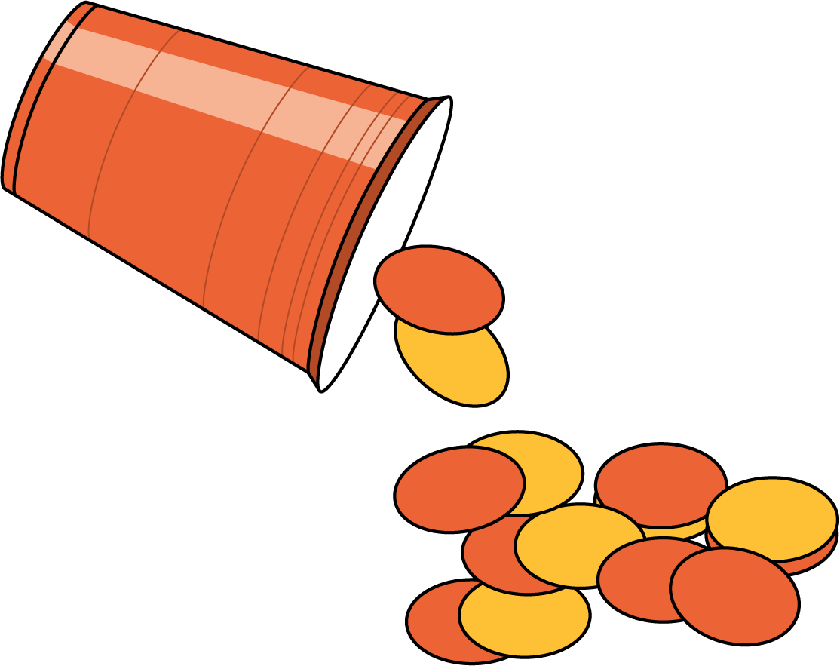
© CC BY 2021 Illustrative Mathematics®

