Unit 4 Lesson 5: Using Function Notation to Describe Rules (Part 2)

1 Make It True (Warm up)

Student Task Statement
Consider the equation $q=4+0.8p$.
- What value of $q$ would make the equation true when:
  - $p$ is 7?
  - $p$ is 100?
- What value of $p$ would make the equation true when:
  - $q$ is 12?
  - $q$ is 60?
Be prepared to explain or show your reasoning.

2 Data Plans

Student Task Statement
A college student is choosing between two data plans for her new cell phone. Both plans include an allowance of 2 gigabytes of data per month. The monthly cost of each option can be seen as a function and represented with an equation:
- Option A: $A\left(x\right)=60$
- Option B: $B\left(x\right)=10x+25$
In each function, the input, $x$, represents the gigabytes of data used over the monthly allowance.
- The student decides to find the values of $A\left(1\right)$ and $B\left(1\right)$ and compare them. What are those values?
- After looking at some of her past phone bills, she decided to compare $A\left(7.5\right)$ and $B\left(7.5\right)$. What are those values?
- Describe each data plan in words.
- Graph each function on the same coordinate plane. Then, explain which plan you think she should choose.
- 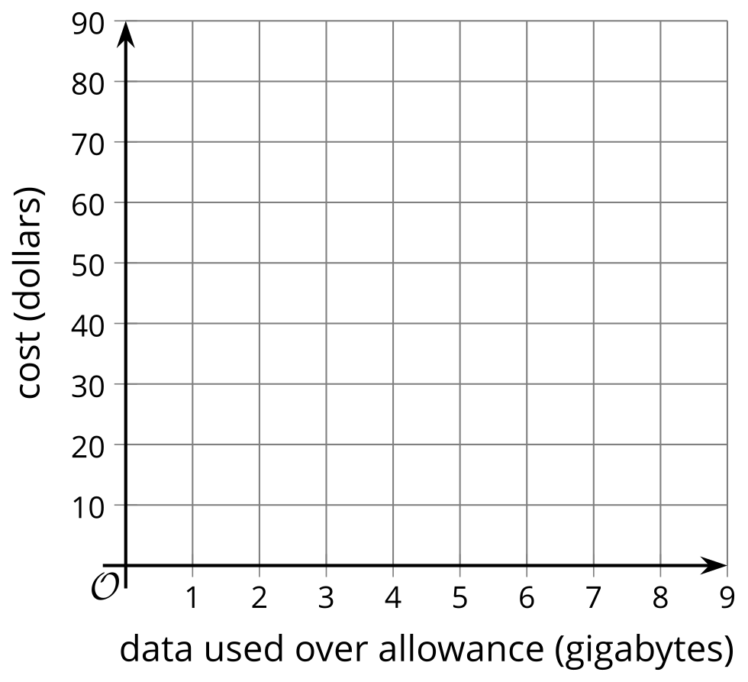
- ​​​​​
- ​​​​​​
- The student only budgeted $50 a month for her cell phone. She thought, “I wonder how many gigabytes of data I would have for $50 if I go with Option B?” and wrote $B\left(x\right)=50$. What is the answer to her question? Explain or show how you know.

3 Function Notation and Graphing Technology (Optional)

Student Task Statement
The function $B$ is defined by the equation $B\left(x\right)=10x+25$. Use graphing technology to:
- Find the value of each expression:
- $B\left(6\right)$
- $B\left(2.75\right)$
- $B\left(1.482\right)$
- Solve each equation:
- $B\left(x\right)=93$
- $B\left(x\right)=42.1$
- $B\left(x\right)=116.25$

Activity Synthesis
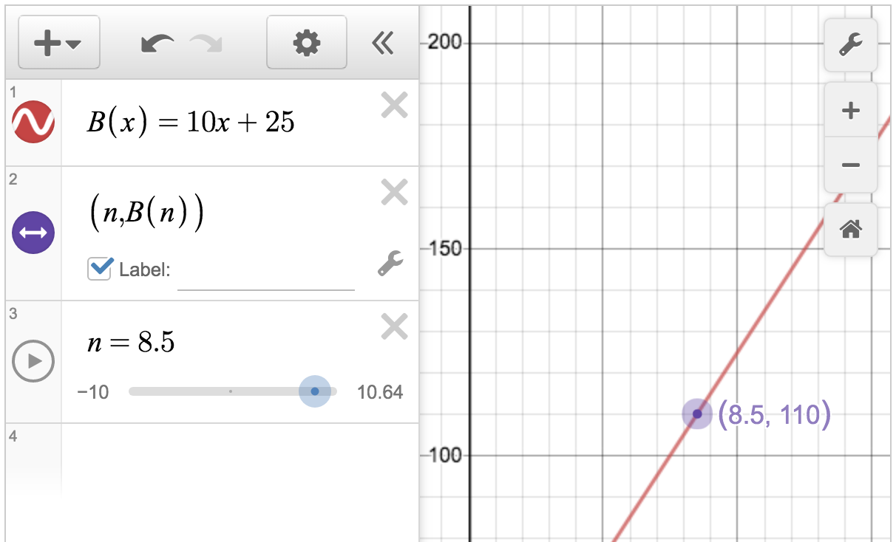

Images for Activity Synthesis
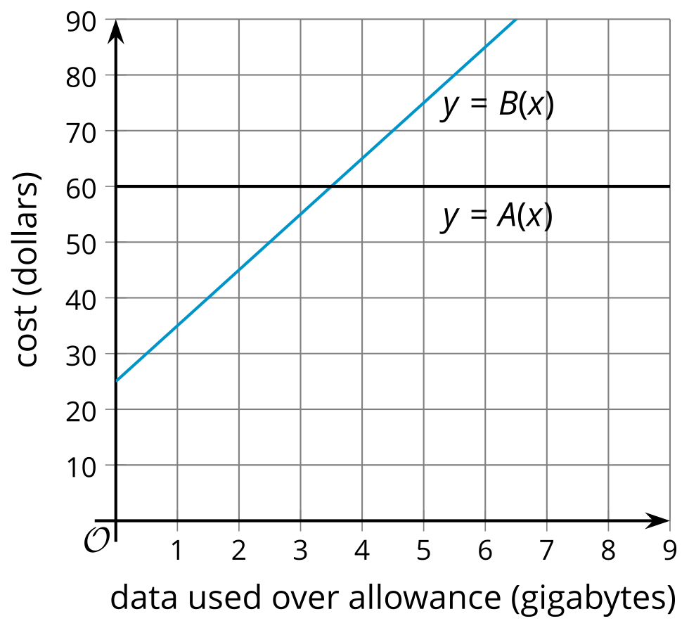
© CC BY 2019 by Illustrative Mathematics®

