Lesson 6 Practice Problems
- How do the values of $α$ and $β$ compare? Explain your reasoning.
- 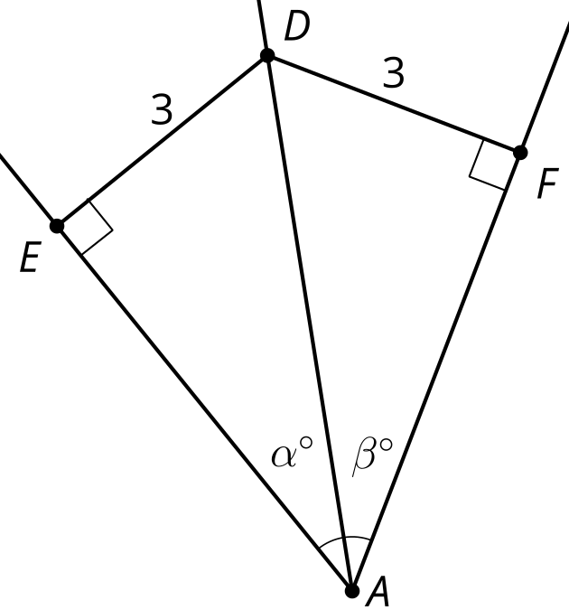
- Triangle $ABC$ is shown together with its angle bisectors. Draw a point $D$ that is equidistant from sides $AC$ and $BC$, but which is closest to side $AB$.
- 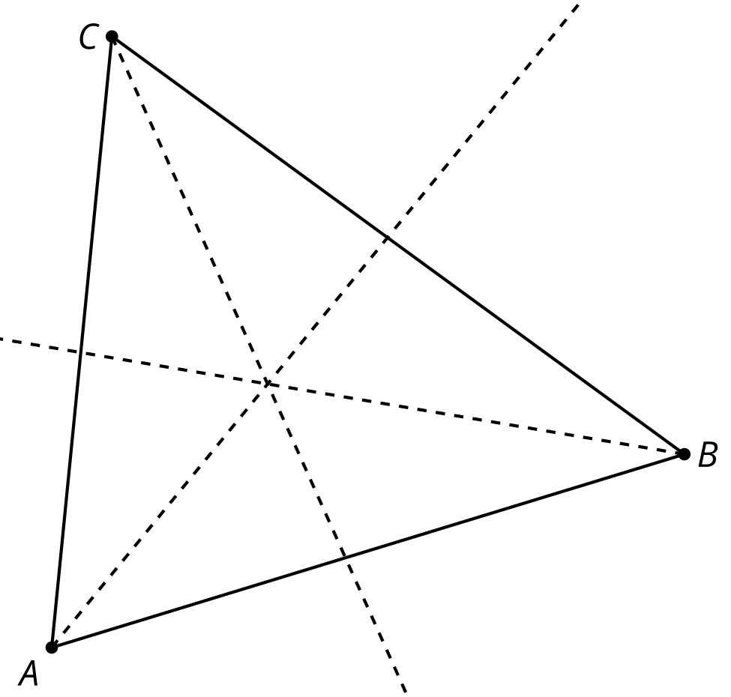
- In triangle $ABC$, point $D$ is the incenter. Sketch segments to represent the distance from point $D$ to the sides of the triangle. How must these distances compare?
- 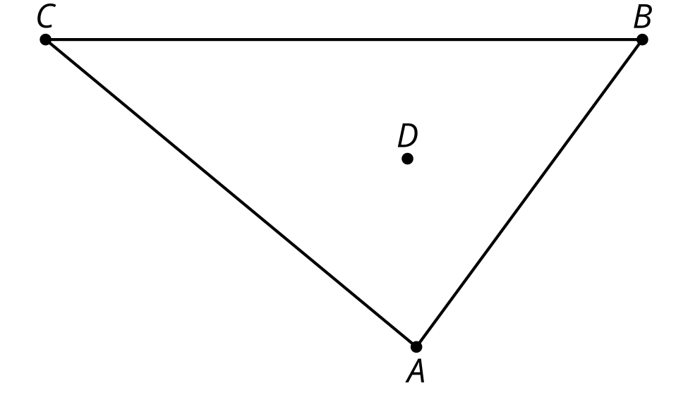
- Triangle $ABC$ has circumcenter $D$.
  - Sketch the 3 lines that intersect at the circumcenter.
  - If the distance from point $D$ to point $A$ is 5 units, what is the distance from point $D$ to point $C$? Explain or show your reasoning.
- 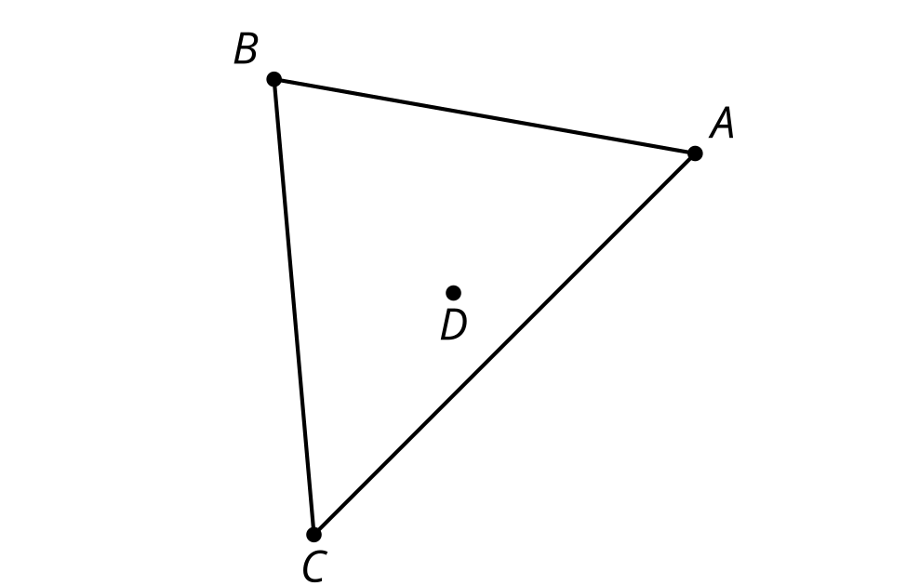

- (From Unit 7, Lesson 5.)
- The angles of triangle $ABC$ measure 50 degrees, 40 degrees, and 90 degrees. Will its circumcenter fall inside the triangle, on the triangle, or outside the triangle?
  - inside the triangle
  - on the triangle
  - outside the triangle
- (From Unit 7, Lesson 5.)
- Tyler and Kiran are discussing the parallelogram in the image. Tyler says the parallelogram cannot be cyclic. Kiran says the parallelogram can be cyclic if a circle is drawn carefully through the vertices.
- Do you agree with either of them? Explain or show your reasoning.
- (From Unit 7, Lesson 4.)
- Find the measures of the remaining angles of quadrilateral $WXYZ$.
- 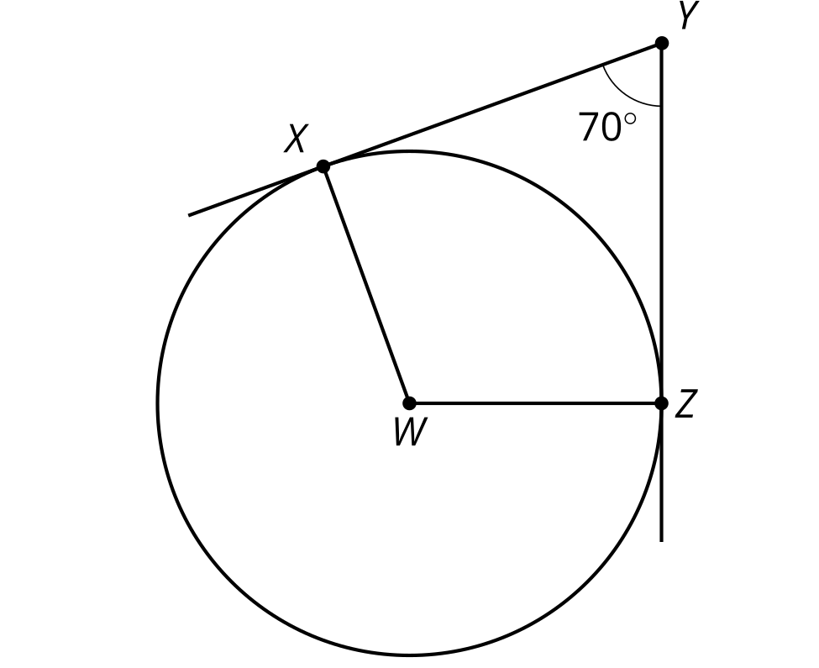
- (From Unit 7, Lesson 3.)
- Which expression describes a point that partitions a segment $AB$ in a $1:5$ ratio?
  - $\frac{1}{5}A+\frac{4}{5}B$
  - $\frac{1}{6}A+\frac{5}{6}B$
  - $\frac{4}{5}A+\frac{1}{5}B$
  - $\frac{5}{6}A+\frac{1}{6}B$
- (From Unit 6, Lesson 15.)
- Write 3 expressions that can be used to find angle $C$.
- 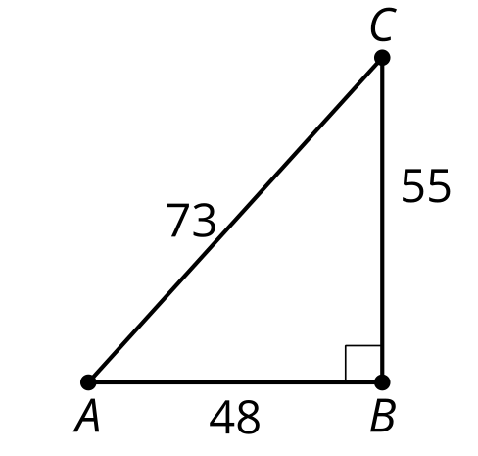
- (From Unit 4, Lesson 9.)
© CC BY 2019 by Illustrative Mathematics®

