Lesson 9: Problem Solving with Volume: Water
- Let's solve problems about volume of water.

Warm-up: Notice and Wonder: Cubic Centimeters and Grams
What do you notice? What do you wonder?
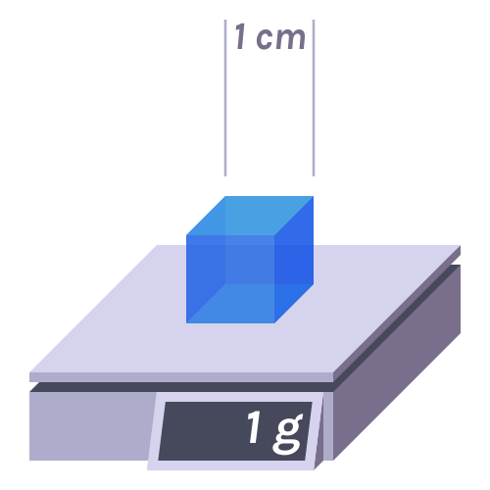

9.1: Catching Rainfall
Here is a diagram showing the roof of a house.
- What is the area of the roof?
- 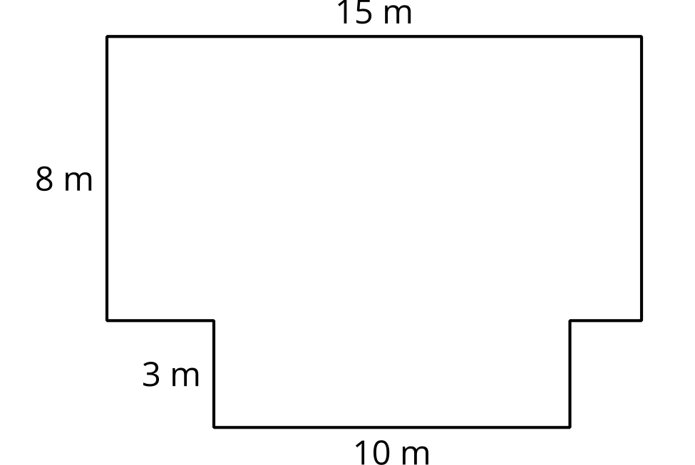
- Each month an average of 5 cm of rain falls on the house. How many cubic cm of rain is that?
- There are 1,000 cubic cm in 1 liter. How many liters of water fall on the house?
- You want to build a reservoir to catch the rain that falls so you can use the water. What side lengths would you suggest for the reservoir? Explain or show your reasoning.

9.2: How Much Water?
- What are some of the ways you use water at home?
- Estimate how much water you use at your home in a month.
- How much rain would need to fall on your home each month to supply all of your water needs?
- What challenges might come up if you tried to use the rainwater that falls on the roof of your home? Do you think it makes sense to try to capture the rain that falls on your home?

Section Summary
Section Summary
We investigated several different complex volume questions. For the ancient pyramids of Egypt we gave an estimate of a couple million cubic meters. Since these pyramids are not rectangular prisms, an estimate is the best we could hope for. Then we estimated the volume of the world's largest wagon, using information from a photograph. Lastly, we investigated the amount of rain that falls on a house and the amount of water our families use in a year.
In each case, we could only make estimates because the situations are all complex. In the previous section we used estimation to check the reasonableness of calculations. In this section we saw that making reasoned estimates is a vital part of applying mathematics to many real world situations.
© CC BY 2021 Illustrative Mathematics®

