Unit 2 Lesson 1: Share Sandwiches

WU Which One Doesn't Belong: Sandwiches (Warm up)

Student Task Statement
Which one doesn’t belong?
A
B
C
D

1 Share Sandwiches

Student Task Statement
__________ sandwiches are shared equally by __________ people.
- Choose numbers to fill in the blanks. You can only use each number once: 2, 3, 5.
- Represent the situation with a diagram or drawing.
- Explain or show how you know that each person will get the same amount of sandwich.

2 The Same Amount

Student Task Statement
- Han’s work shows how 3 people could equally share 2 sandwiches.
- 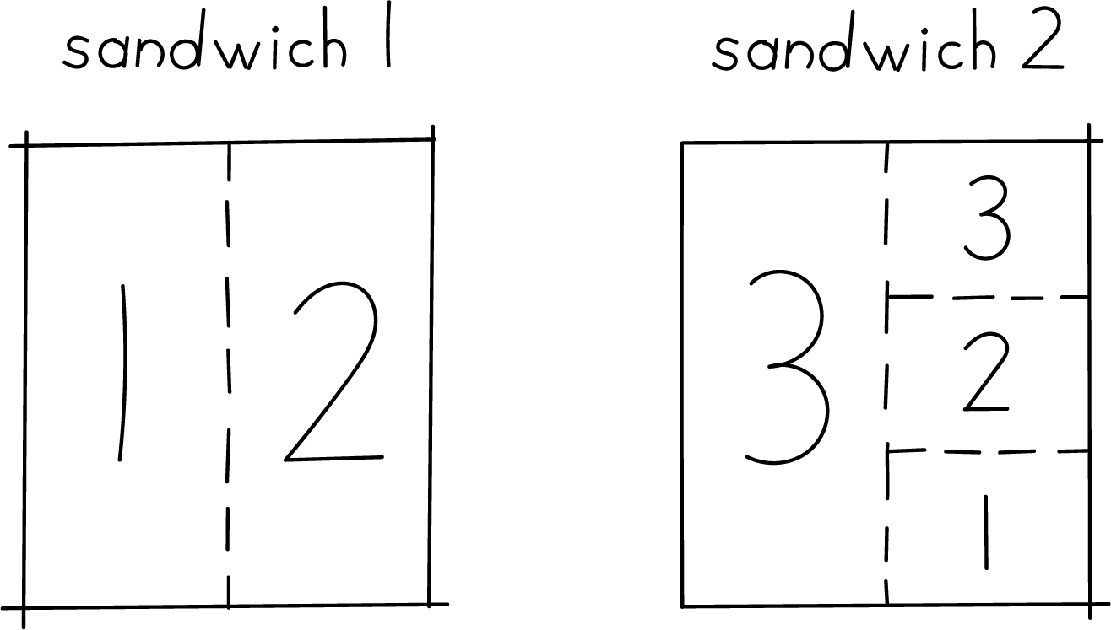
- How do you know that each person gets about the same amount of sandwich? Explain or show your thinking. Organize it so it can be followed by others.
- Draw a diagram to show a different way that 3 people could share 2 sandwiches so each person got about the same amount of sandwich.
© CC BY 2021 Illustrative Mathematics®

