Lesson 13: Divide Using Partial Quotients
- Let's use an algorithm using partial quotients to divide three-digit and four-digit dividends by two-digit divisors.

Warm-up: Number Talk: Divide
Find the value of each expression mentally.
- $110÷10$
- $121÷11$
- $132÷12$
- $154÷14$

13.1: Compare Solutions
- Use an algorithm using partial quotients to find the value of one of the quotients. Be prepared to explain how you found the quotient.
- Partner 1:
- Partner 2:
- 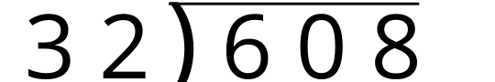
- 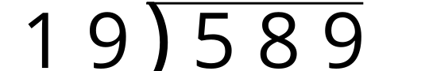
- Explain to your partner how you found the value of the quotient.
- Pair up with another group and compare your work.

13.2: Estimate and Solve
Estimate the value of each quotient. Then, use an algorithm using partial quotients to find the value.
- A reasonable estimate for $612÷34$ is:
- 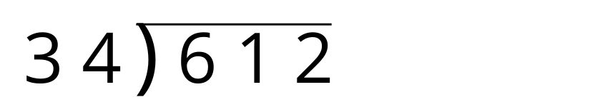
- A reasonable estimate for $529÷23$ is:
- 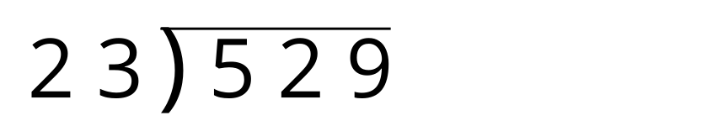
- A reasonable estimate for $1,​044÷29$ is:
- 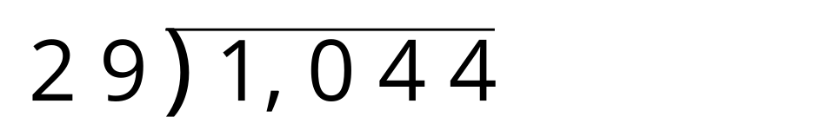
© CC BY 2021 Illustrative Mathematics®

