Unit 3 Lesson 19: Methods for Addition Within 20

WU Number Talk: Related Expressions (Warm up)

Student Task Statement
Find the value of each expression mentally.
- $5+8$
- $6+7$
- $8+7$
- $6+9$

1 Lin, Han, and Kiran Add

Student Task Statement
Lin, Han, and Kiran are finding the value of $8+7$.
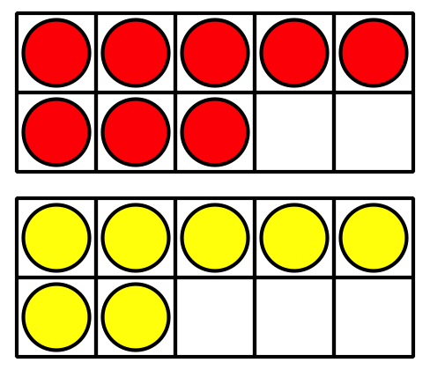
Lin thinks about $8+2+5$ .
Han thinks about $7+7+1$.
Kiran thinks about $8+8−1$.
Explain how each student’s method works.
Show your thinking using drawings, numbers, or words.

2 How Did You Add?

Student Task Statement
- Choose an addition card.
- Each partner finds the value independently.
- Each partner gives a signal when they are ready to explain their thinking.
- Each partner shares their thinking.
- Each partner writes the equation.
Choose your favorite equation.
Show how you found the value using drawings, numbers, or words.
© CC BY 2021 Illustrative Mathematics®

