Unit 2 Lesson 8: Different Ways to Decompose

WU Number Talk: Multiples of 10 (Warm up)

Student Task Statement
Find the value of each expression mentally.
- $18+10+10$
- $18+20+10$
- $38−20$
- $48−30$

1 Aren’t You Missing Something?

Student Task Statement
Lin and Clare made base-ten diagrams to find the value of $71−56$.
Lin
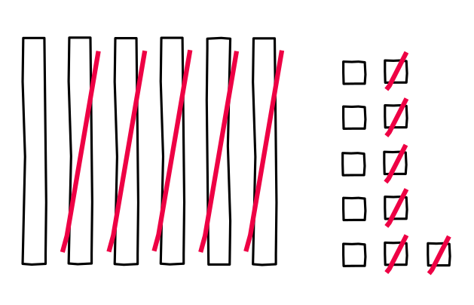
Clare
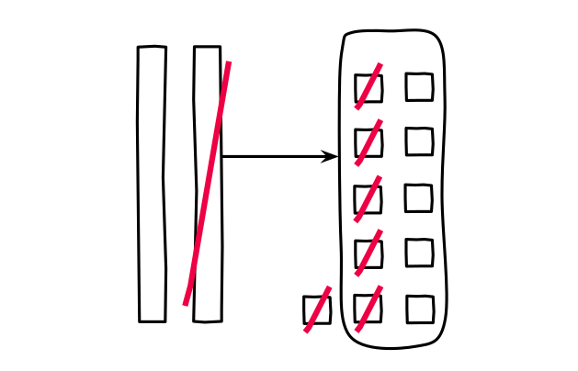
- What do you notice about their work? What do you wonder?
- Lin and Clare each wrote equations to show their thinking. Explain how you know which group of equations matches Lin’s work and which matches Clare’s work.
- A
- B
- $71−50=21$
$21=10+11$
$11−6=5$
$10+5=15$
- $71=60+11$
$11−6=5$
$60−50=10$
$10+5=15$
- How are Lin and Clare’s methods the same? How are they different?

2 Different Ways to Decompose

Student Task Statement
Andre found the value of $65−28$. He made a base-ten diagram and wrote equations to show his thinking.
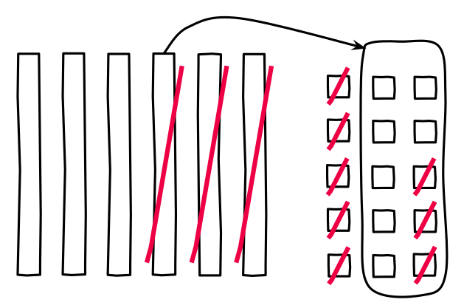
$65−28$
$65−20=45$
$45=30+15$
$15−8=7$
$30+7=37$
- Do you think Andre’s method is more like Clare’s or Lin’s method? Explain.
- Find the value of each difference. Show your thinking.
  - $34−18$
  - $82−37$
  - $71−53$
© CC BY 2021 Illustrative Mathematics®

