Lesson 17: Base-ten Diagrams to Represent Division

Standards Alignments
Addressing | 4.NBT.B.6

Teacher-facing Learning Goals
- Divide two- and three-digit by one-digit numbers using base-ten diagrams.

Student-facing Learning Goals
- Let’s divide using base-ten blocks or diagrams.

Lesson Purpose
The purpose of this lesson is for students to find the quotients of two-digit and three-digit dividends and one-digit divisors. They do so by decomposing the dividend by place value—decomposing a larger unit to 10 of a smaller unit—and by reasoning in terms of equal-size groups.
In grade 3, students used base-ten representations to help them reason about division of a two-digit number into equal-size groups. This lesson builds on that understanding and revisits it in the context of three-digit dividends. Students recall that they can exchange or decompose one or more units of a higher place value for 10 units of the next lower place value in order to have enough units to put into equal groups.
The work here sets the groundwork for students to later decompose a dividend by place value (even when not using base-ten blocks or diagrams). It is also the basis for dividing multi-digit numbers using the standard division algorithm (in grade 5), which relies on dividing by place value, one digit at a time.

Access for:

Students with Disabilities
- Engagement (Activity 2)

English Learners
- MLR8 (Activity 1)

Instructional Routines
Which One Doesn’t Belong? (Warm-up)

Materials to Gather
- Base-ten blocks: Activity 1, Activity 2

Lesson Timeline
Warm-up | 10 min
Activity 1 | 15 min
Activity 2 | 20 min
Lesson Synthesis | 10 min
Cool-down | 5 min

Teacher Reflection Question
How did the representations in today’s lesson support students in dividing multi-digit numbers?

Cool-down
(to be completed at the end of the lesson) 5min
Find the Value of a Quotient

Standards Alignments
Addressing | 4.NBT.B.6

Student-facing Task Statement
Find the value of $132÷4$. Show your reasoning.
The base-ten diagram represents 132. Use the diagram if you find it helpful.
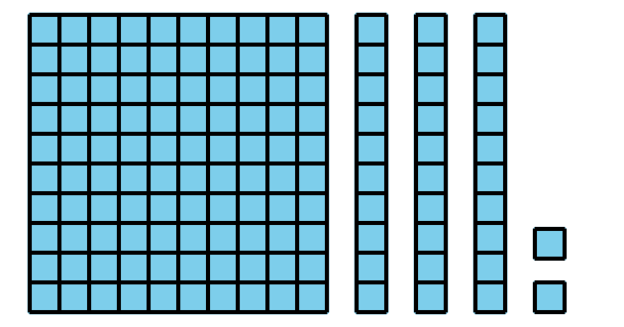

Student Responses
33. Sample reasoning:
- I know that $132=100+32$. I also know that $100÷4=25$ and $32÷4=8$, so $132÷4$ is the sum of 25 and 8, which is 33.
- The large square represents 1 hundred and can be decomposed into 10 tens. Now we have 13 tens. Twelve of the tens can be put into 4 groups of 3 tens. The last ten can be decomposed into 10 ones. There are now 12 ones, or 4 groups of 3 ones. Three tens and 3 ones is 33.
- I know that $120÷4=30$ and $12÷4=3$, so $132÷4=33$.

