Unit 8 Lesson 8: Ways to Find Unknown Length (Part 2)

WU True or False: Equations with Fractions (Warm up)

Student Task Statement
Decide if each statement is true or false. Be prepared to explain your reasoning.
- $1\frac{1}{5}+2\frac{2}{5}+3\frac{3}{5}+4\frac{4}{5}=12$
- $10−\frac{1}{2}−\frac{2}{2}−\frac{3}{2}−\frac{4}{2}=5$
- $1\frac{1}{6}+2\frac{2}{6}+3\frac{3}{6}+4\frac{4}{6}+5\frac{5}{6}=15\frac{3}{6}$
- $\frac{1}{3}+\frac{2}{3}+\frac{3}{3}=3×\frac{2}{3}$

1 Unknown Lengths

Student Task Statement
Here are four shapes.
- Each shape has a perimeter of 64 inches.
- P, R, and S each have 1 line of symmetry.
- Q has 4 lines of symmetry.
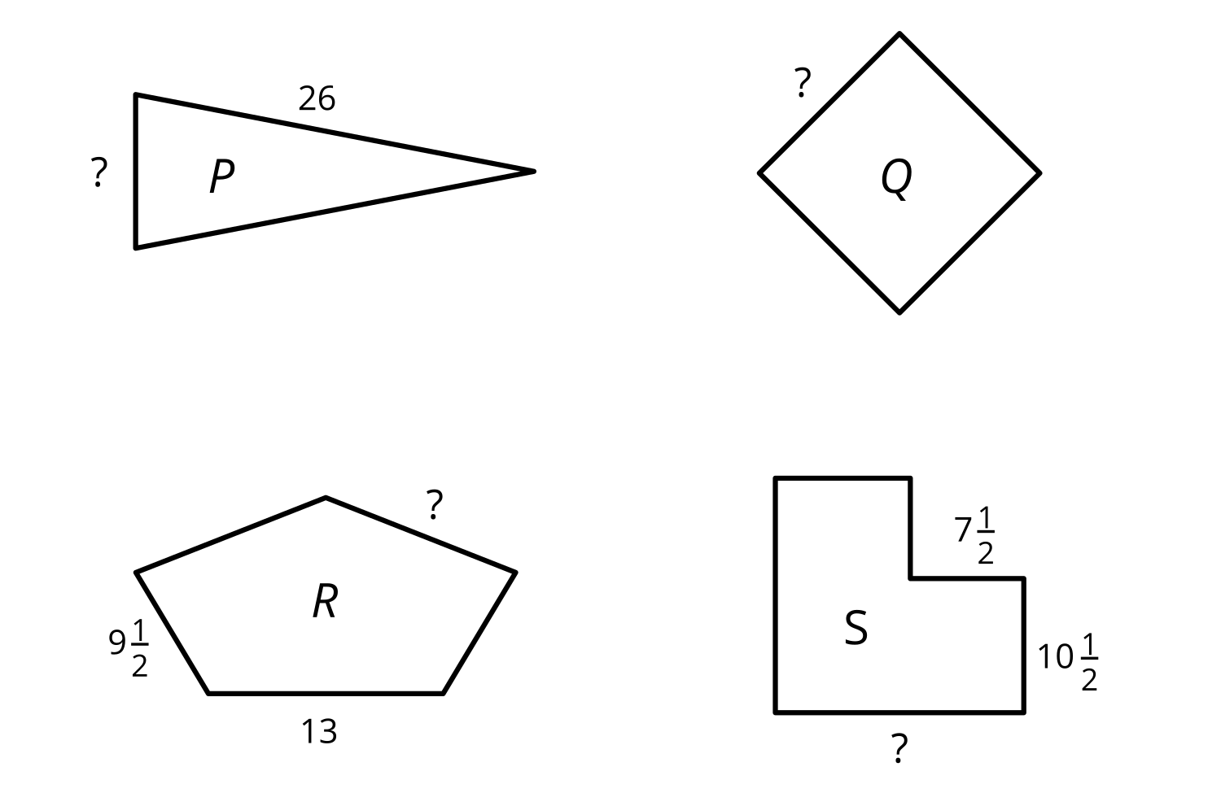
- Draw the lines of symmetry of each shape.
- Find the unknown side length in each shape. Show your reasoning.

2 Lin’s Design

Student Task Statement
Lin is using 145 inches of fancy tape for the outline of a design with line symmetry.
Here is half of the design. The dashed line is the line of symmetry.
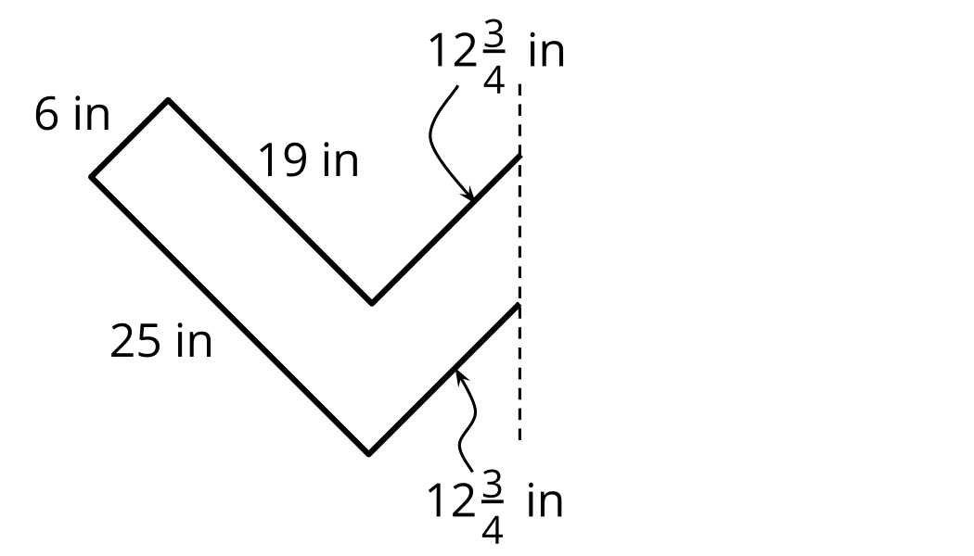
- Sketch Lin’s entire design.
- Does she have enough tape for the entire outline? Show your reasoning.
If you have time: Lin has a sheet of fancy paper that she can cut up to cover the inside of the design. The paper is a rectangle that is 30 inches by 18 inches. If the angles in the design are right angles, does Lin have enough paper to cover the inside of the design? Show your reasoning.

Images for Activity Synthesis
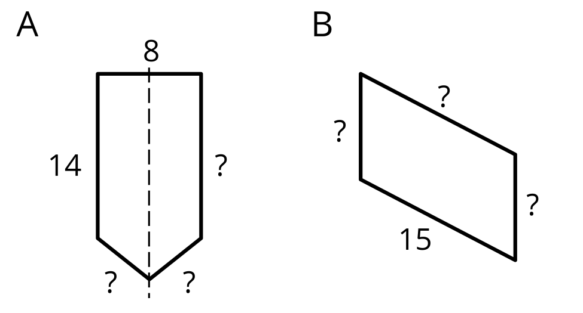
© CC BY 2021 Illustrative Mathematics®

