Lesson 9: Using the Partial Quotients Method

9.1: Using Base-Ten Diagrams to Calculate Quotients
Elena used base-ten diagrams to find $372÷3$. She started by representing 372.
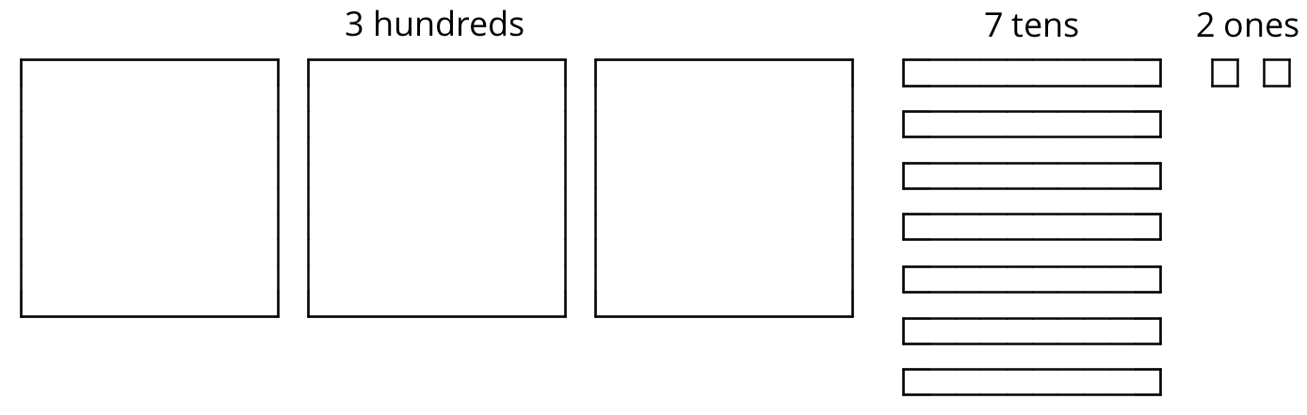
She made 3 groups, each with 1 hundred. Then, she put the tens and ones in each of the 3 groups. Here is her diagram for $372÷3$.
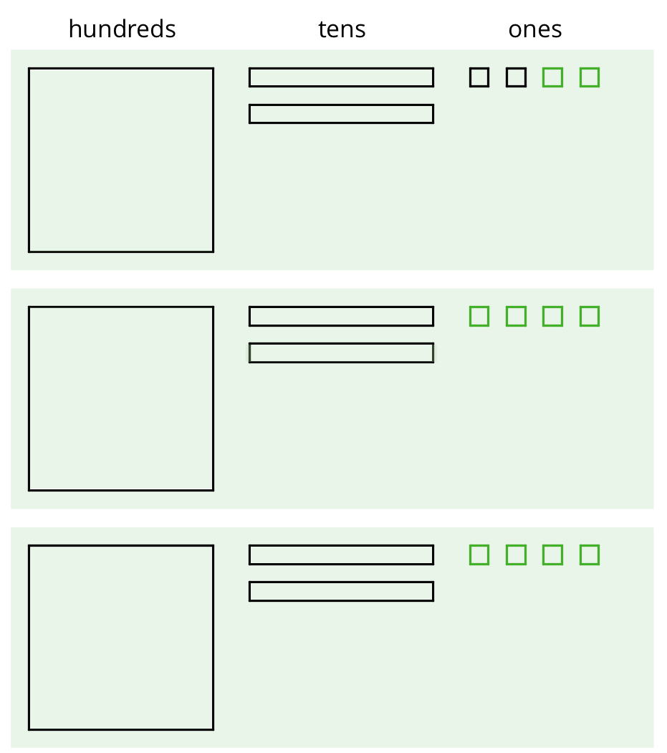
Discuss with a partner:
- Elena’s diagram for 372 has 7 tens. The one for $372÷3$ has only 6 tens. Why?
- Where did the extra ones (small squares) come from?

9.2: Using the Partial Quotients Method to Calculate Quotients
- Andre calculated $657÷3$ using a method that was different from Elena’s.
- 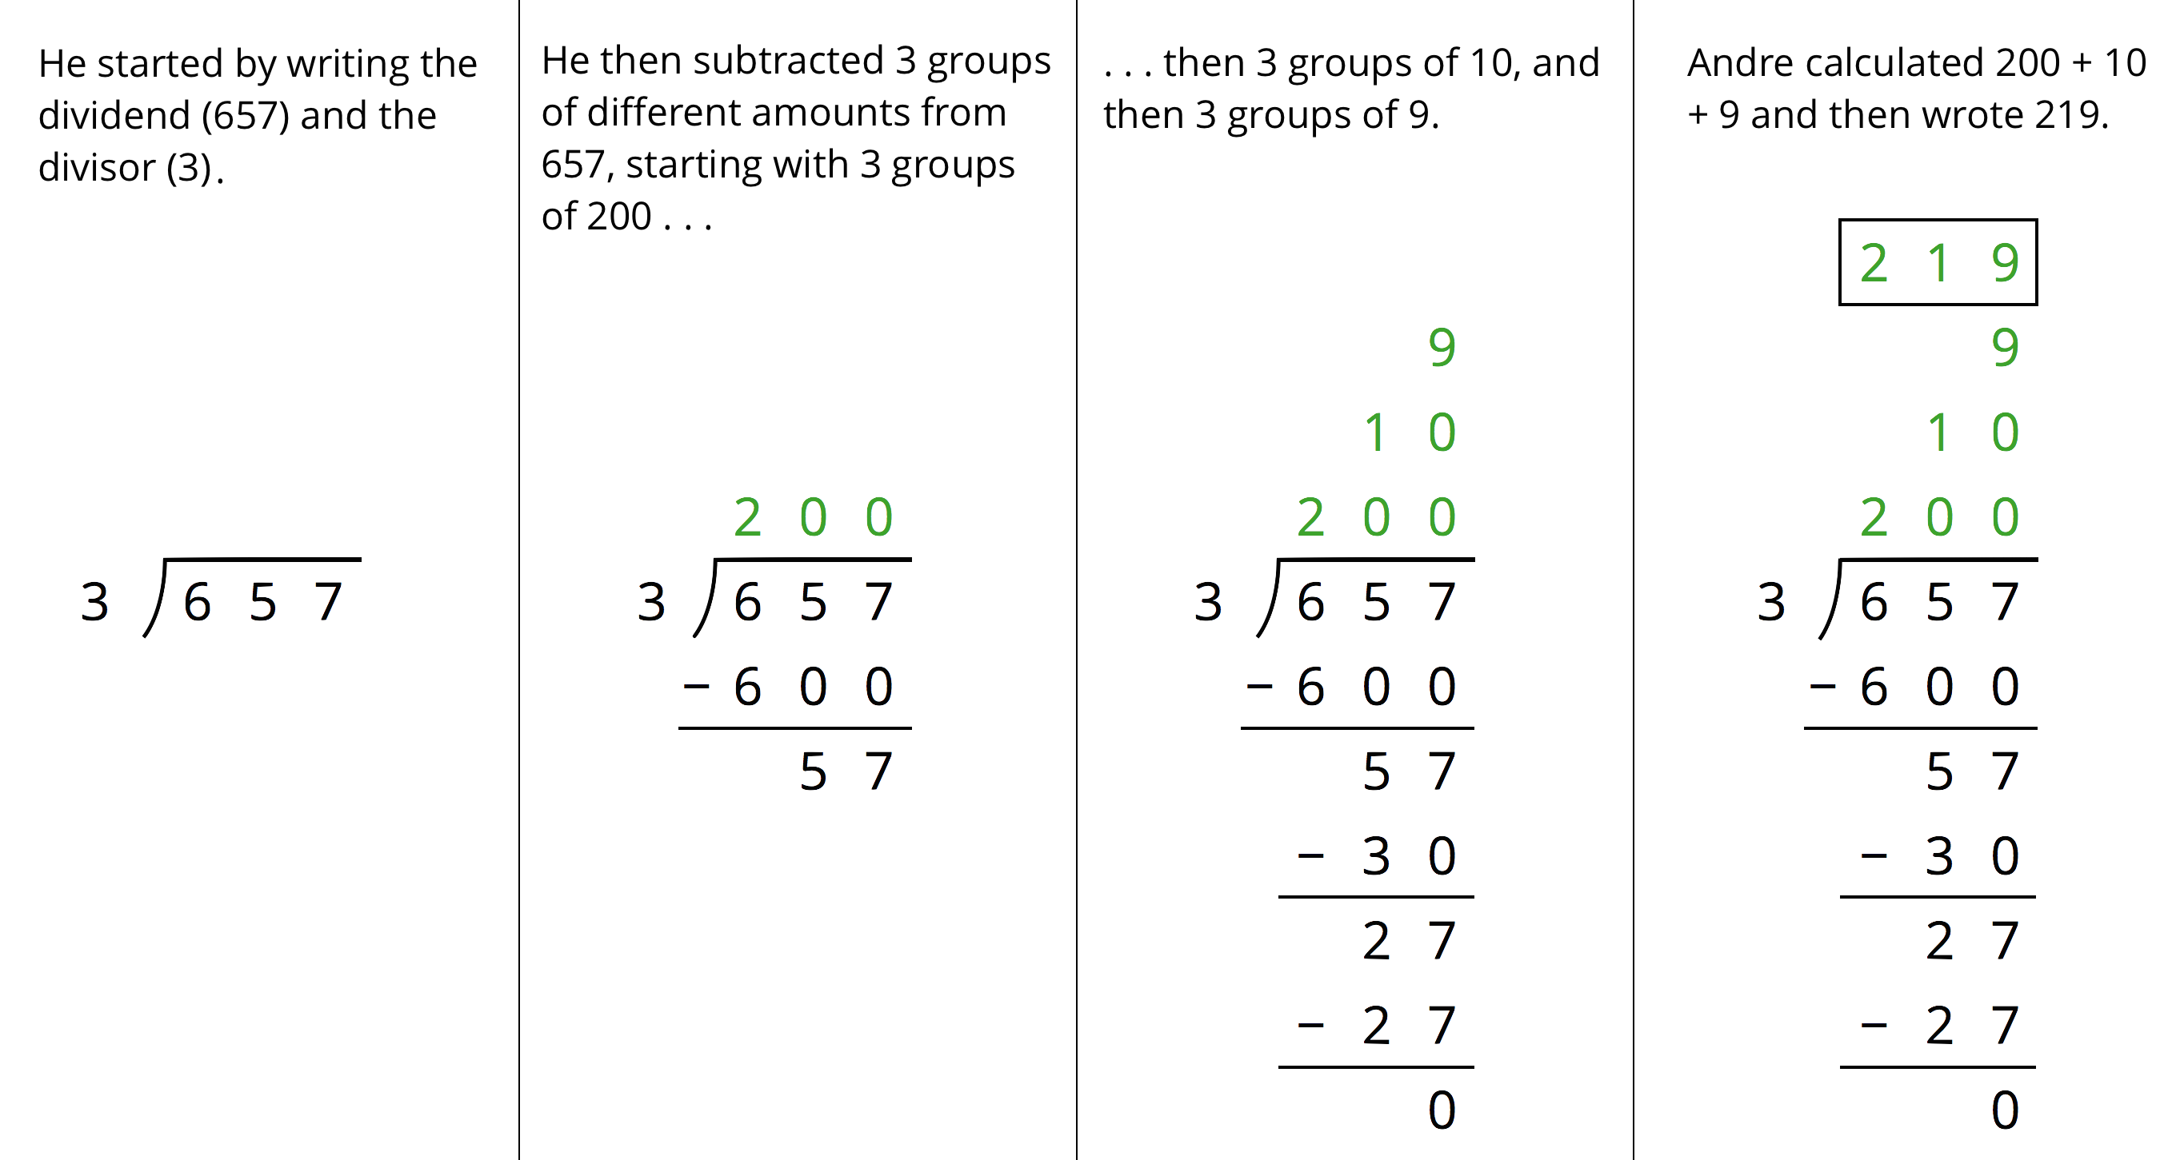
  - Andre subtracted 600 from 657. What does the 600 represent?
  - Andre wrote 10 above the 200, and then subtracted 30 from 57. How is the 30 related to the 10?
  - What do the numbers 200, 10, and 9 represent?
  - What is the meaning of the 0 at the bottom of Andre’s work?
- How might Andre calculate $896÷4$? Explain or show your reasoning.

9.3: What’s the Quotient?
- Find the quotient of $1,​332÷9$ using one of the methods you have seen so far. Show your reasoning.
- Find each quotient and show your reasoning. Use the partial quotients method at least once.
  - $1,​115÷5$
  - $665÷7$
  - $432÷16$

Lesson 9 Summary
We can find the quotient $345÷3$ in different ways.
One way is to use a base-ten diagram to represent the hundreds, tens, and ones and to create equal-sized groups.
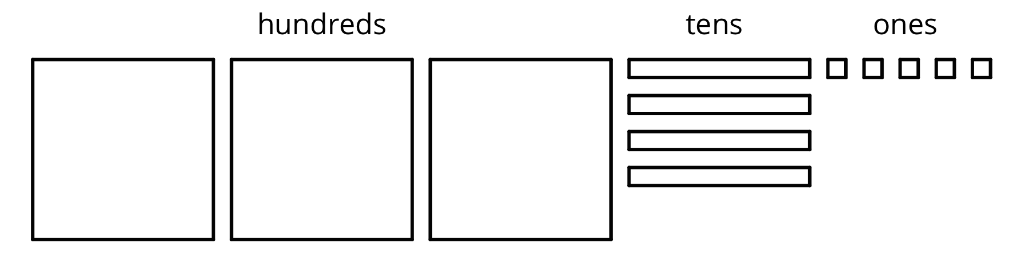
We can think of the division by 3 as splitting up 345 into 3 equal groups.
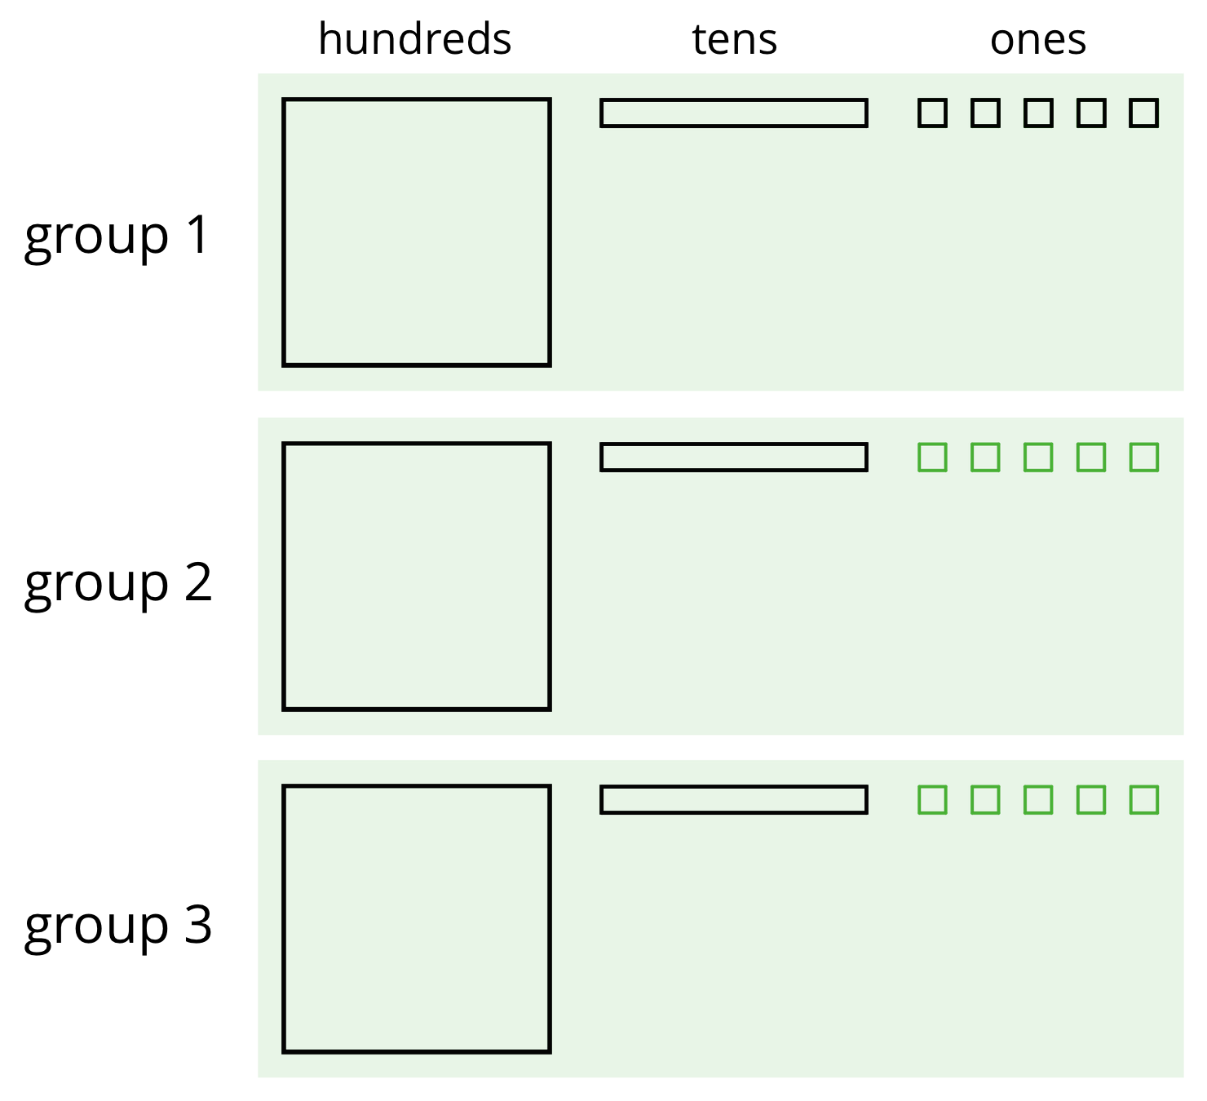
Each group has 1 hundred, 1 ten, and 5 ones, so $345÷3=115$. Notice that in order to split 345 into 3 equal groups, one of the tens had to be unbundled or decomposed into 10 ones.
Another way to divide 345 by 3 is by using the partial quotients method, in which we keep subtracting 3 groups of some amount from 345.
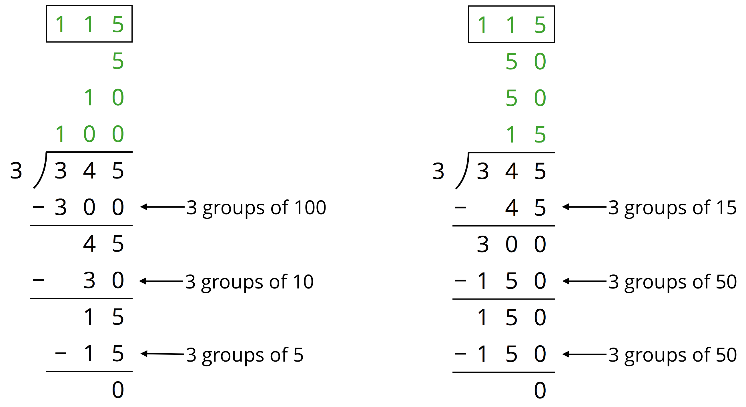
- In the calculation on the left, first we subtract 3 groups of 100, then 3 groups of 10, and then 3 groups of 5. Adding up the partial quotients ($100+10+5$) gives us 115.
- The calculation on the right shows a different amount per group subtracted each time (3 groups of 15, 3 groups of 50, and 3 more groups of 50), but the total amount in each of the 3 groups is still 115. There are other ways of calculating $345÷3$ using the partial quotients method.
Both the base-ten diagrams and partial quotients methods are effective. If, however, the dividend and divisor are large, as in $1,​248÷26$, then the base-ten diagrams will be time-consuming.
© CC BY Open Up Resources. Adaptations CC BY IM.

