Unit 1 Lesson 12: More Nets, More Surface Area

1 Notice and Wonder: Wrapping Paper (Warm up)

Student Task Statement
Kiran is wrapping this box of sports cards as a present for a friend.
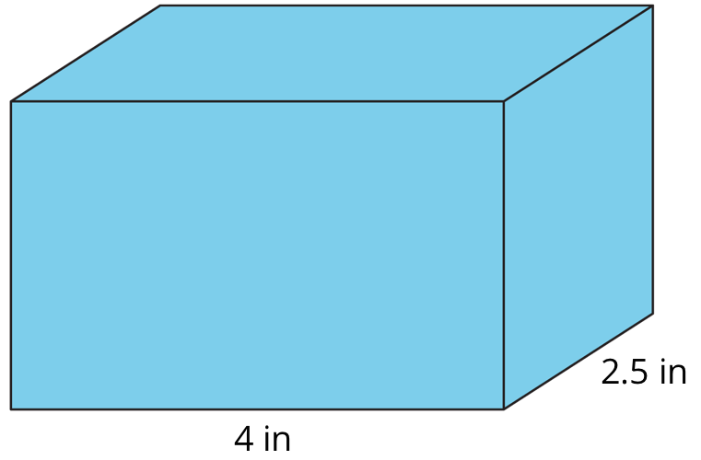
What do you notice? What do you wonder?

2 Building Prisms and Pyramids

Student Task Statement
Your teacher will give you a drawing of a polyhedron. You will draw its net and calculate its surface area.
- What polyhedron do you have?
- Study your polyhedron. Then, draw its net on graph paper. Use the side length of a grid square as the unit.
- Label each polygon on the net with a name or number.
- Find the surface area of your polyhedron. Show your thinking in an organized manner so that it can be followed by others.

3 Comparing Boxes (Optional)

Student Task Statement
Here are the nets of three cardboard boxes that are all rectangular prisms. The boxes will be packed with 1-centimeter cubes. All lengths are in centimeters.
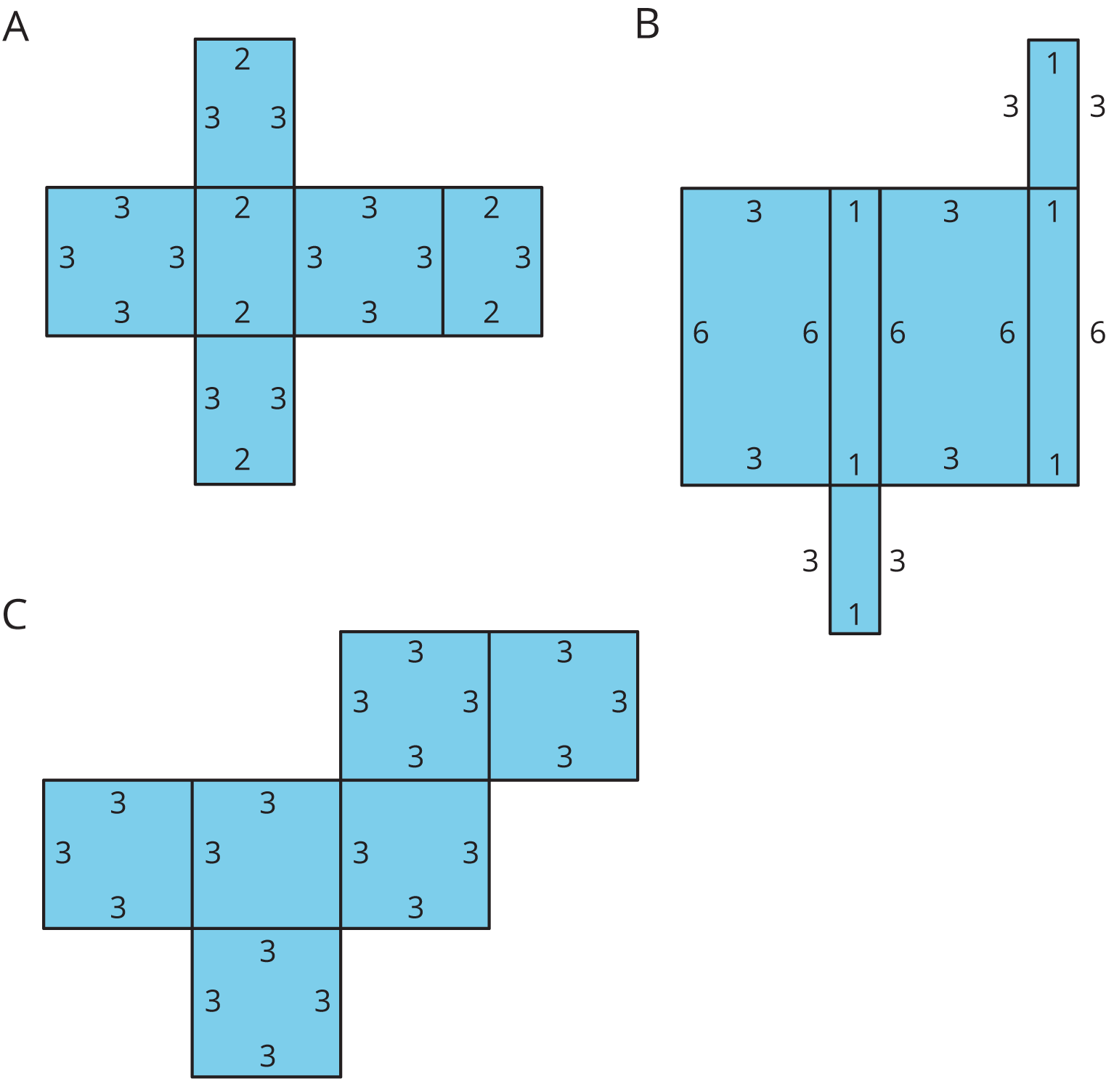
- Compare the surface areas of the boxes. Which box will use the least cardboard? Show your reasoning.
- Now compare the volumes of these boxes in cubic centimeters. Which box will hold the most 1-centimeter cubes? Show your reasoning.
© CC BY Open Up Resources. Adaptations CC BY IM.

