Lesson 3 Practice Problems
- Here is Quadrilateral $ABCD$.
- 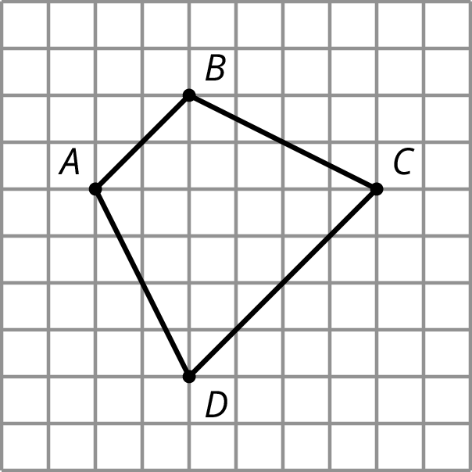
- Quadrilateral $PQRS$ is a scaled copy of Quadrilateral $ABCD$. Point $P$ corresponds to $A$, $Q$ to $B$, $R$ to $C$, and $S$ to $D$.
- If the distance from $P$ to $R$ is 3 units, what is the distance from $Q$ to $S$? Explain your reasoning.
- Rectangles P, Q, R, and S are scaled copies of one another. For each pair, decide if the scale factor from one to the other is greater than 1, equal to 1, or less than 1.
- 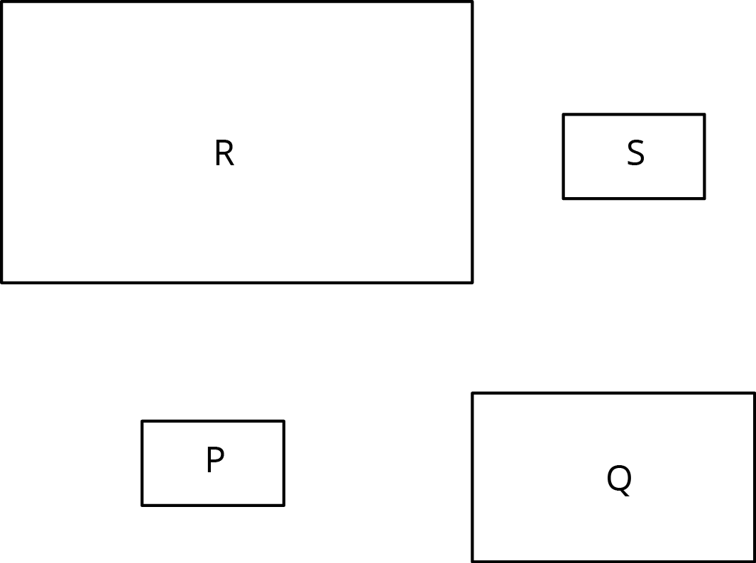
  - from P to Q
  - from P to R
  - from Q to S
  - from Q to R
  - from S to P
  - from R to P
  - from P to S
- Triangle S and Triangle L are scaled copies of one another.
  - What is the scale factor from S to L?
  - What is the scale factor from L to S?
  - Triangle M is also a scaled copy of S. The scale factor from S to M is $\frac{3}{2}$. What is the scale factor from M to S?
- 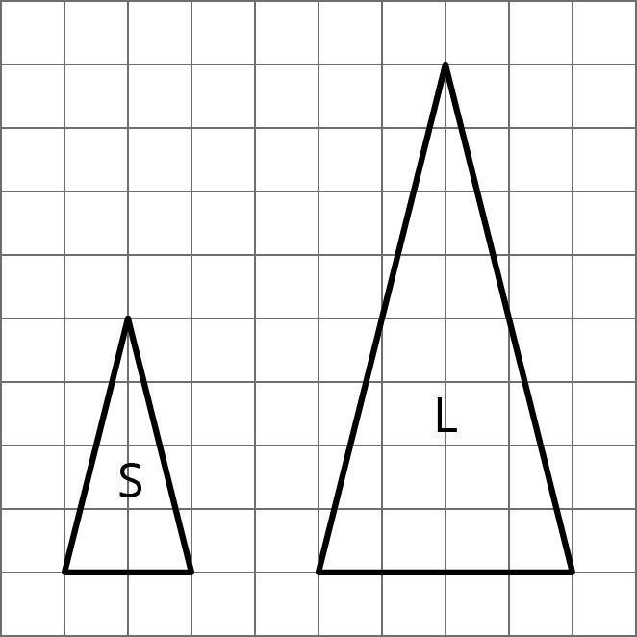
- Are two squares with the same side lengths scaled copies of one another? Explain your reasoning.
- Quadrilateral A has side lengths 2, 3, 5, and 6. Quadrilateral B has side lengths 4, 5, 8, and 10. Could one of the quadrilaterals be a scaled copy of the other? Explain.
- (From Unit 2, Lesson 2.)
- The line has been partitioned into three angles.
- 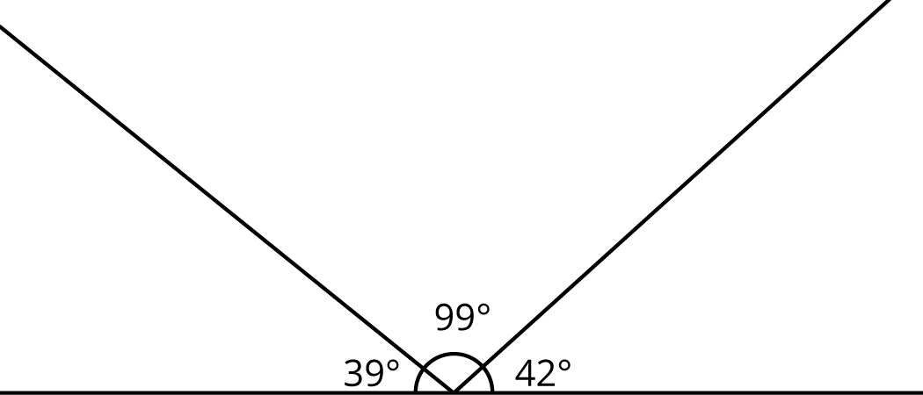
- Is there a triangle with these three angle measures? Explain.
- (From Unit 1, Lesson 13.)
© CC BY Open Up Resources. Adaptations CC BY IM.

