Unit 5 Lesson 9: All of the Story Problems

WU Choral Count: Count to 70 and Count On (Warm up)

Student Task Statement

1 All the Story Problems

Student Task Statement
- Mai grew 7 tomatoes in her garden.
- She picked 5 of the tomatoes to make salsa.
- How many tomatoes are still in the garden?
- Expression: ________________________________
- 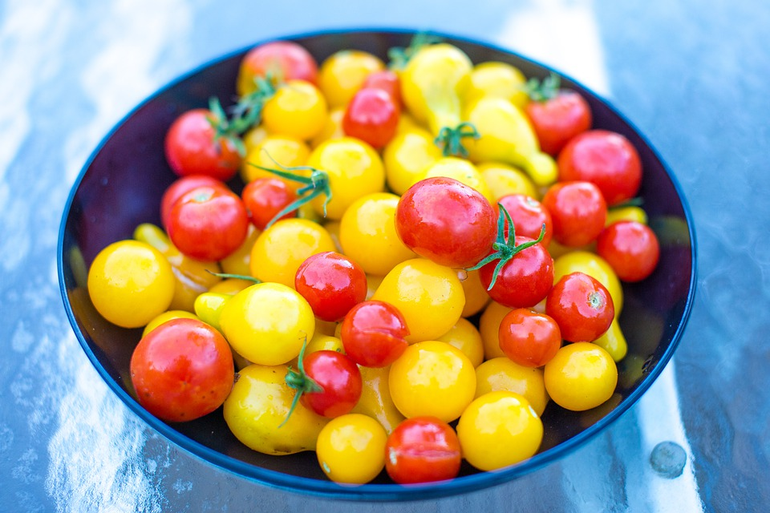
- There are 9 tomatoes in Mai’s garden.
- Some of the tomatoes are yellow.
- The rest of the tomatoes are red.
- How many of the tomatoes are yellow?
- Then how many of the tomatoes are red?
- Expression: ________________________________

2 Make and Match Story Problems

Student Task Statement
Record your story problem.
Solve the story problem your partner told you.
Show your thinking using objects, drawings, numbers, or words.
Expression: ___________________________________

3 Centers: Choice Time

Student Task Statement
Choose a center.
What’s Behind My Back?
5-frames
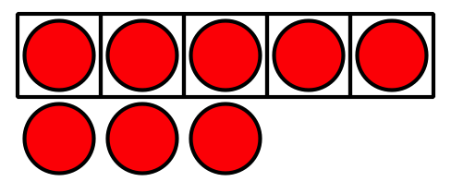
Make or Break Apart Numbers
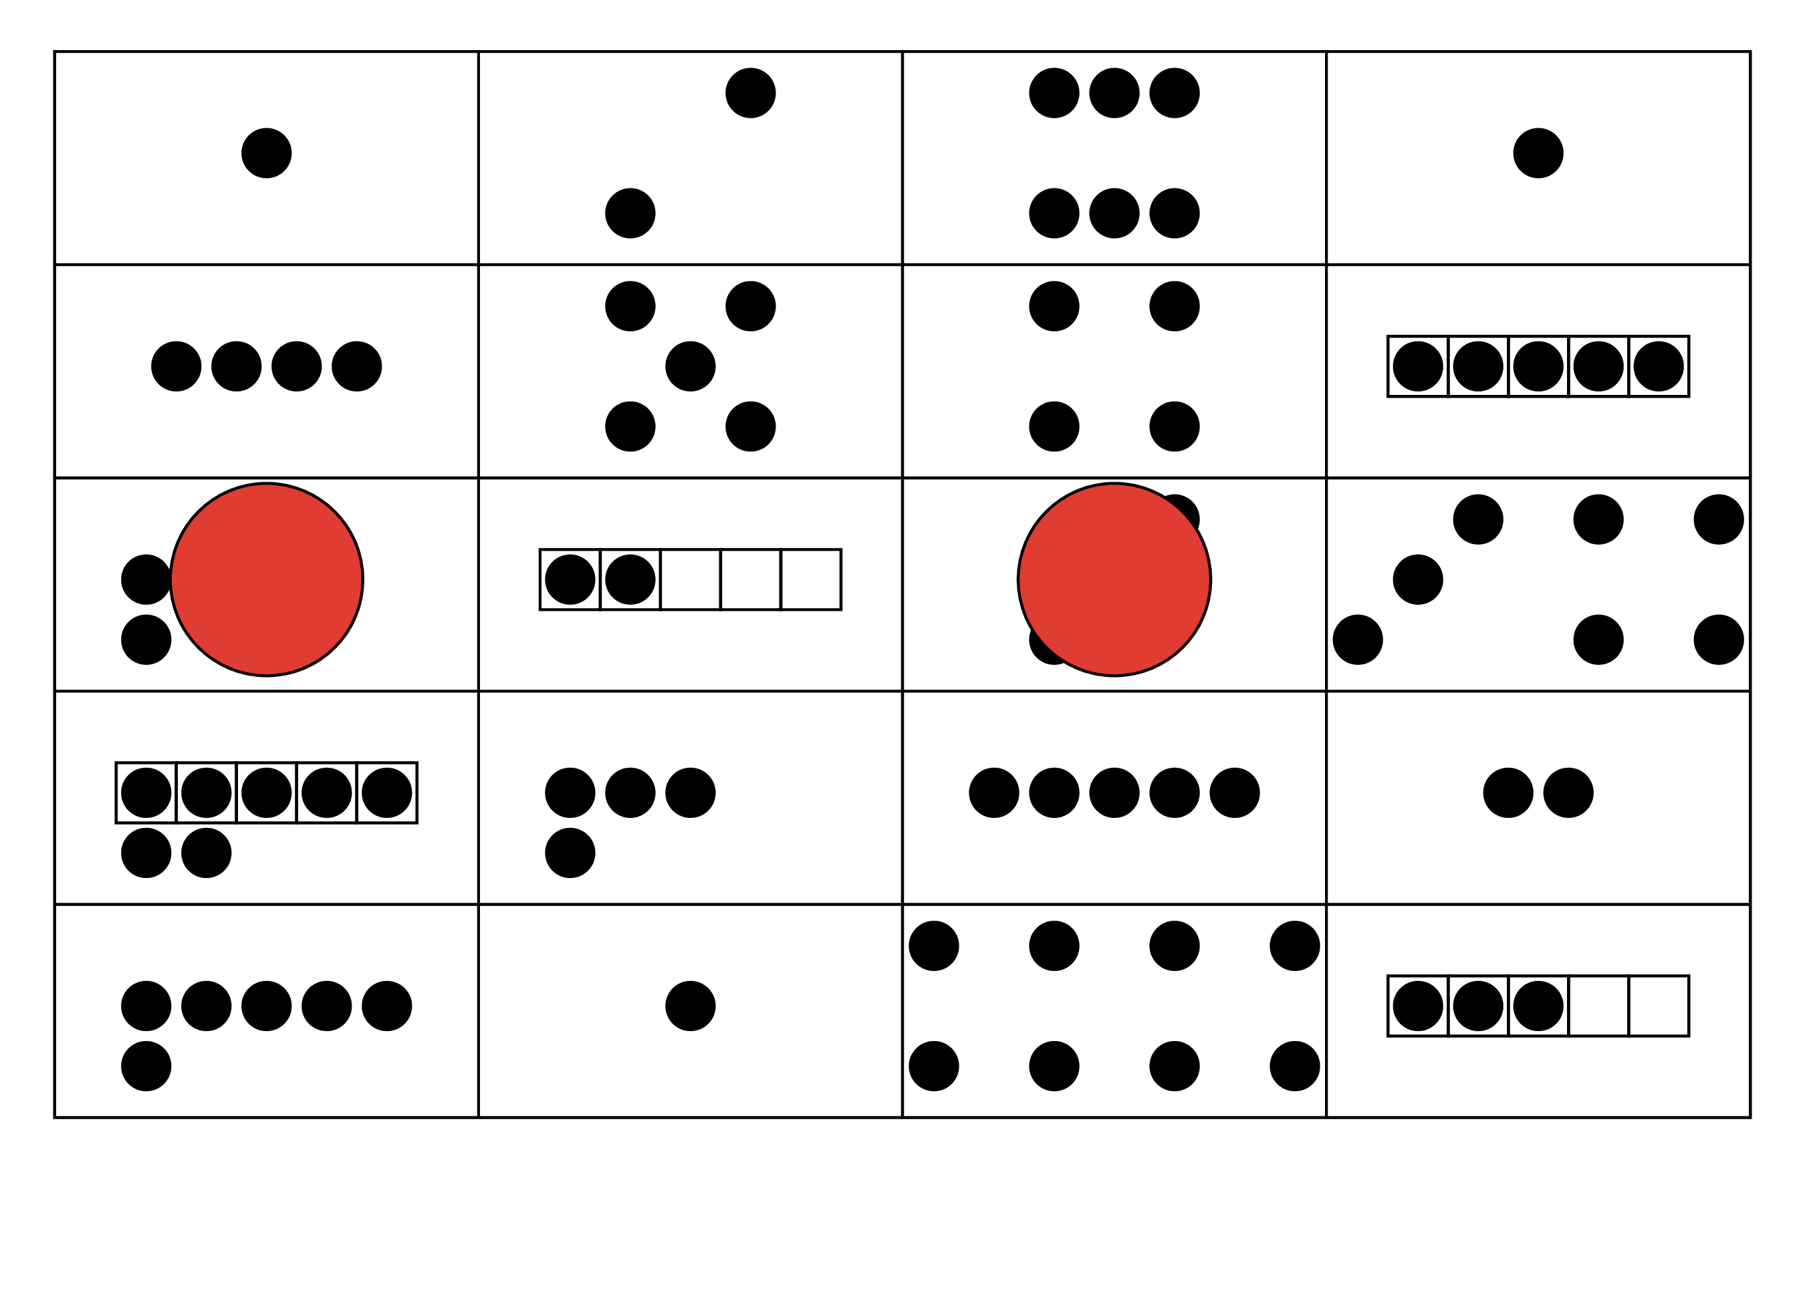
Math Stories
© CC BY 2021 Illustrative Mathematics®

