Unit 7 Lesson 14: Compose with Solid Shapes

WU Number Talk: Subtract 1 and 2 (Warm up)

Student Task Statement
Find the value of each expression.
- $3−1$
- $3−2$
- $4−2$
- $5−1$

1 Build with Solid Shapes

Student Task Statement

2 Build My Shape

Student Task Statement

3 Introduce Match Mine, Solid Shapes

Student Task Statement
Choose a center.
Build Shapes
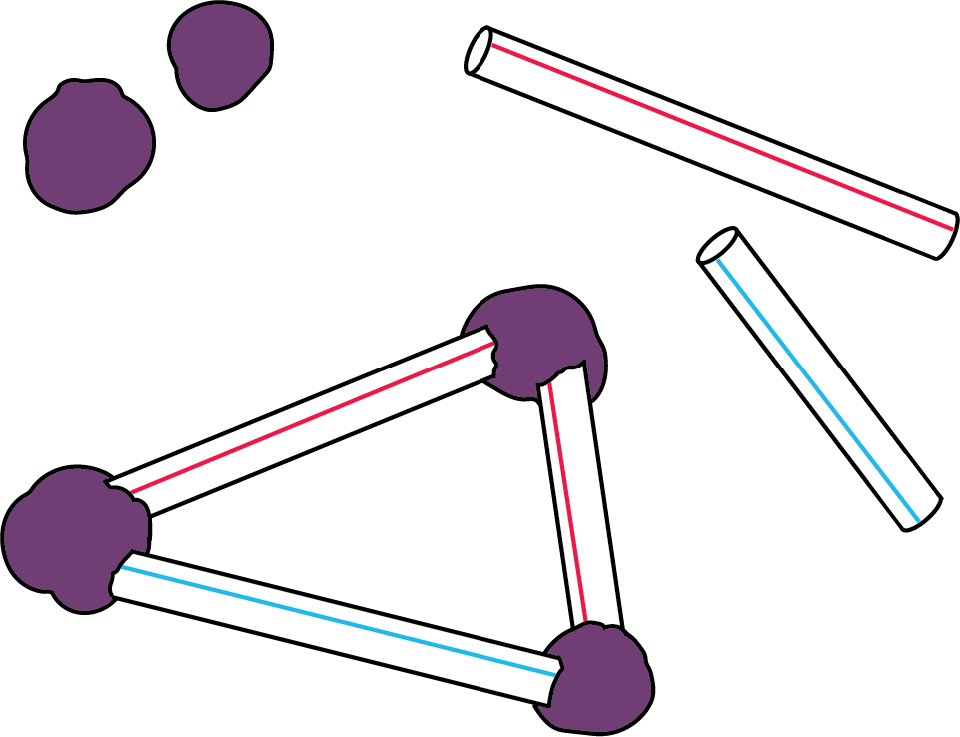
Geoblocks
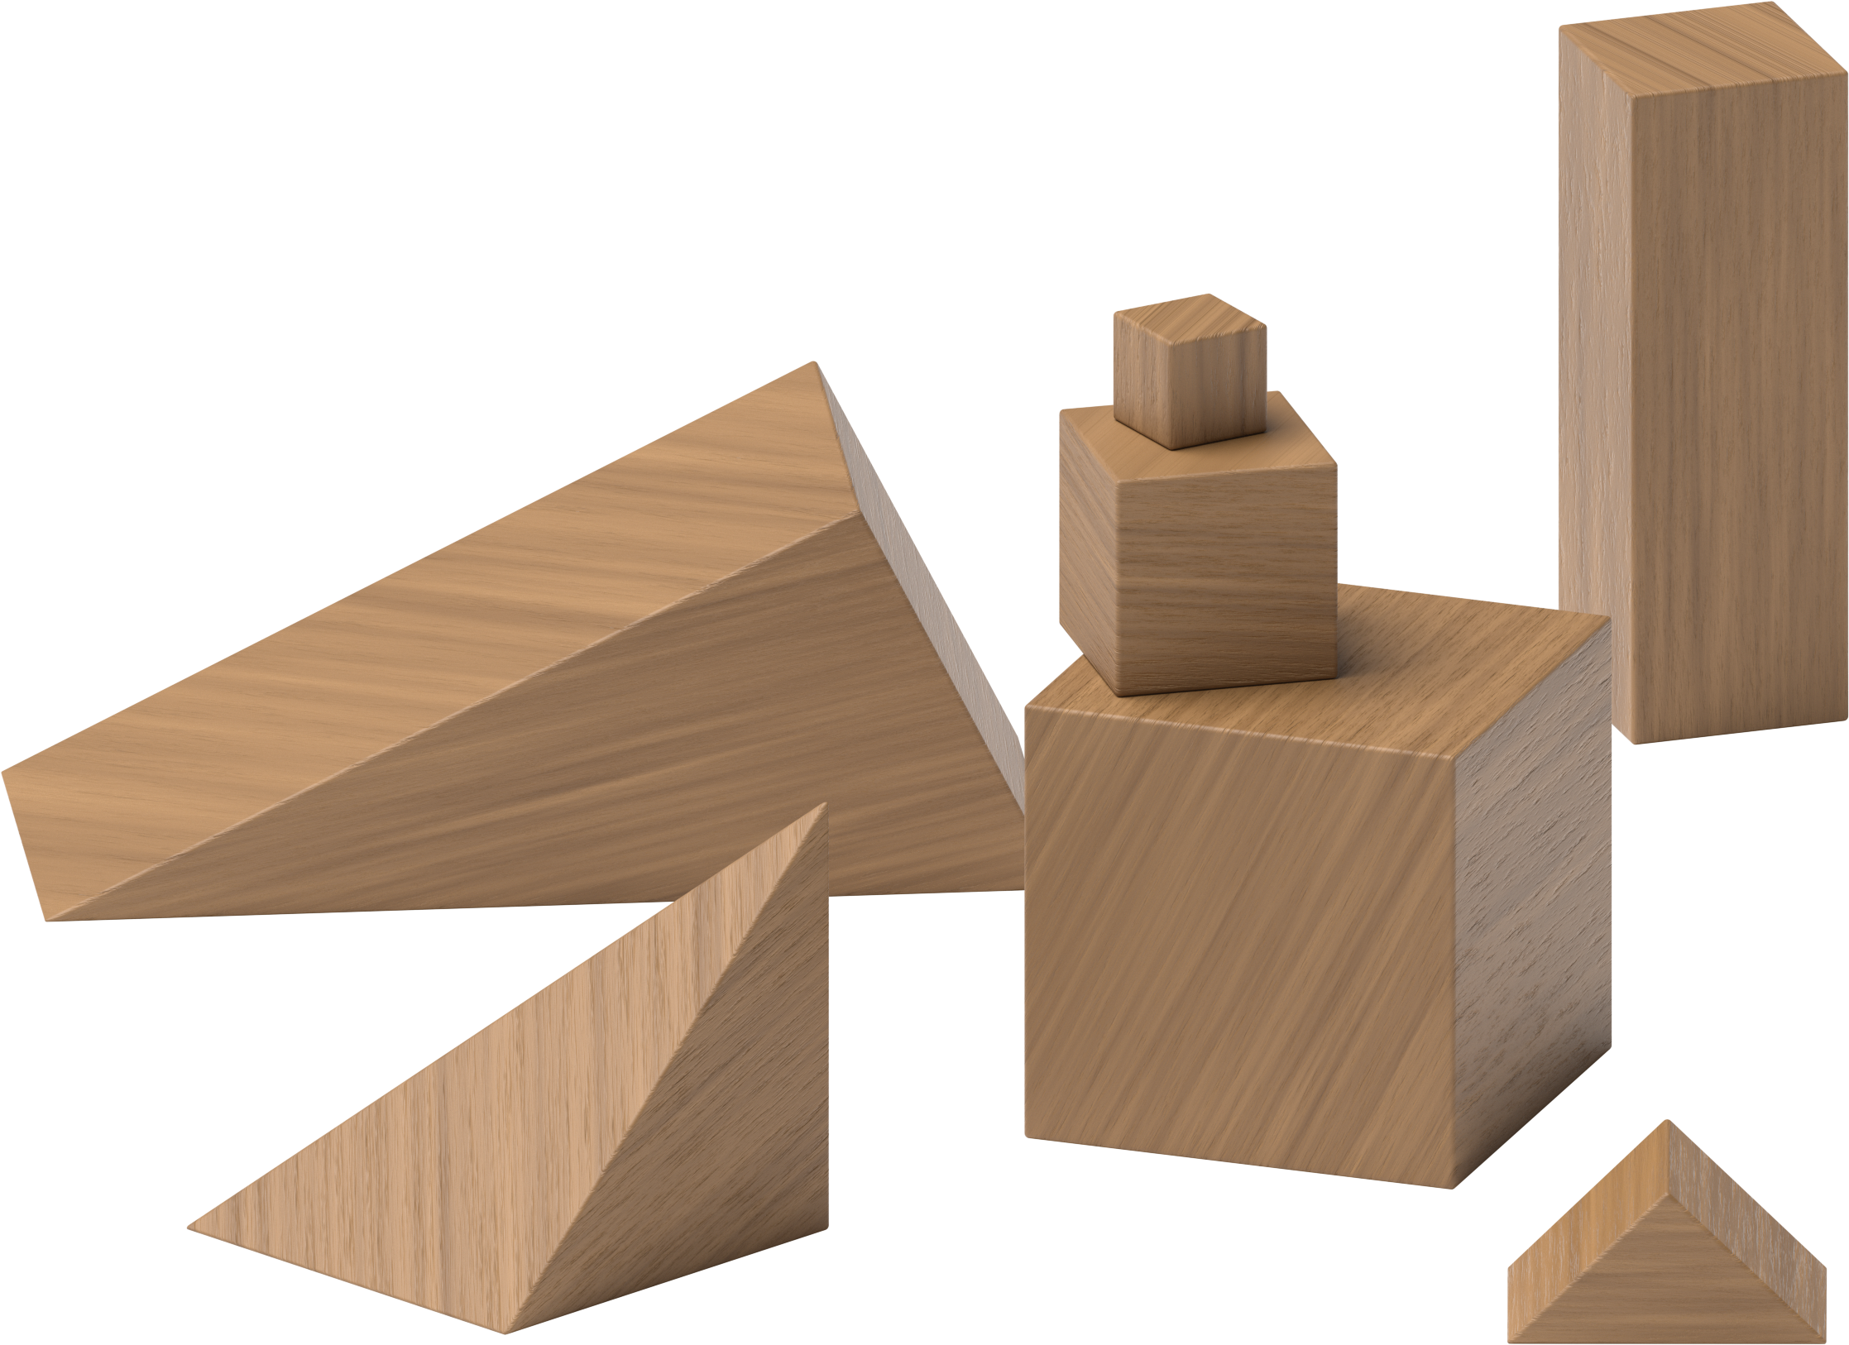
Counting Collections
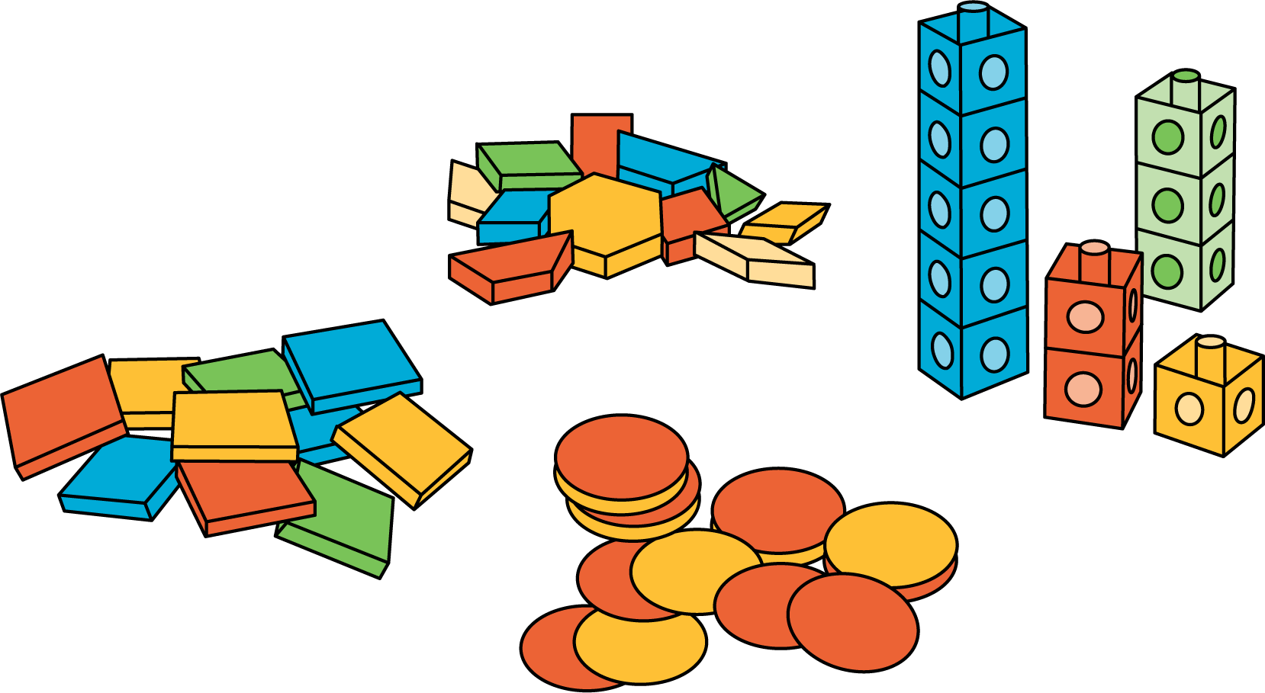
Match Mine
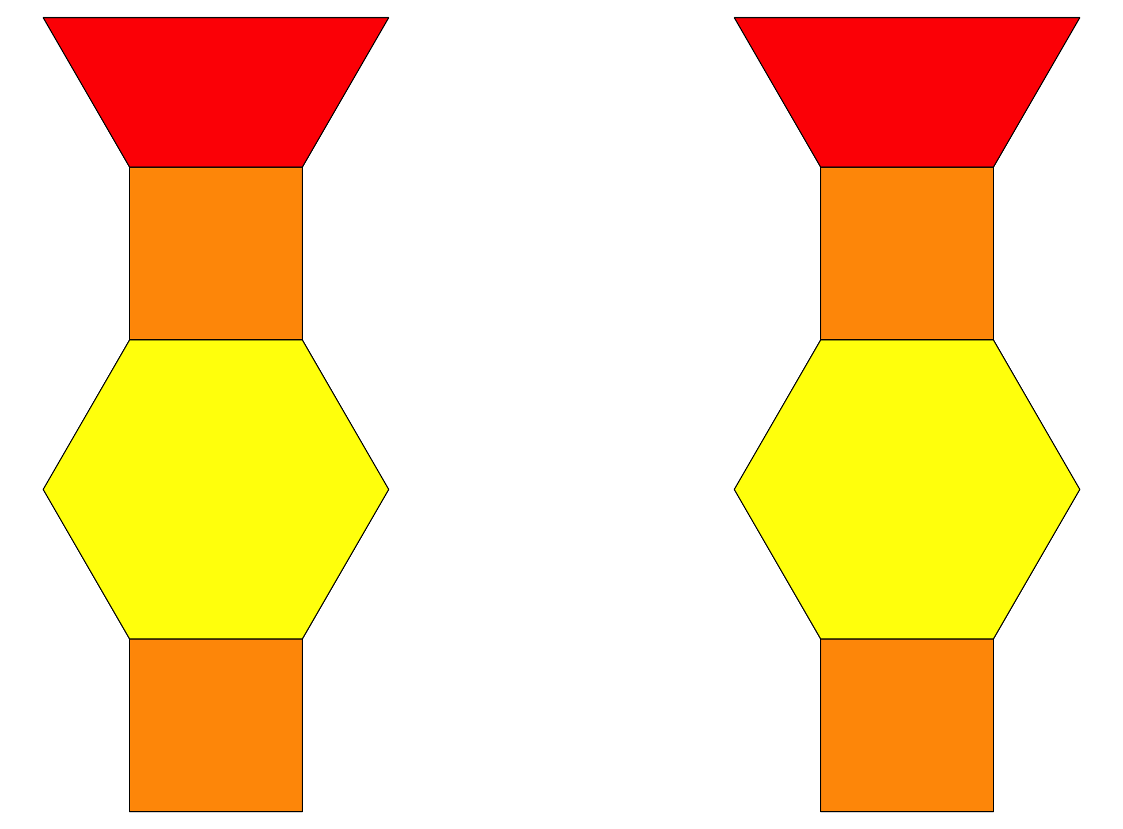
Shake and Spill
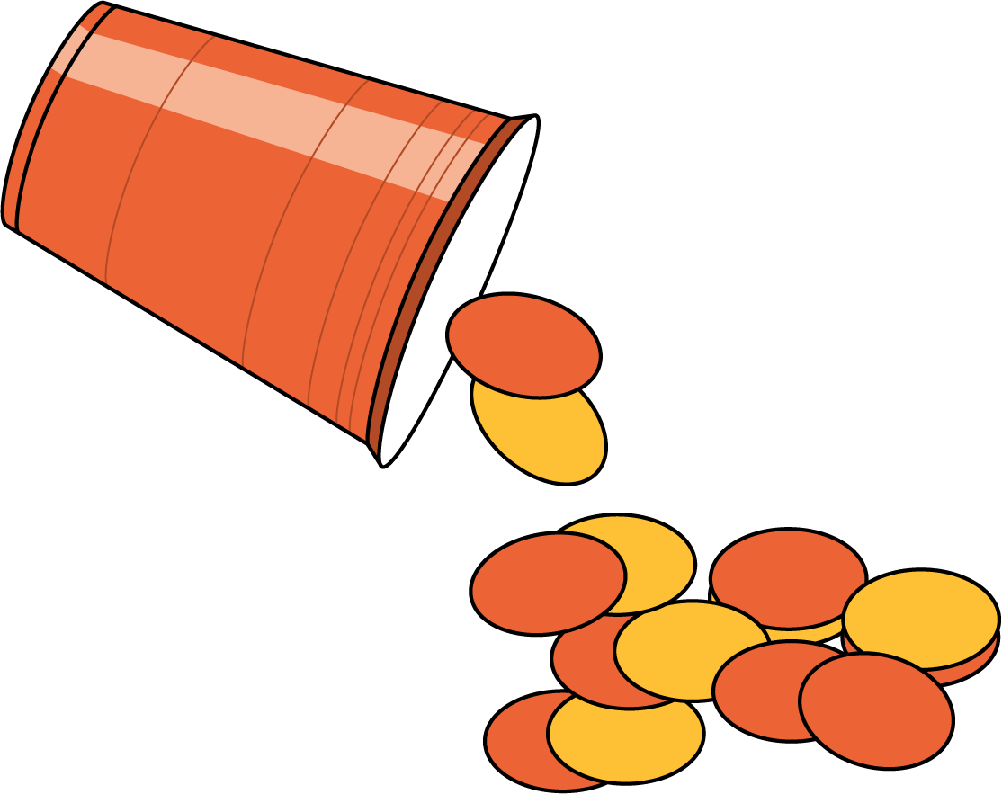
© CC BY 2021 Illustrative Mathematics®

