Lesson 9: All of the Story Problems
- Let’s solve story problems.

9.1: All the Story Problems
- Mai grew 7 tomatoes in her garden.
- She picked 5 of the tomatoes to make salsa.
- How many tomatoes are still in the garden?
- Expression: ________________________________
- 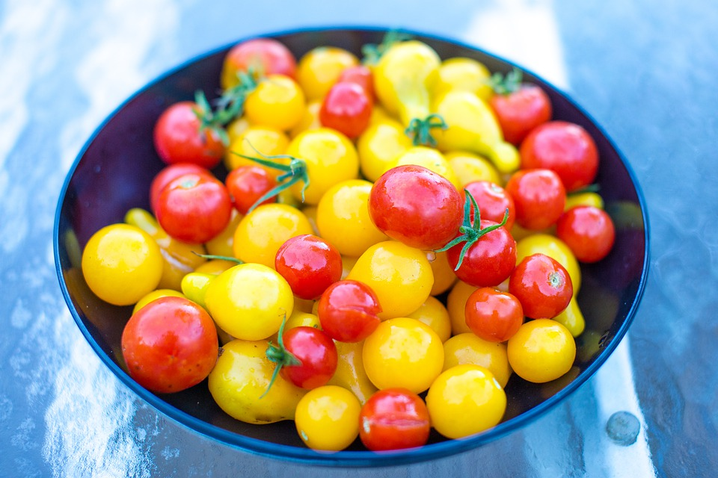
- There are 9 tomatoes in Mai’s garden.
- Some of the tomatoes are yellow.
- The rest of the tomatoes are red.
- How many of the tomatoes are yellow?
- Then how many of the tomatoes are red?
- Expression: ________________________________

9.2: Make and Match Story Problems
Record your story problem.
Solve the story problem your partner told you.
Show your thinking using objects, drawings, numbers, or words.
Expression: ___________________________________

9.3: Centers: Choice Time
Choose a center.
What’s Behind My Back?
5-frames
Make or Break Apart Numbers
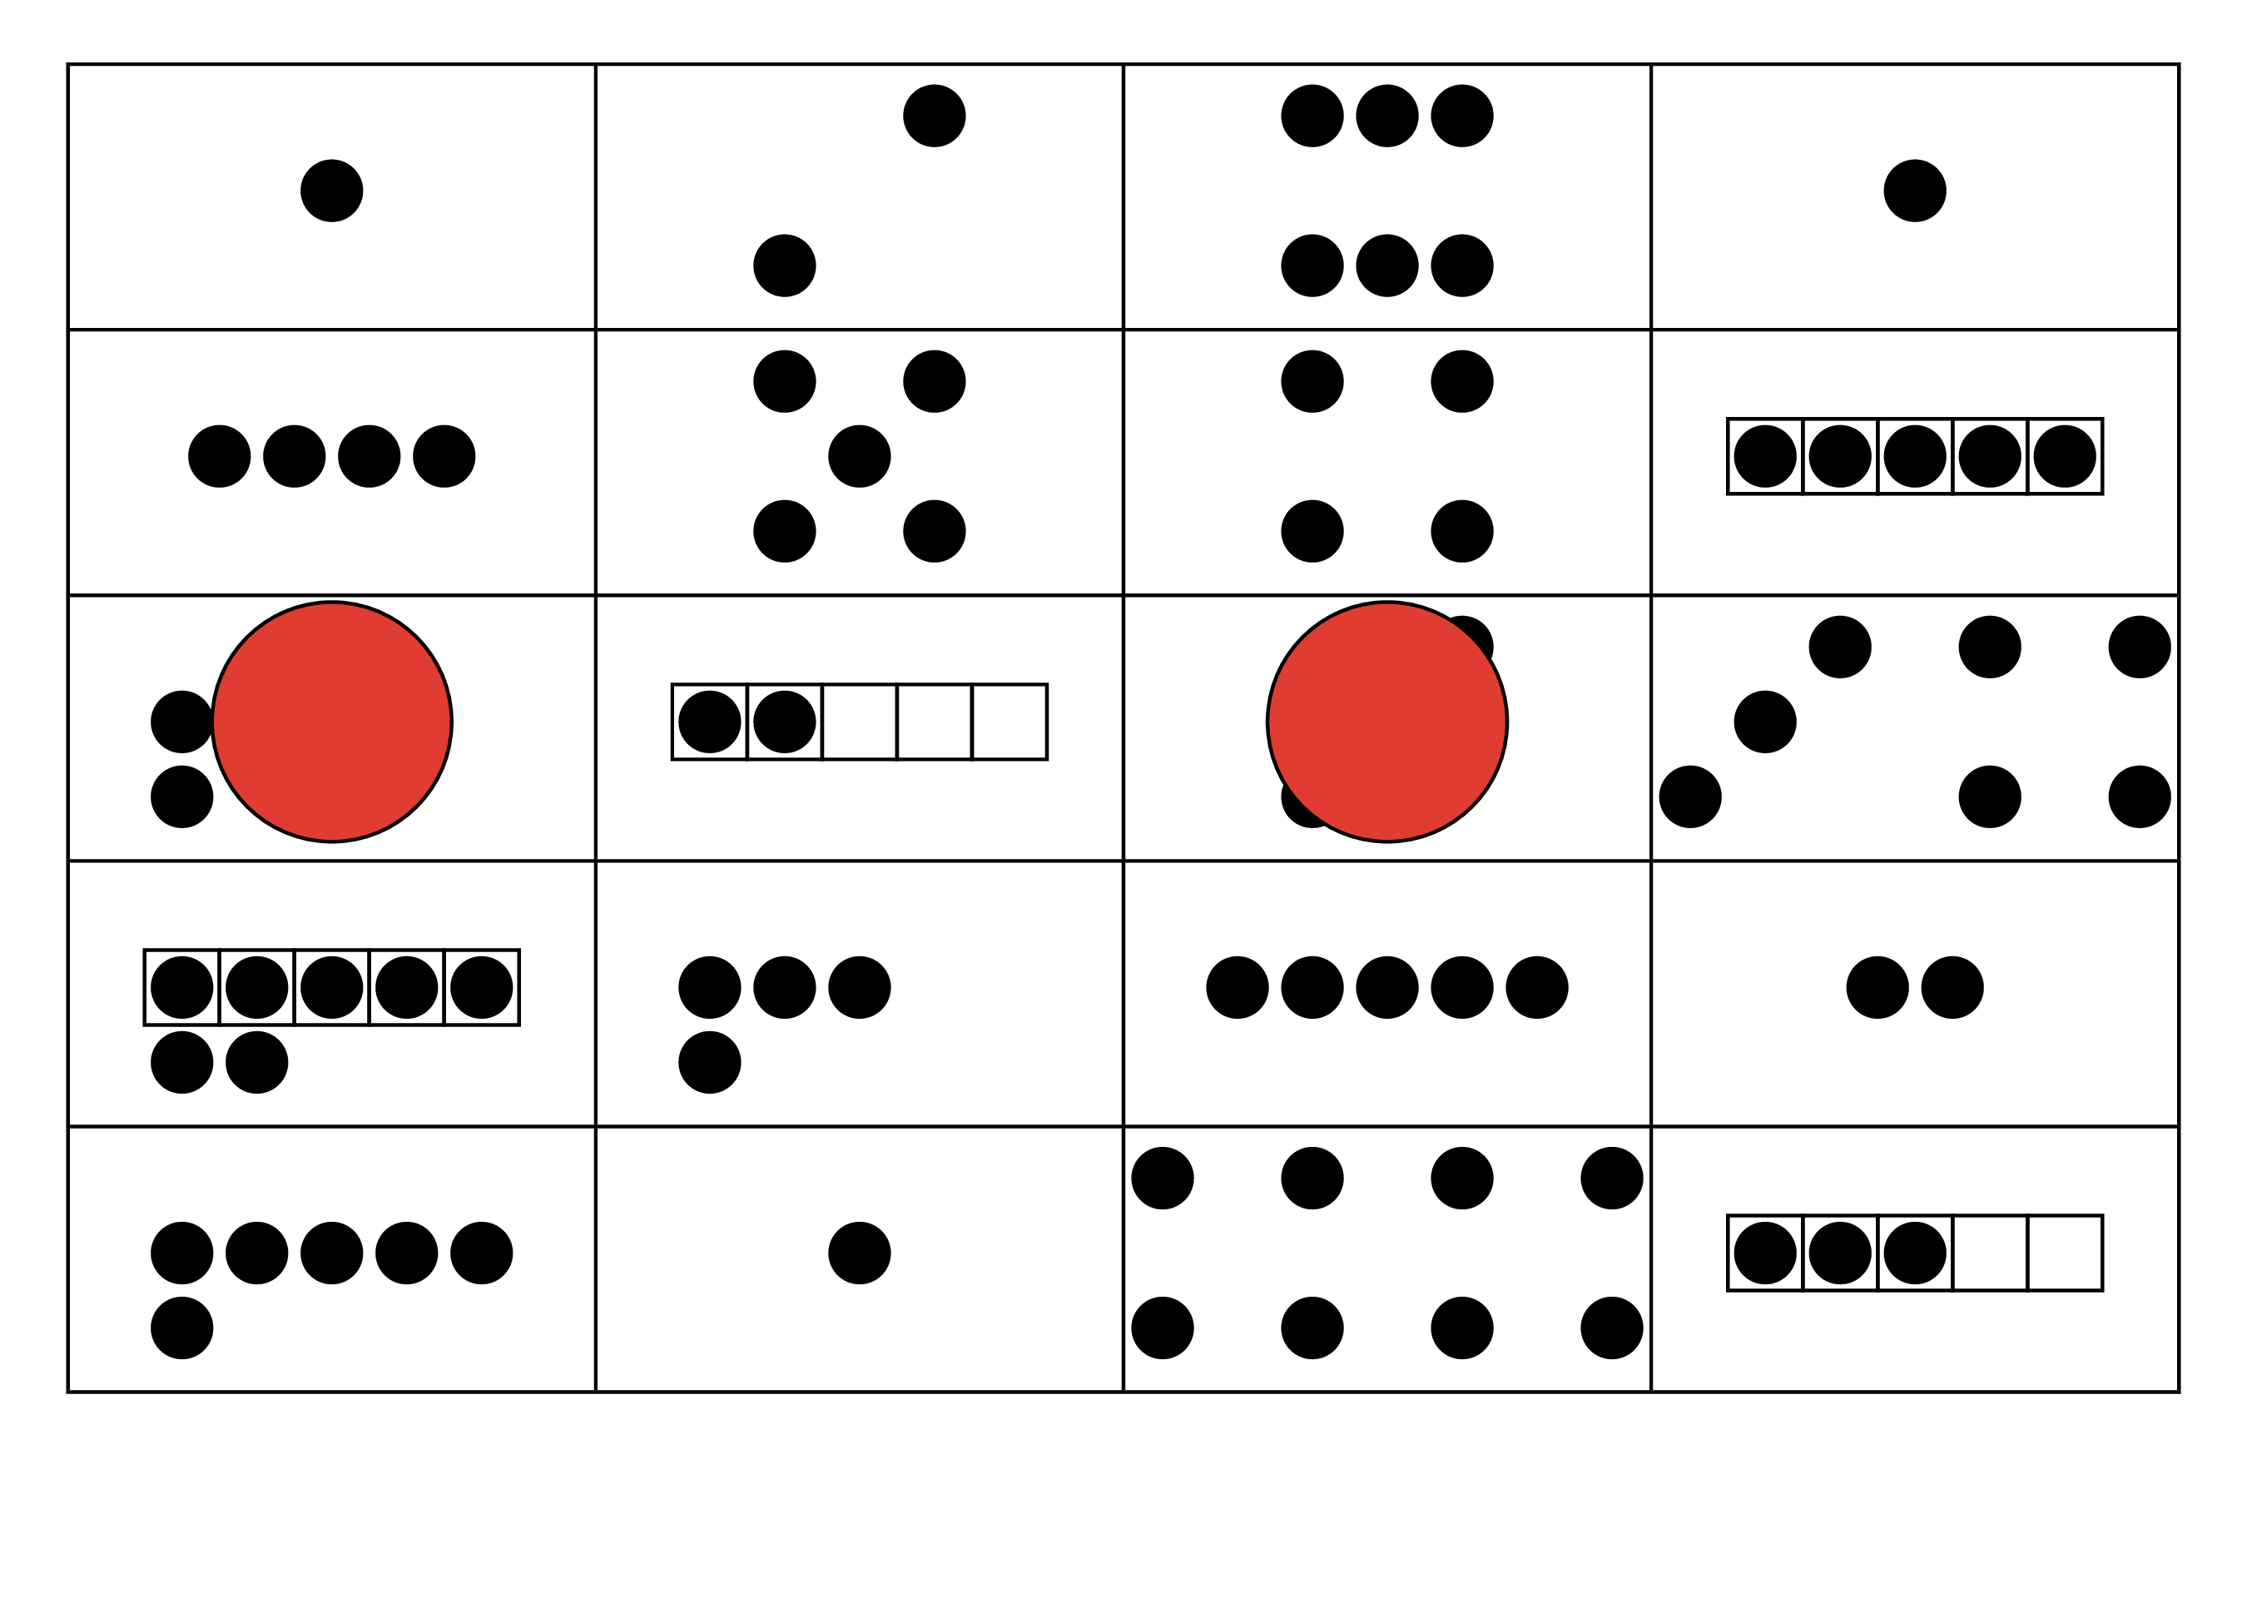
Math Stories

Section Summary
Section Summary
In this section, we solved story problems with more than one solution.
Han squeezed 9 pieces of fruit to make juice.
Some of the fruits were satsumas.
The rest of the fruits were grapefruits.
How many of the fruits were satsumas?
Then how many of the fruits were grapefruits?
We used objects and drawings to solve story problems.
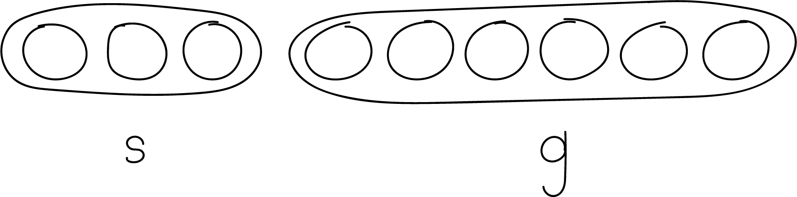
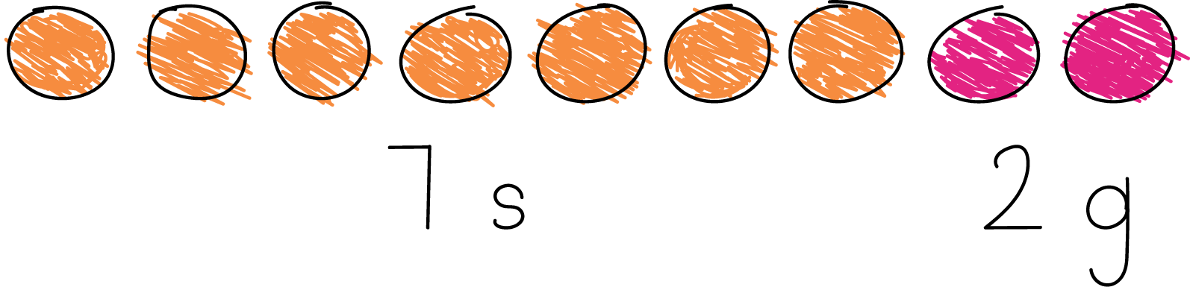
© CC BY 2021 Illustrative Mathematics®

