Lesson 8 Practice Problems
- Suppose a circle is divided into congruent slices. Match each number of slices with the resulting central angle measure of each slice.
  - 2
  - 3
  - 4
  - 5
  - 6
  - 8
  - 45$​^{∘}$
  - 60$​^{∘}$
  - 72$​^{∘}$
  - 120$​^{∘}$
  - 90$​^{∘}$
  - 180$​^{∘}$
- A circle of radius 12 units is divided into 8 congruent slices.
  - What is the area of each slice?
  - What is the arc length of each slice?
- Diego says, “To find arc length, divide the measure of the central angle by 360. Then multiply that by the area of the circle.“ Do you agree with Diego? Show or explain your reasoning.
- The image shows a triangle.
- 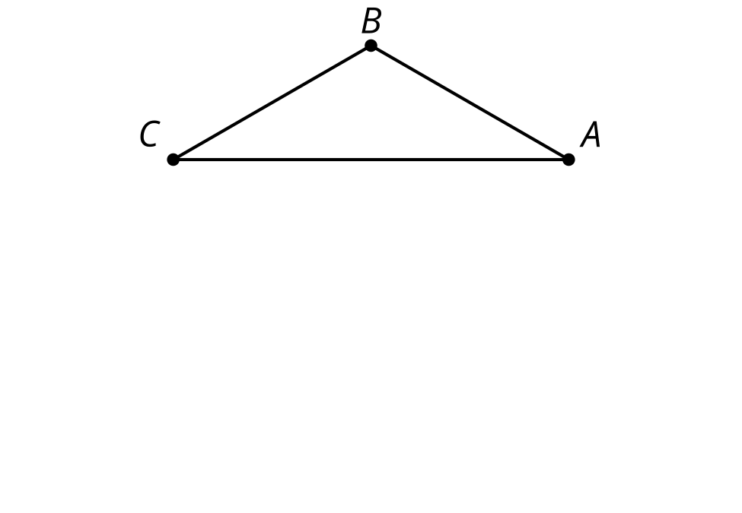
  - Sketch the inscribed and circumscribed circles for this triangle.
  - Compare and contrast the 2 circles.
- (From Unit 7, Lesson 7.)
- Triangle $ABC$ is shown with its inscribed circle drawn. The measure of angle $ECF$ is 72 degrees. What is the measure of angle $EGF$? Explain or show your reasoning.
- 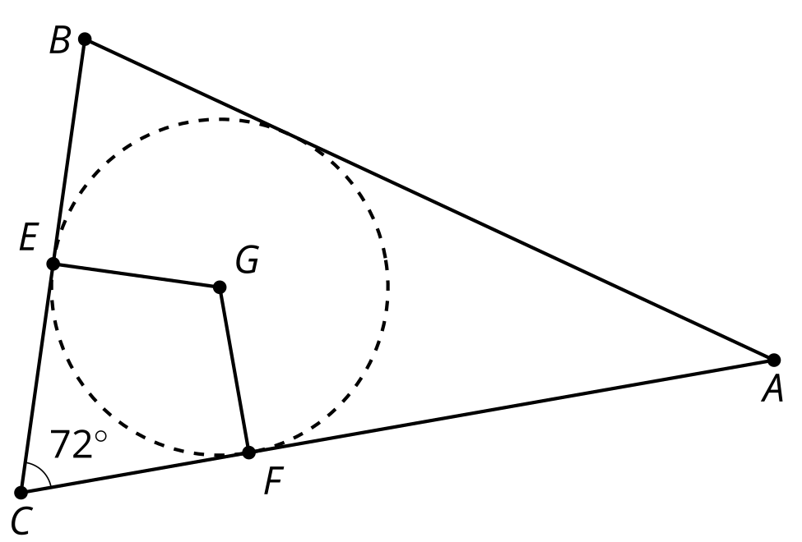
- (From Unit 7, Lesson 7.)
- How do the values of $x$ and $y$ compare? Explain your reasoning.
- 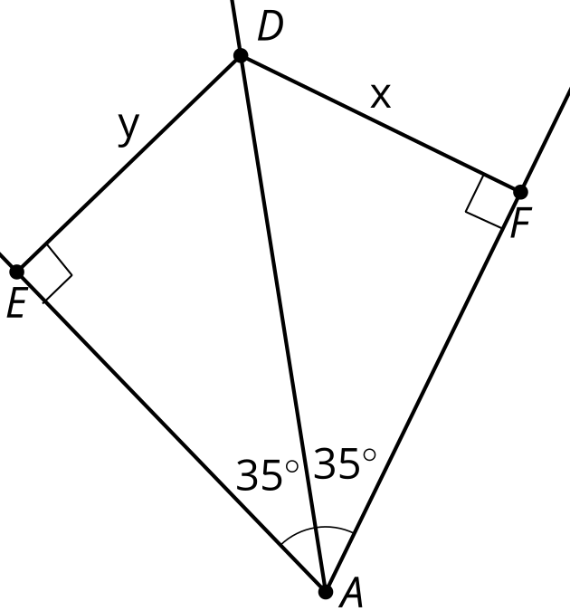
- (From Unit 7, Lesson 6.)
- Points $A,B,$ and $C$ are the corners of a triangular park. The park district is going to add a set of swings inside the park. The goal is to have the swings equidistant from the vertices of the park. Find a location that meets this goal. Explain or show your reasoning.

- (From Unit 7, Lesson 5.)
- In the diagram, the measure of the arc from $A$ to $B$ not passing through $C$ is 80 degrees. What is the measure of angle $ACB$?
- 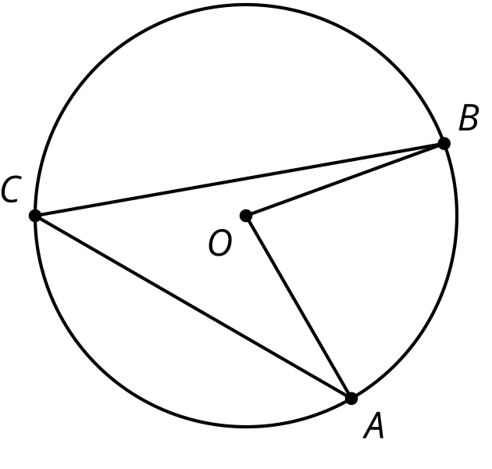
  - 20 degrees
  - 40 degrees
  - 80 degrees
  - 160 degrees
- (From Unit 7, Lesson 2.)
- This solid has curved sides. All cross sections parallel to the base are squares measuring 3 units on each side. The height from the base to the top is 8 units. What is the volume of this solid?
- 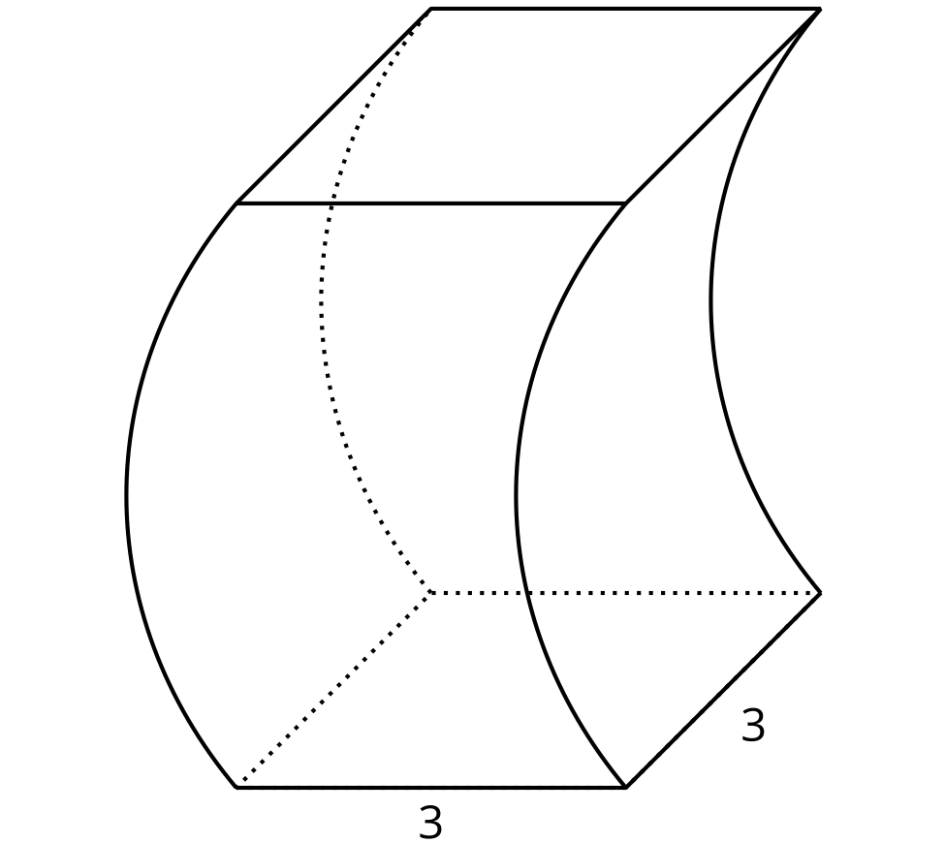

- (From Unit 5, Lesson 10.)
© CC BY 2019 by Illustrative Mathematics®

