Lesson 11: What’s the Difference?
- Let's subtract fractions.

Warm-up: Number Talk: Subtracting Fractions
Find the value of each difference mentally.
- $\frac{2}{3}−\frac{1}{6}$
- $\frac{2}{3}−\frac{1}{2}$
- $\frac{2}{3}−\frac{4}{6}$
- $\frac{2}{3}−\frac{1}{4}$

11.1: Greatest Difference
Use the directions to play Greatest Difference with a partner.
- Spin the spinner.
- Each player writes the number that was spun in an empty box for Round 1. Be sure your partner cannot see your paper.
- Once a number is written down, it cannot be changed.
- Continue spinning and writing numbers in the empty boxes until all 4 boxes have been filled.
- Find the difference.
- The person with the greatest difference wins the round.
- After all 4 rounds, the player who won the most rounds, wins the game.
- If there is a tie, players add the differences from all 4 rounds and the highest total wins the game.
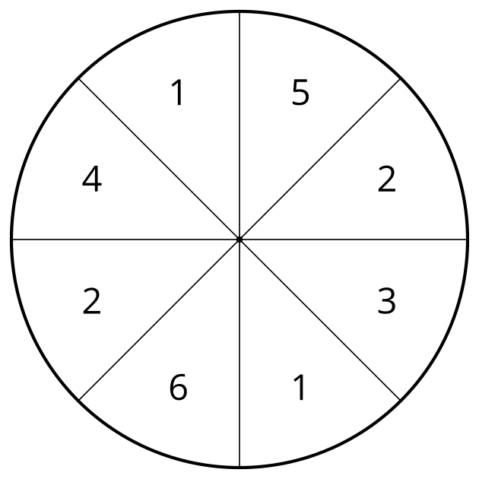
Round 1
1111111111 − 1111111111 =
Round 2
1111111111 − 1111111111 =
Round 3
1111111111 − 1111111111 =
Round 4
1111111111 − 1111111111 =

11.2: What is the Smallest Difference?
Use the numbers below to fill in the squares. Find each difference. Add the 2 differences together.
1 | 1 | 2 | 2 | 3 | 4 | 5 | 6

1111111111 − 1111111111 =
1111111111 − 1111111111 =
© CC BY 2021 Illustrative Mathematics®

