Unit 2 Lesson 10: Center Day 2

WU Notice and Wonder: Compare the Representations (Warm up)

Student Task Statement
What do you notice? What do you wonder?

- 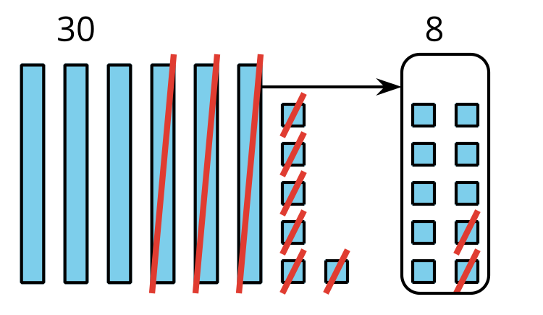
- $66−28$
$66=50+16$
$16−8=8$
$50−20=30$
$30+8=38$
$66−28=38$

1 Introduce Target Numbers, Subtract Two-digit Numbers

Student Task Statement

2 Centers: Choice Time

Student Task Statement
Choose a center.
Target Numbers
Capture Squares
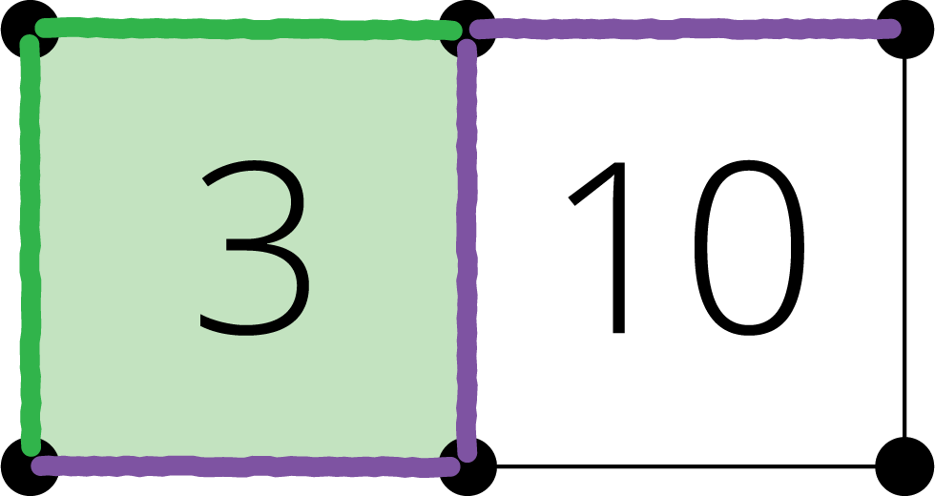
Five in a Row
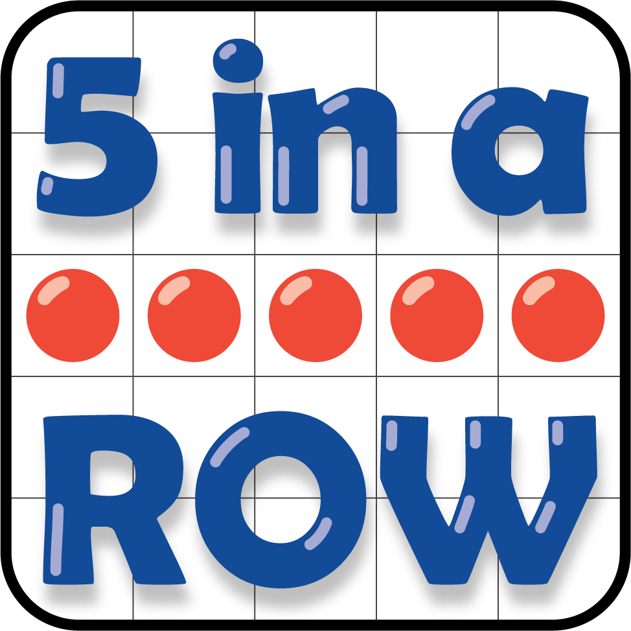
© CC BY 2021 Illustrative Mathematics®

