Unit 5 Lesson 13: Multi-step Measurement Problems with Fractions

WU True or False: Some Number Times a Fraction (Warm up)

Student Task Statement
Decide whether each statement is true or false. Be prepared to explain your reasoning.
- $16×\frac{1}{4}=4$
- $8×\frac{3}{4}=12$
- $32×\frac{2}{8}=8$
- $60×\frac{1}{12}=10$

1 Info Gap: Noah’s School Day (Part 1)

Student Task Statement
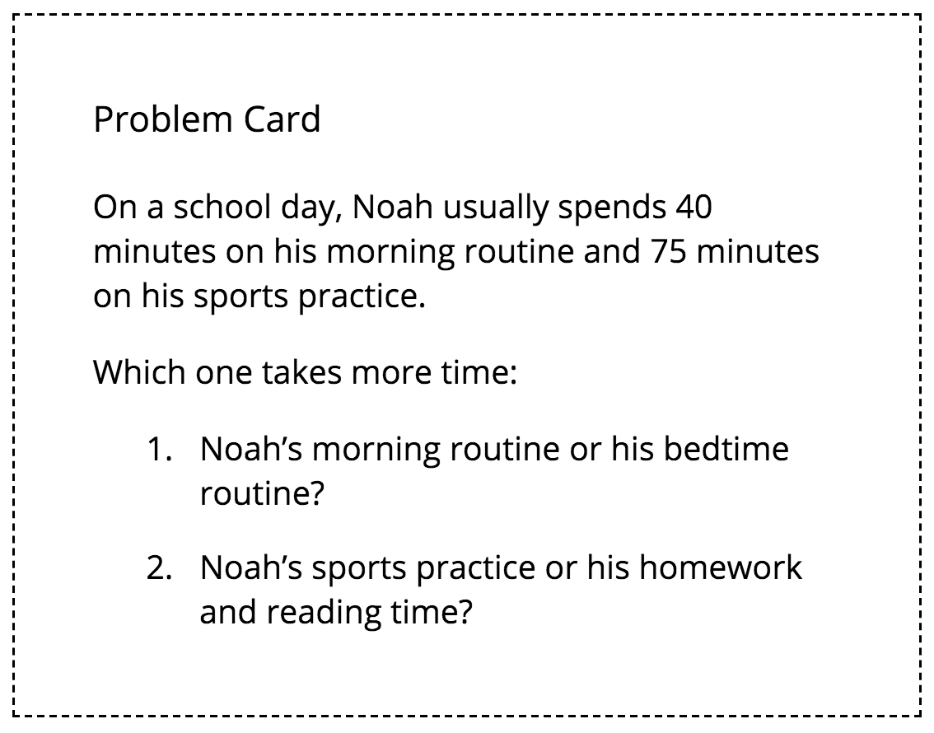

2 Info Gap: Noah’s School Day (Part 2)

Student Task Statement
Your teacher will give you either a problem card or a data card. Do not show or read your card to your partner.
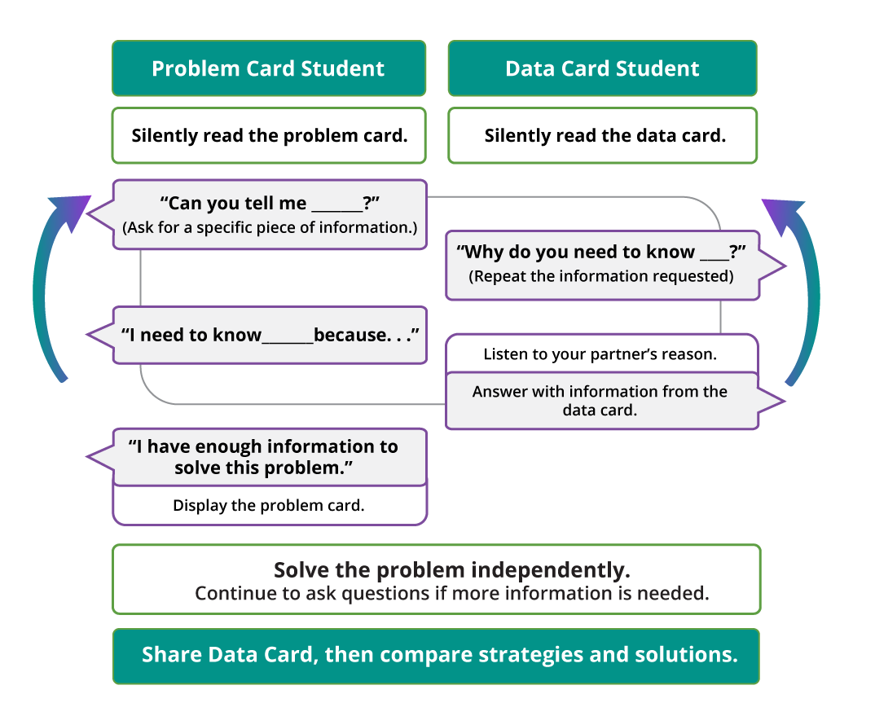
Pause here so your teacher can review your work.
Ask your teacher for a new set of cards and repeat the activity, trading roles with your partner.

3 Shopping List (Optional)

Student Task Statement
Here are six ingredients that a shopper bought and some clues about each quantity.
The items are listed in order of weight, from least to greatest.
ingredient | pounds | ounces
rice noodles
shrimp
tapioca flour
tofu
carrots
brown rice
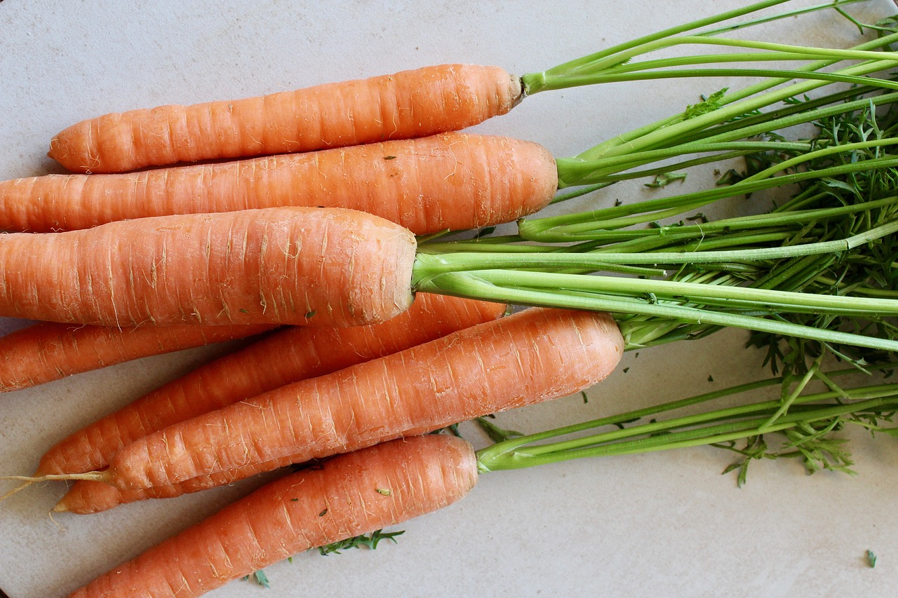
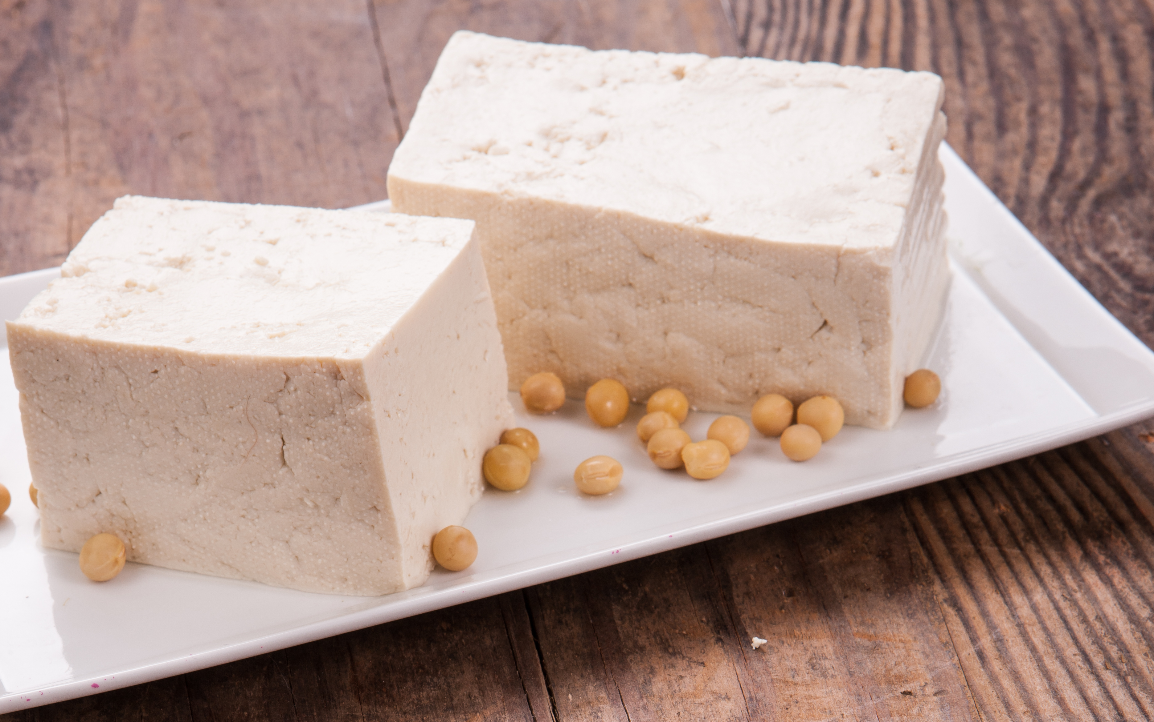
- The heaviest item weighs 4 times the weight of tofu.
- One ingredient weighs $\frac{1}{2}$ pound.
- The item that weighs 10 pounds is 10 times the weight of shrimp.
- The carrots are 3 times as heavy as the shrimp.
- The carrots are 2 times as heavy as the tapioca flour.
- Brown rice weighs 20 times as much as the weight of noodles.
Use the clues to find out the weight of each ingredient in both pounds and ounces.
© CC BY 2021 Illustrative Mathematics®

