Unit 5 Lesson 13: Expressions with Rational Numbers

1 True or False: Rational Numbers (Warm up)

Student Task Statement
Decide if each statement is true or false. Be prepared to explain your reasoning.
- $\left(\text{-}38.76\right)\left(\text{-}15.6\right)$ is negative
- $10,000−99,999<0$
- $\left(\frac{3}{4}\right)\left(\text{-}\frac{4}{3}\right)=0$
- $\left(30\right)\left(\text{-}80\right)−50=50−\left(30\right)\left(\text{-}80\right)$

2 Card Sort: The Same But Different

Student Task Statement
Your teacher will give you a set of cards. Group them into pairs of expressions that have the same value.

3 Near and Far From Zero

Student Task Statement
$a$ | $b$ | $\text{-}a$ | $\text{-}4b$ | $\text{-}a+b$ | $a÷\text{-}b$ | $a^{2}$ | $b^{3}$
$\text{-}\frac{1}{2}$ | 6
$\frac{1}{2}$ | -6
-6 | $\text{-}\frac{1}{2}$
- For each set of values for $a$ and $b$, evaluate the given expressions and record your answers in the table.
- When $a=\text{-}\frac{1}{2}$ and $b=6$, which expression:
- has the largest value?
- has the smallest value?
- is the closest to zero?
- When $a=\frac{1}{2}$ and $b=\text{-}6$, which expression:
- has the largest value?
- has the smallest value?
- is the closest to zero?
- When $a=\text{-}6$ and $b=\text{-}\frac{1}{2}$, which expression:
- has the largest value?
- has the smallest value?
- is the closest to zero?

4 Seagulls and Sharks Again (Optional)

Student Task Statement
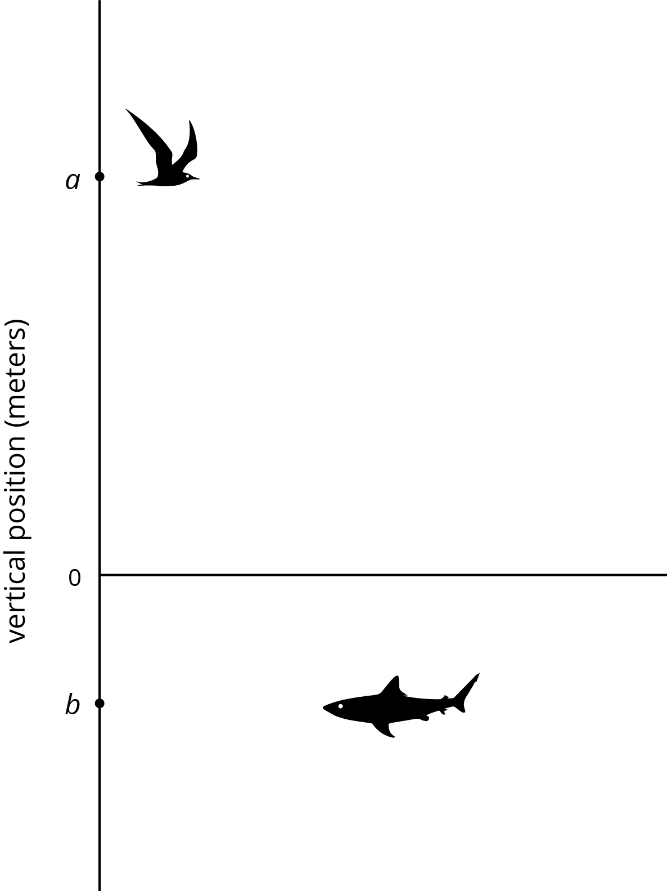
A seagull has a vertical position $a$, and a shark has a vertical position $b$. Draw and label a point on the vertical axis to show the vertical position of each new animal.
- A dragonfly at $d$, where $d=\text{-}b$
- A jellyfish at $j$, where $j=2b$
- An eagle at $e$, where $e=\frac{1}{4}a$.
- A clownfish at $c$, where $c=\frac{\text{-}a}{2}$
- A vulture at $v$, where $v=a+b$
- A goose at $g$, where $g=a−b$
© CC BY Open Up Resources. Adaptations CC BY IM.

