Unit 1 Lesson 13 Cumulative Practice Problems
- Select all the polyhedra.
- 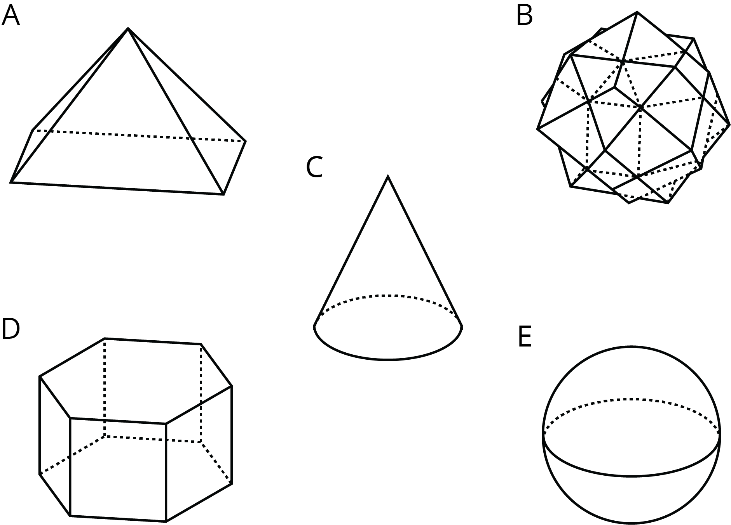
  - A
  - B
  - C
  - D
  - E
  - Is this polyhedron a prism, a pyramid, or neither? Explain how you know.
  - 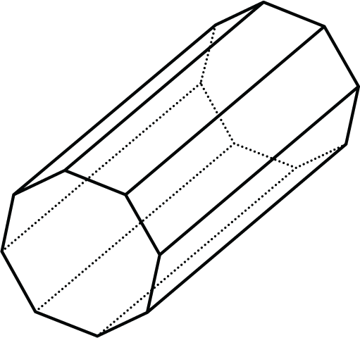
  - How many faces, edges, and vertices does it have?
- Tyler said this net cannot be a net for a square prism because not all the faces are squares.
- Do you agree with Tyler? Explain your reasoning.
- 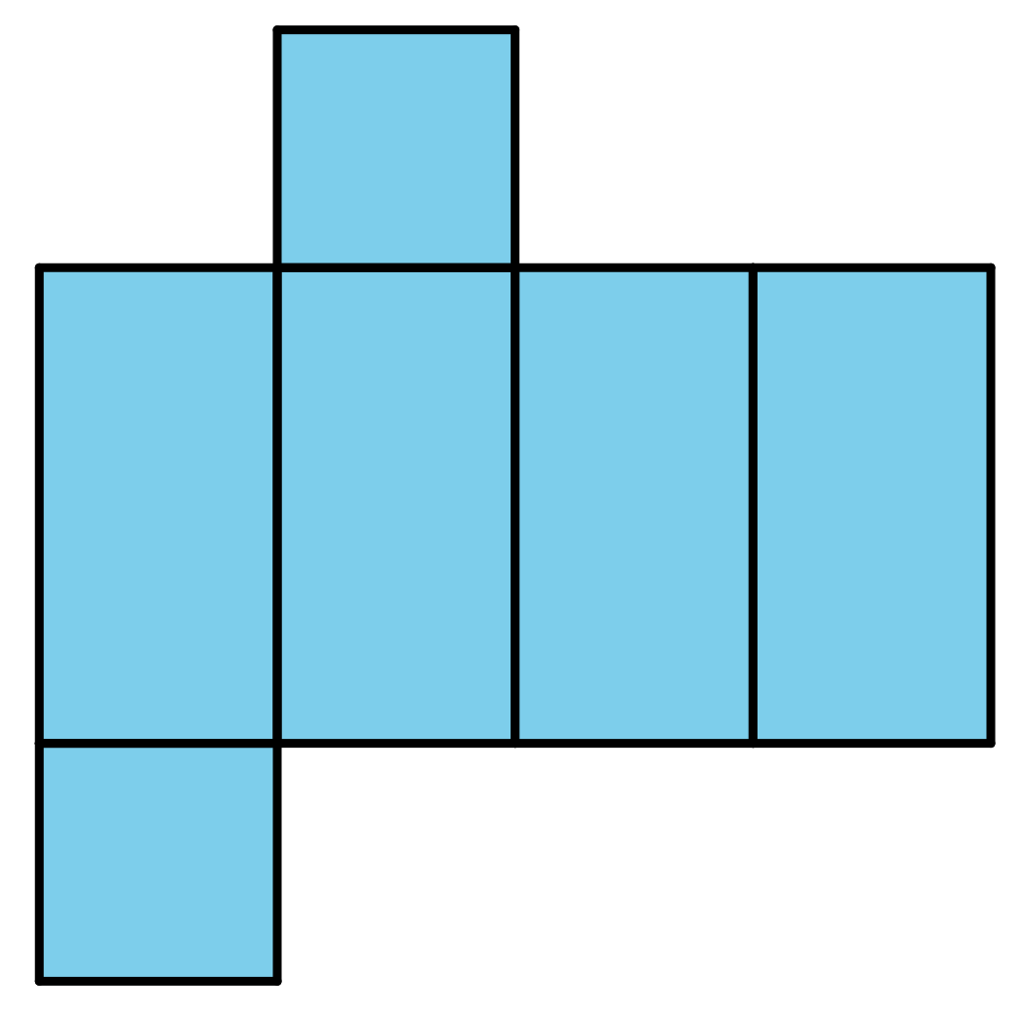
- Explain why each of these triangles has an area of 9 square units.
- 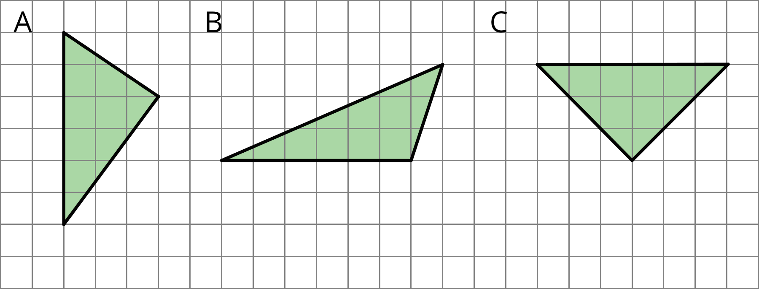
- (From Unit 1, Lesson 8.)
  - A parallelogram has a base of 12 meters and a height of 1.5 meters. What is its area?
  - A triangle has a base of 16 inches and a height of $\frac{1}{8}$ inches. What is its area?
  - A parallelogram has an area of 28 square feet and a height of 4 feet. What is its base?
  - A triangle has an area of 32 square millimeters and a base of 8 millimeters. What is its height?
- (From Unit 1, Lesson 9.)
- Find the area of the shaded region. Show or explain your reasoning.
- 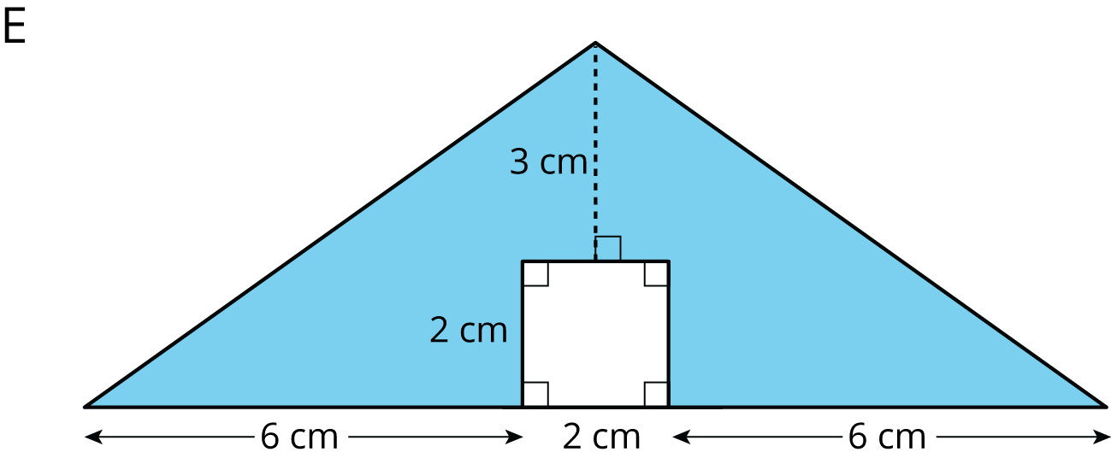
- (From Unit 1, Lesson 3.)
© CC BY Open Up Resources. Adaptations CC BY IM.

