Lesson 13: Analicemos errores en sumas

Standards Alignments
Addressing | 5.NBT.B.7

Teacher-facing Learning Goals
- Add decimals to the hundredths place using strategies based on place value.

Student-facing Learning Goals
- Usemos estrategias de valor posicional para sumar números decimales.

Lesson Purpose
The purpose of this lesson is for students to add decimals and consider common errors in lining up place values when adding with the standard algorithm.
In previous lessons, students used strategies based on place value and properties of operations to add decimal numbers including the standard algorithm. The purpose of this lesson is to highlight the importance of adding the same place values when making vertical calculations with decimals. This issue does not arise when adding whole numbers as the numbers are always aligned to the right, starting with ones, then tens, and so on. For decimal numbers it is more complicated because the last digits in two decimals, such as 5.18 and 16.7, may not have the same place value. Rather than aligning these numbers to the right as shown here
they need to be aligned by place value. After examining this alignment error, students practice adding decimals taking care to add using the correct place values.

Access for:

Students with Disabilities
- Engagement (Activity 2)

Instructional Routines
Estimation Exploration (Warm-up), MLR3 Clarify, Critique, Correct (Activity 1)

Lesson Timeline
Warm-up | 10 min
Activity 1 | 20 min
Activity 2 | 15 min
Lesson Synthesis | 10 min
Cool-down | 5 min

Teacher Reflection Question
Reflect on a time your thinking changed about something in class recently. How will you alter your teaching practice to incorporate your new understanding?

Cool-down
(to be completed at the end of the lesson) 5min
¿Cuál es el error?

Standards Alignments
Addressing | 5.NBT.B.7

Student-facing Task Statement
Este cálculo tiene un error:
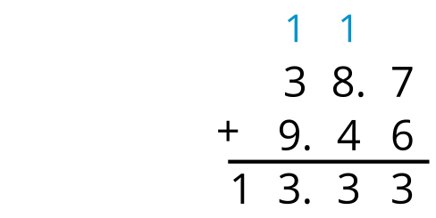
- Explica el error.
- Encuentra el valor correcto de $38.7+9.46$.

Student Responses
- The decimal places are not lined up so the 30 in 38.7 is treated like it's only 3.

- 