Unit 5 Lesson 10: Introduce the 10-frame

WU Notice and Wonder: Fingers and 5-frames (Warm up)

Student Task Statement
What do you notice?
What do you wonder?

1 Introduce 10-frames

Student Task Statement
Cut out and glue the 5-frames to make each number.

Activity Synthesis

2 Numbers on Fingers and 10-frames

Student Task Statement

Activity Synthesis
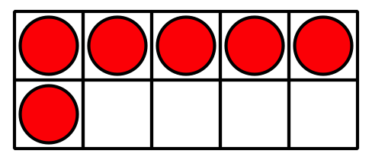
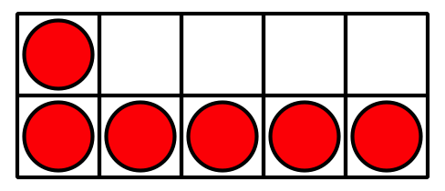
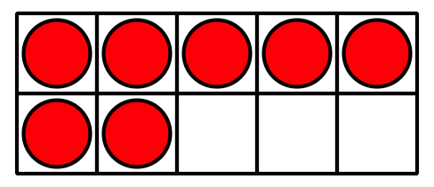

3 Centers: Choice Time

Student Task Statement
Choose a center.
Shake and Spill
Counting Collections
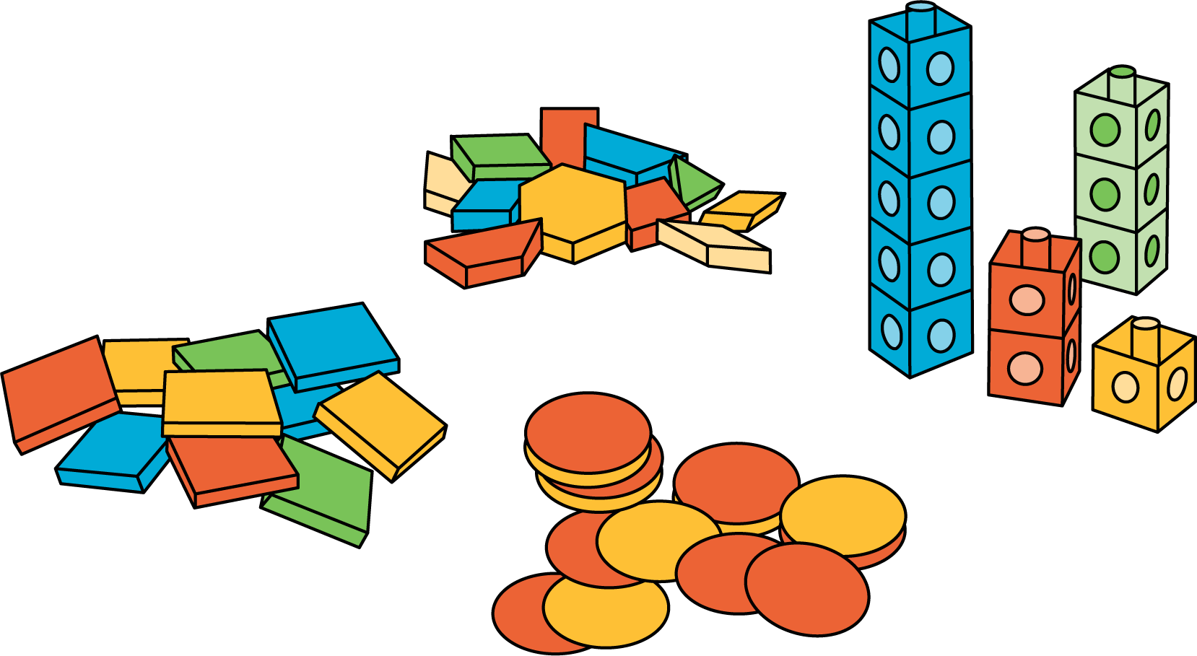
Roll and Add
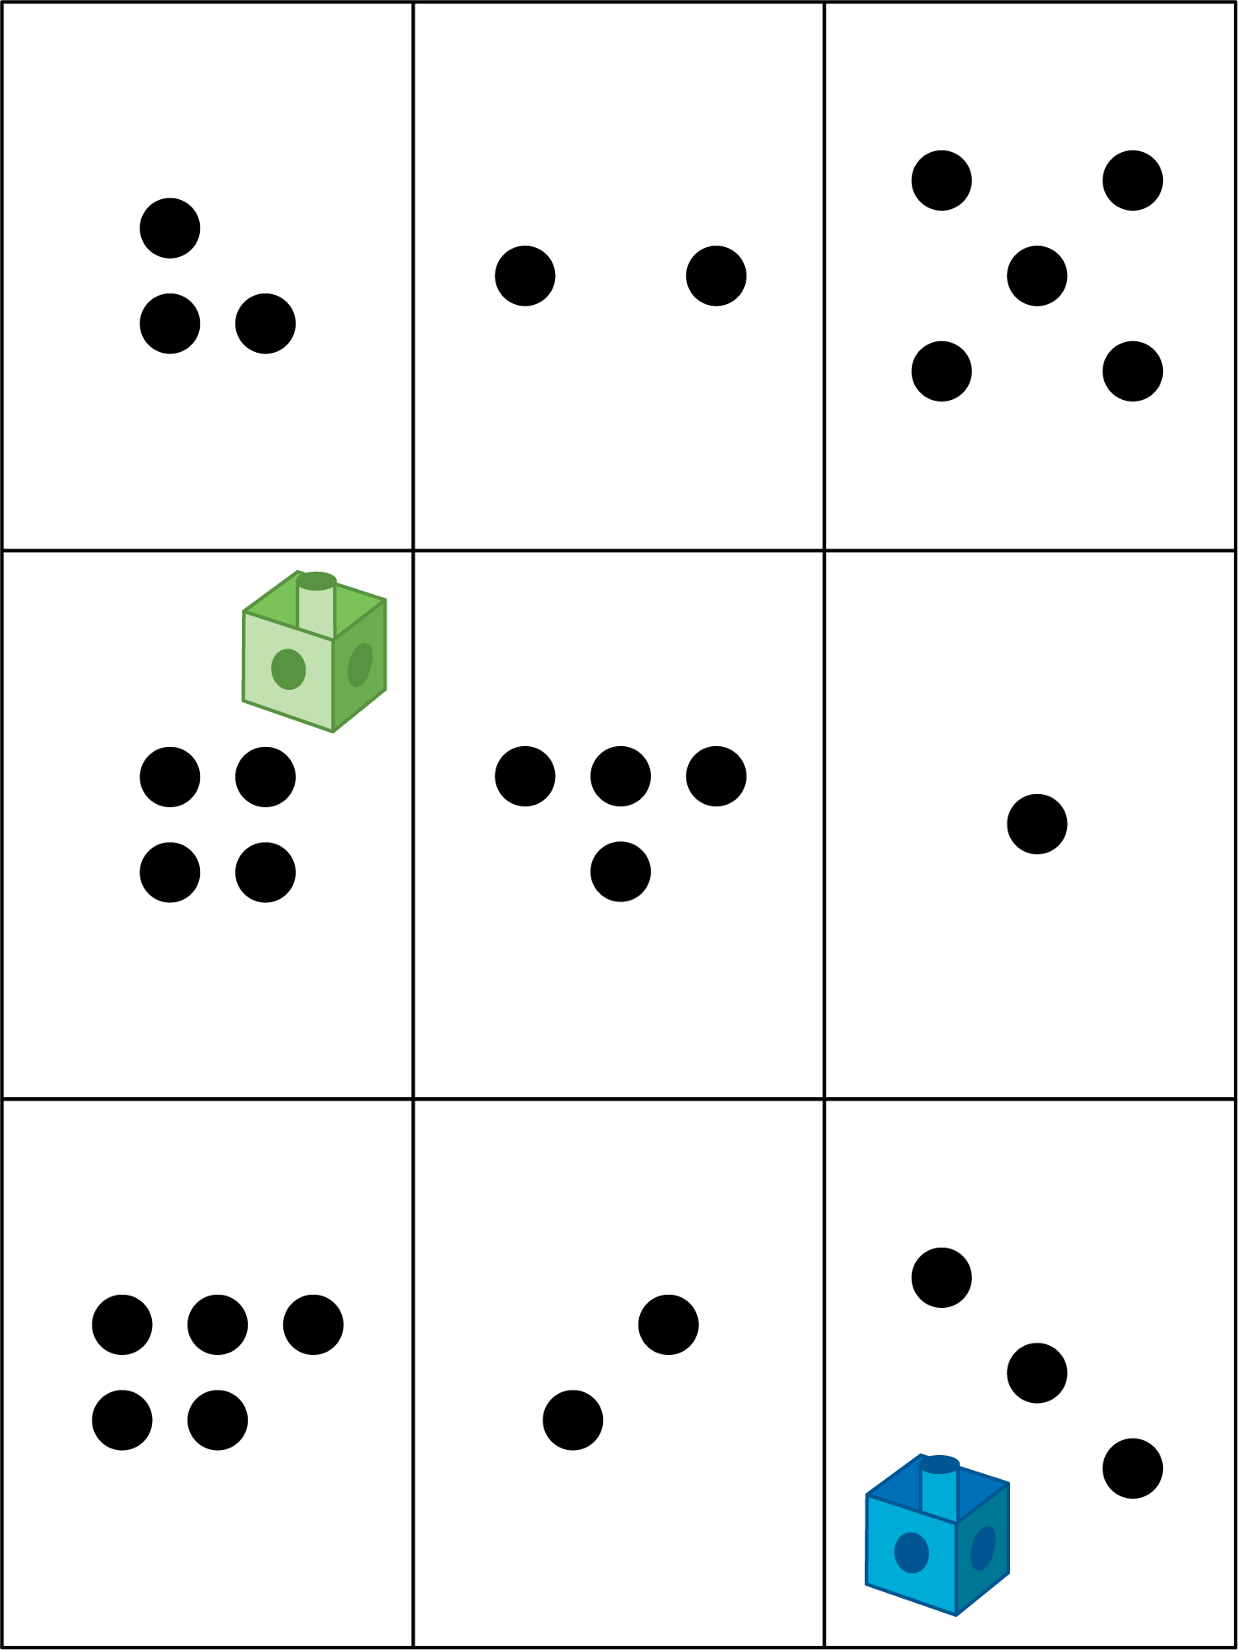
© CC BY 2021 Illustrative Mathematics®

