Unit 7 Lesson 15: Build and Count with Solid Shapes

WU Estimation Exploration: How Many Cubes? (Warm up)

Student Task Statement
- Record an estimate that is:
- too low | - about right | - too high
- Record an estimate that is:
- too low | - about right | - too high

1 A Tall Tower

Student Task Statement
How many solid shapes did you use in your tower?
_______________

2 What Can You Make With These Shapes?

Student Task Statement
- 5 cubes
- 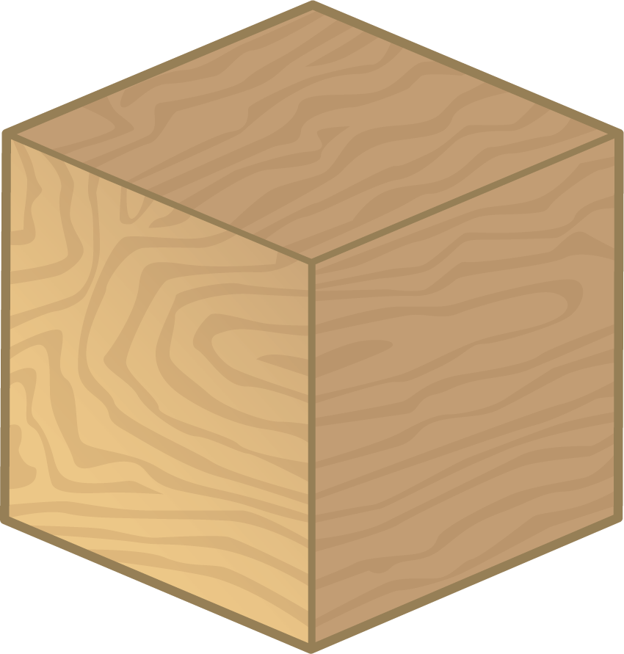
- 4 cylinders
- 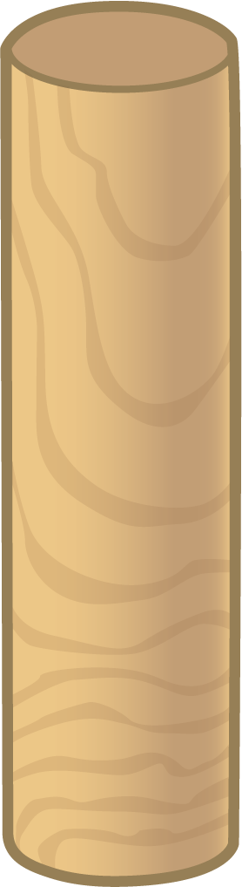
- 6 cones
- 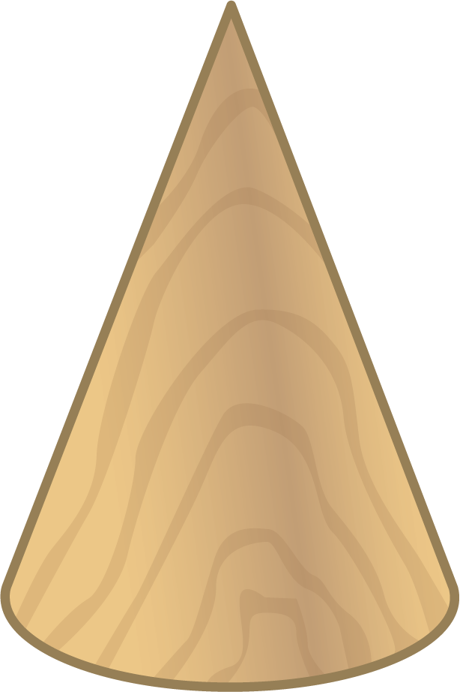
- How many shapes did you use all together?
- _______________
- 3 cones
- 4 cubes
- 5 cylinders
- How many shapes did you use all together?
- _______________

3 Centers: Choice Time

Student Task Statement
Choose a center.
Build Shapes
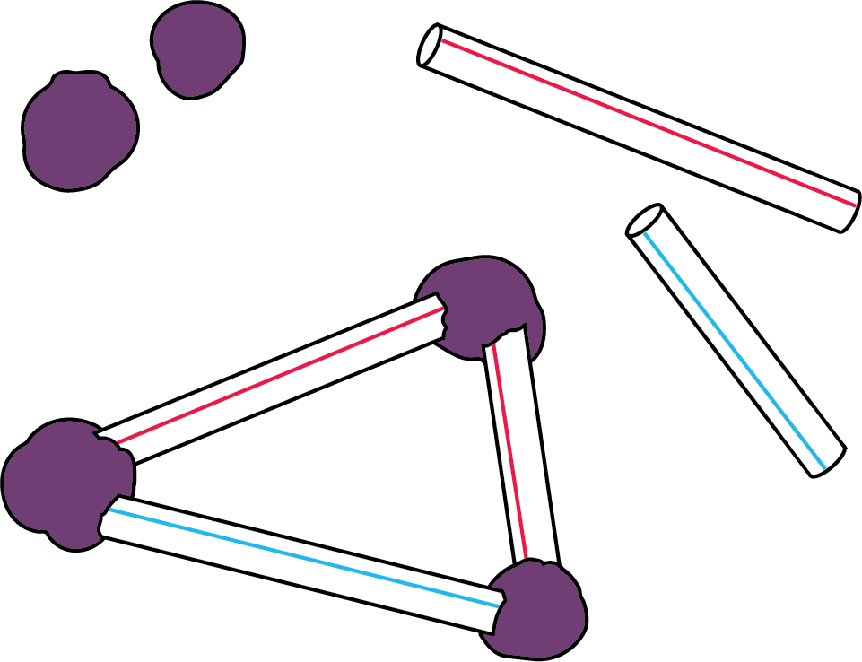
Geoblocks
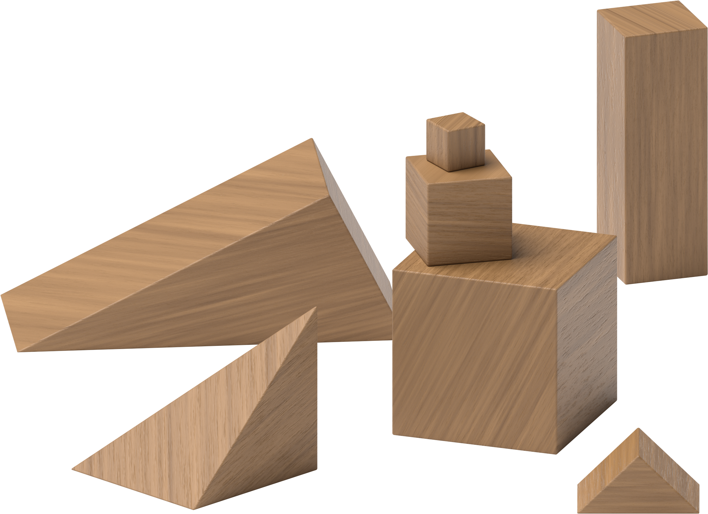
Counting Collections
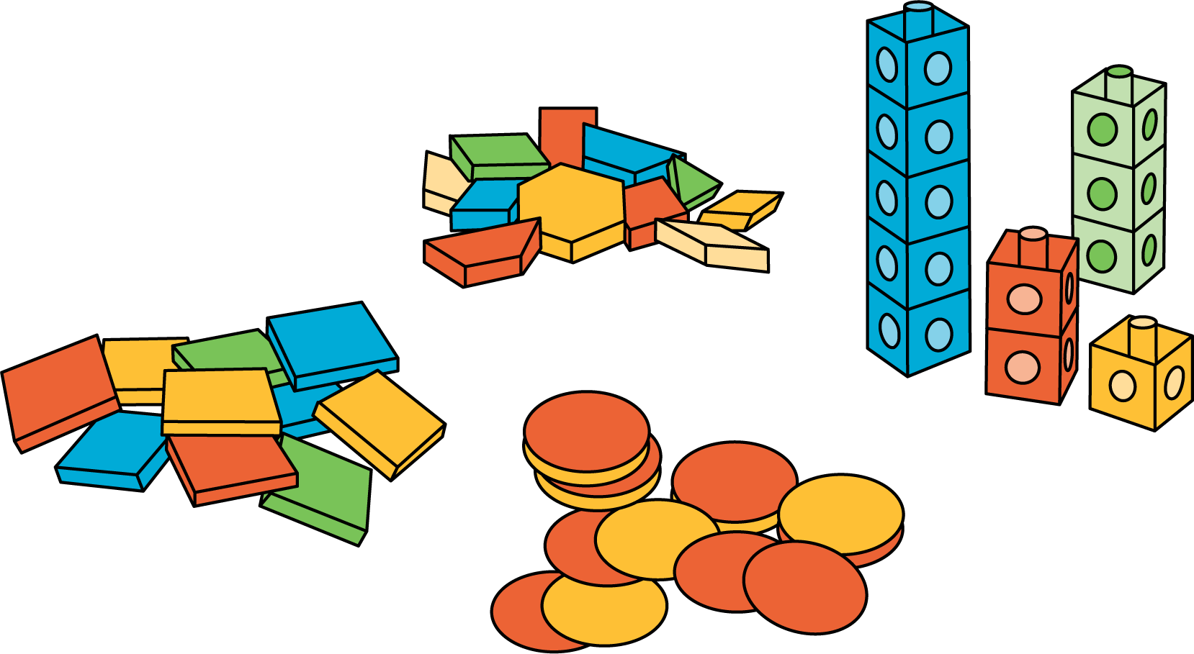
Match Mine
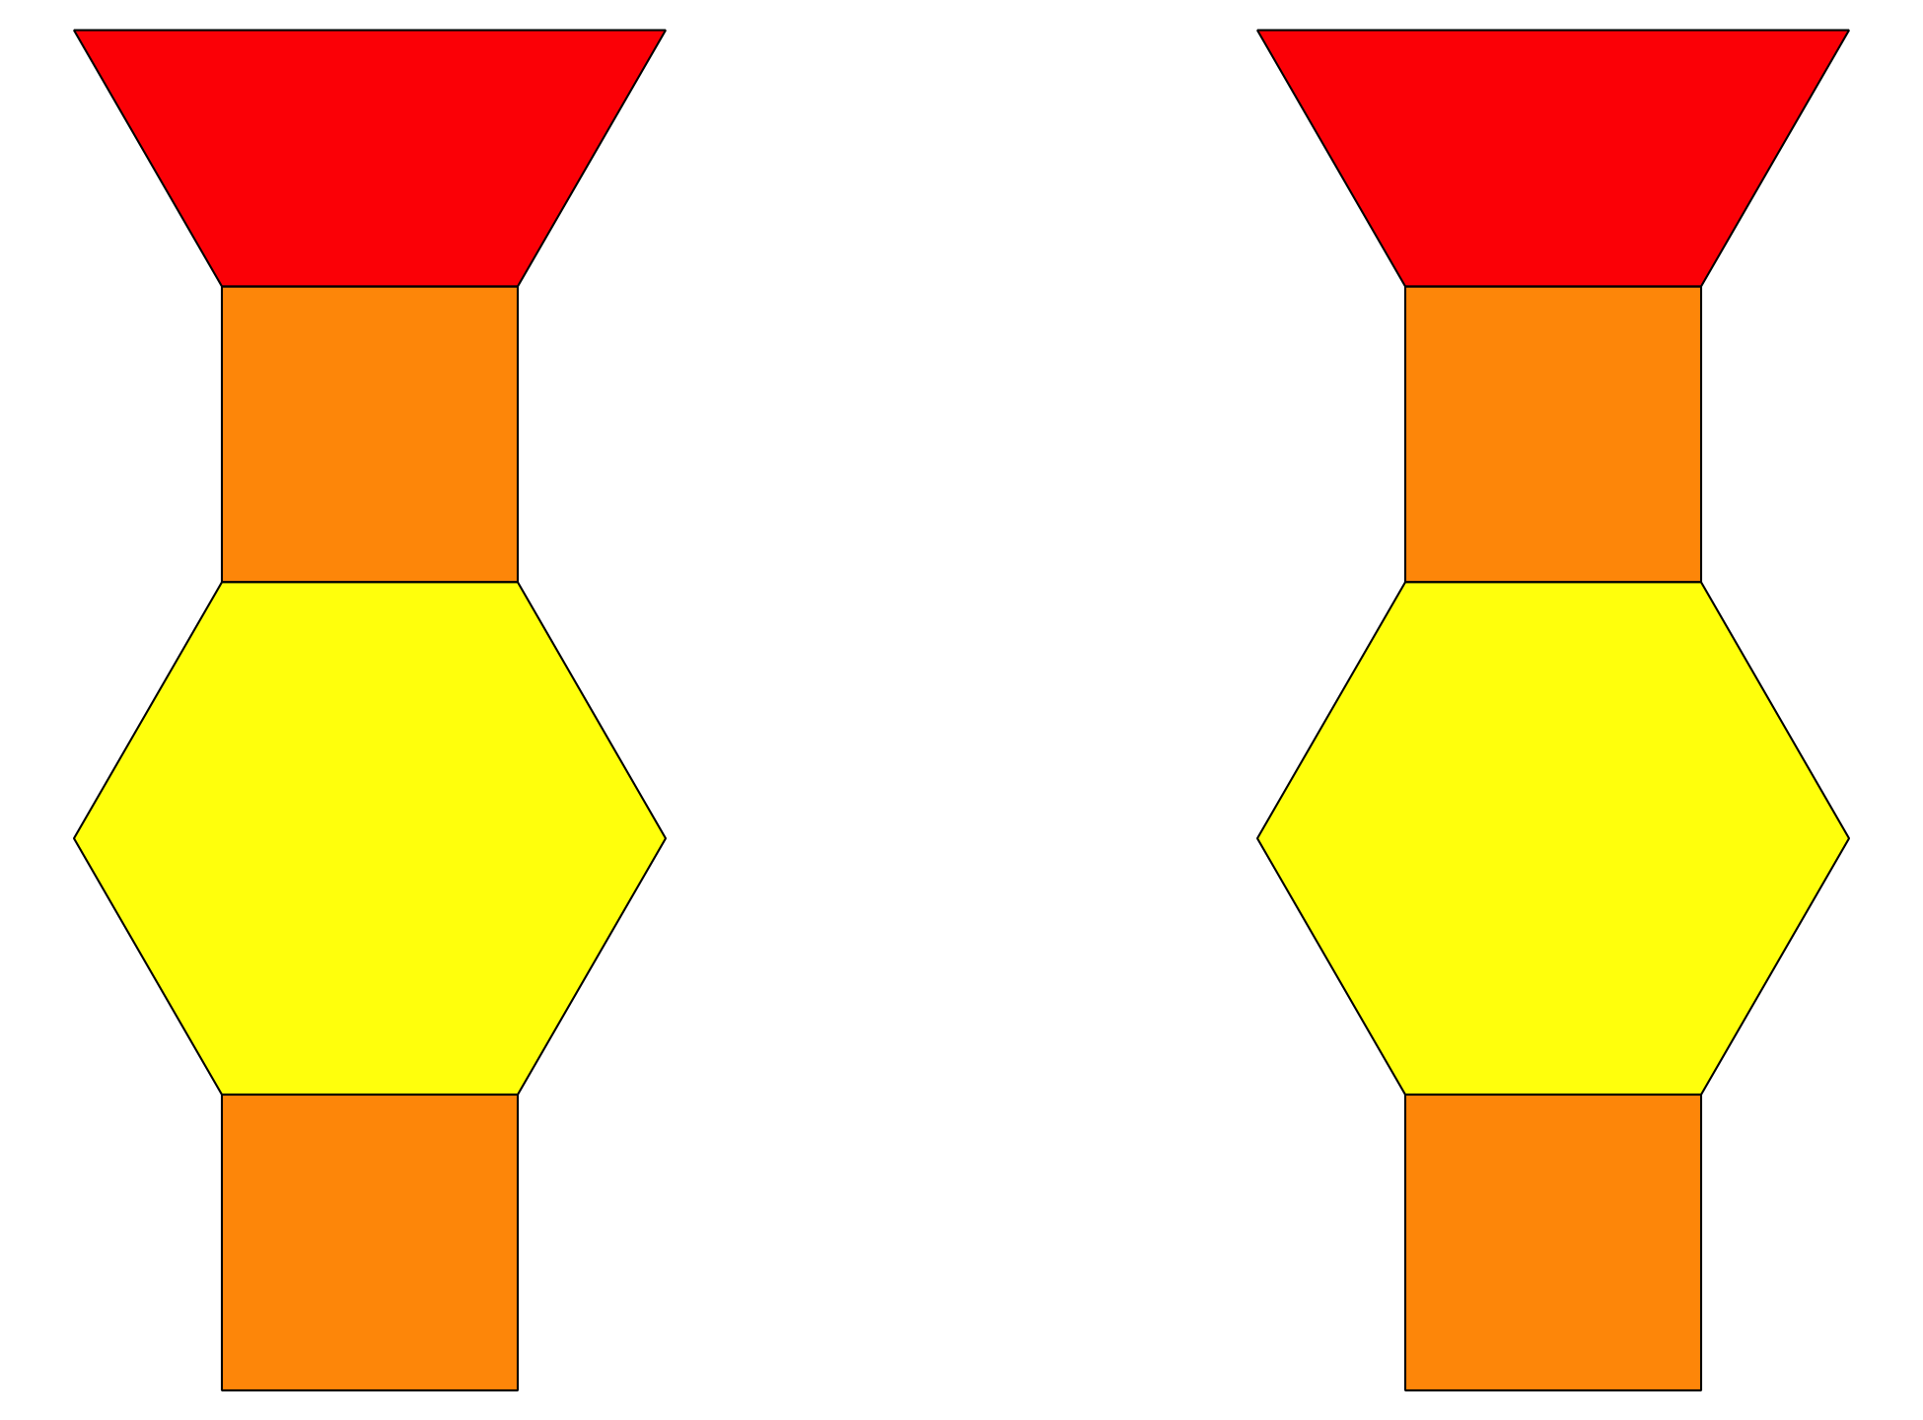
Shake and Spill
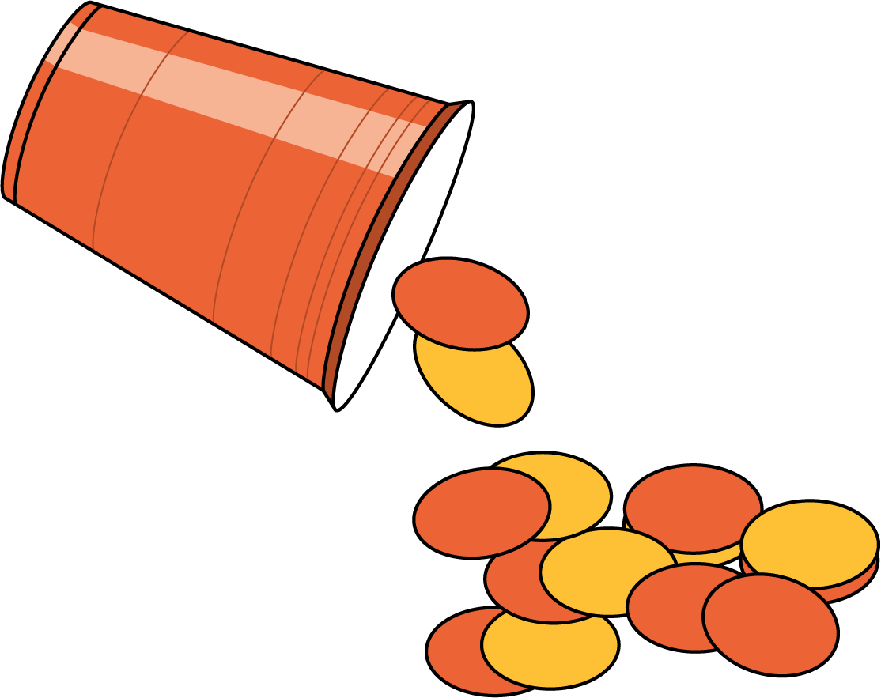
© CC BY 2021 Illustrative Mathematics®

