Unit 2 Lesson 11: How Do You Solve Story Problems?

WU What Do You Know About Story Problems? (Warm up)

Student Task Statement
What do you know about story problems?

1 How Many Seeds?

Student Task Statement
- Diego gathered 42 orange seeds. Jada gathered 16 apple seeds. How many more seeds did Diego gather than Jada? Show your thinking.
- 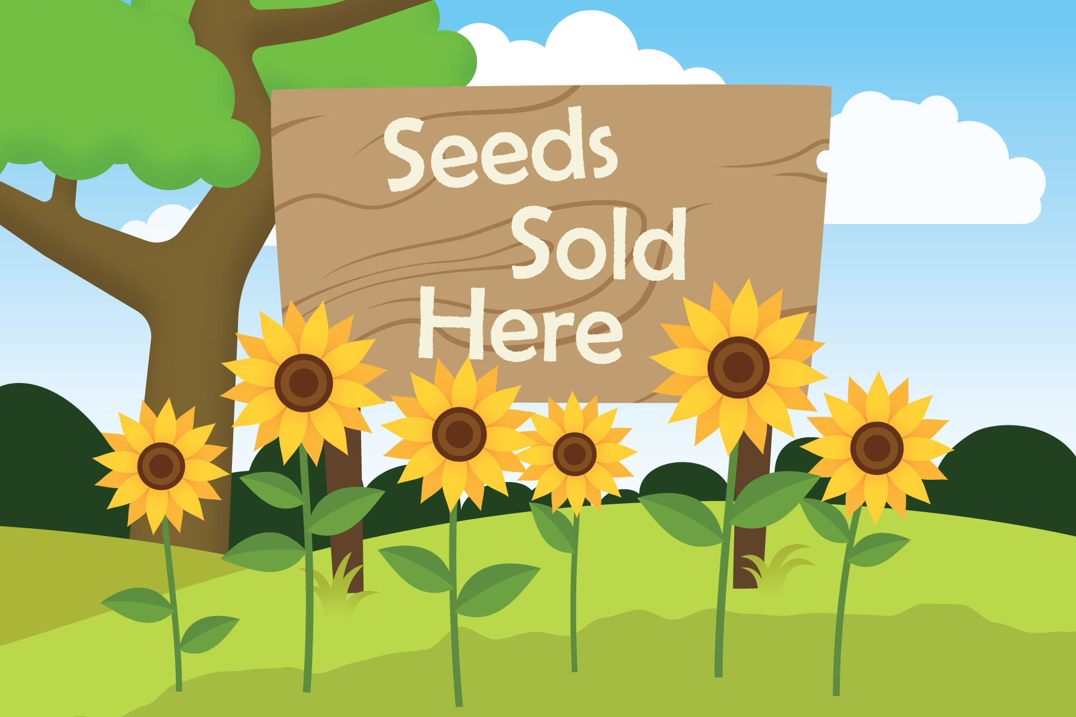

2 The Seeds of Greatness

Student Task Statement
Solve each story problem. Show your thinking.
- Lin had 31 sunflower seeds. She gave Priya 15 seeds. How many seeds does Lin have now?
- Noah used yellow and blue corn seeds to make a design. He used 37 seeds altogether. He used 28 yellow seeds. How many blue seeds did he use?
- Elena gathered 50 pumpkin seeds. Andre collected 23 fewer pumpkin seeds than Elena. How many seeds did Andre collect?
© CC BY 2021 Illustrative Mathematics®

