## Unit 5 Lesson 11: Equations that Show 10

### WU Notice and Wonder: Expressions for 10 (Warm up)

#### Student Task Statement

What do you notice?  
What do you wonder?

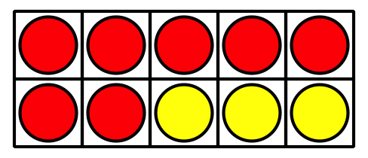



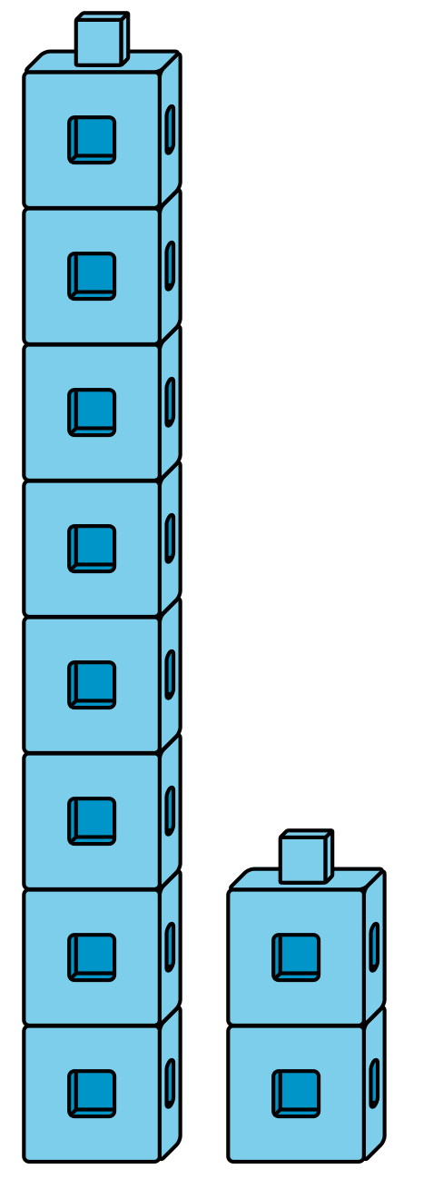

### 1 Match Equations and 10-frames

#### Student Task Statement



* 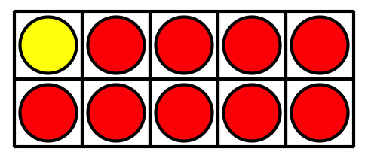



* 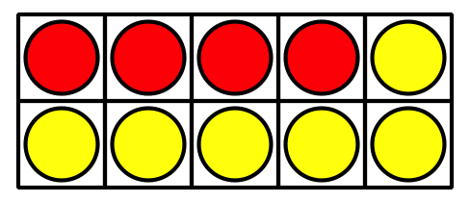



* 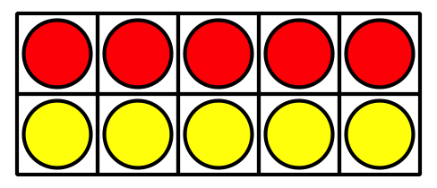



* 



* 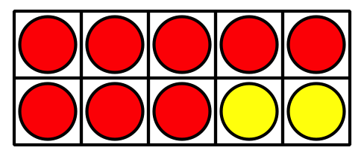

### 2 Represent Equations with Fingers

#### Student Task Statement













### 3 Centers: Choice Time

#### Student Task Statement

Choose a center.

Shake and Spill



Counting Collections

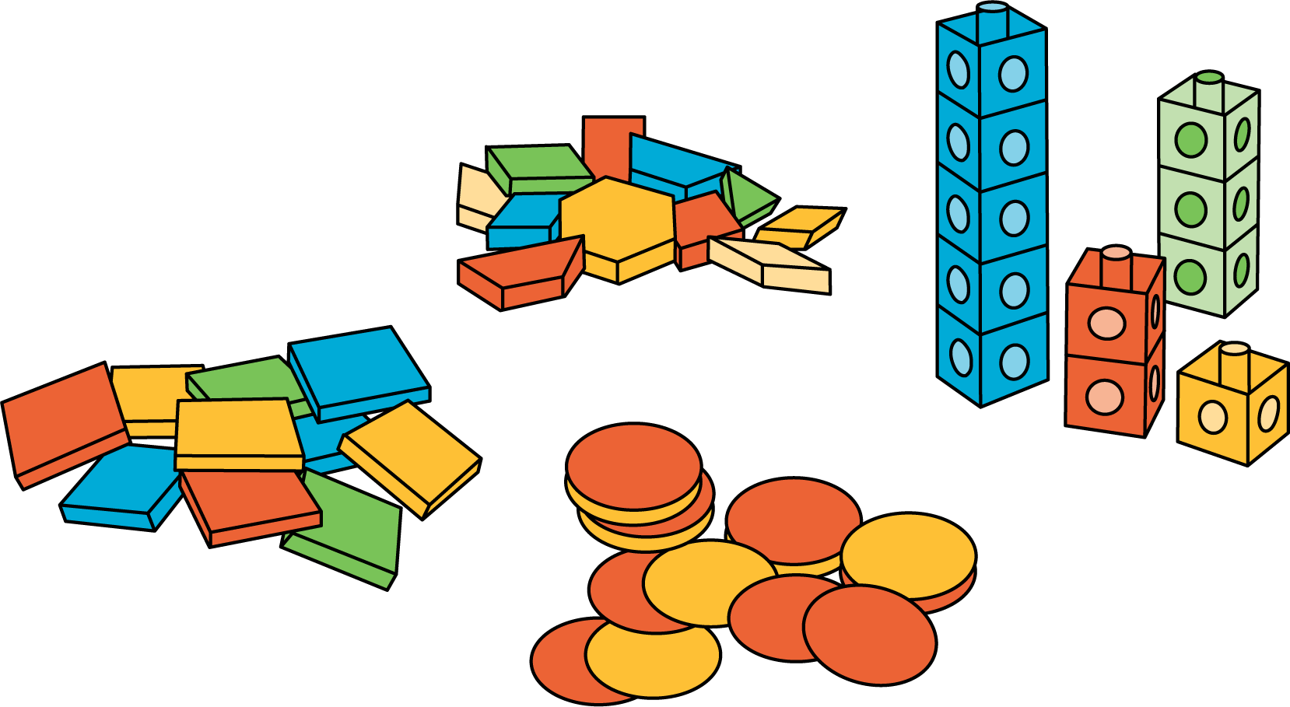

Roll and Add

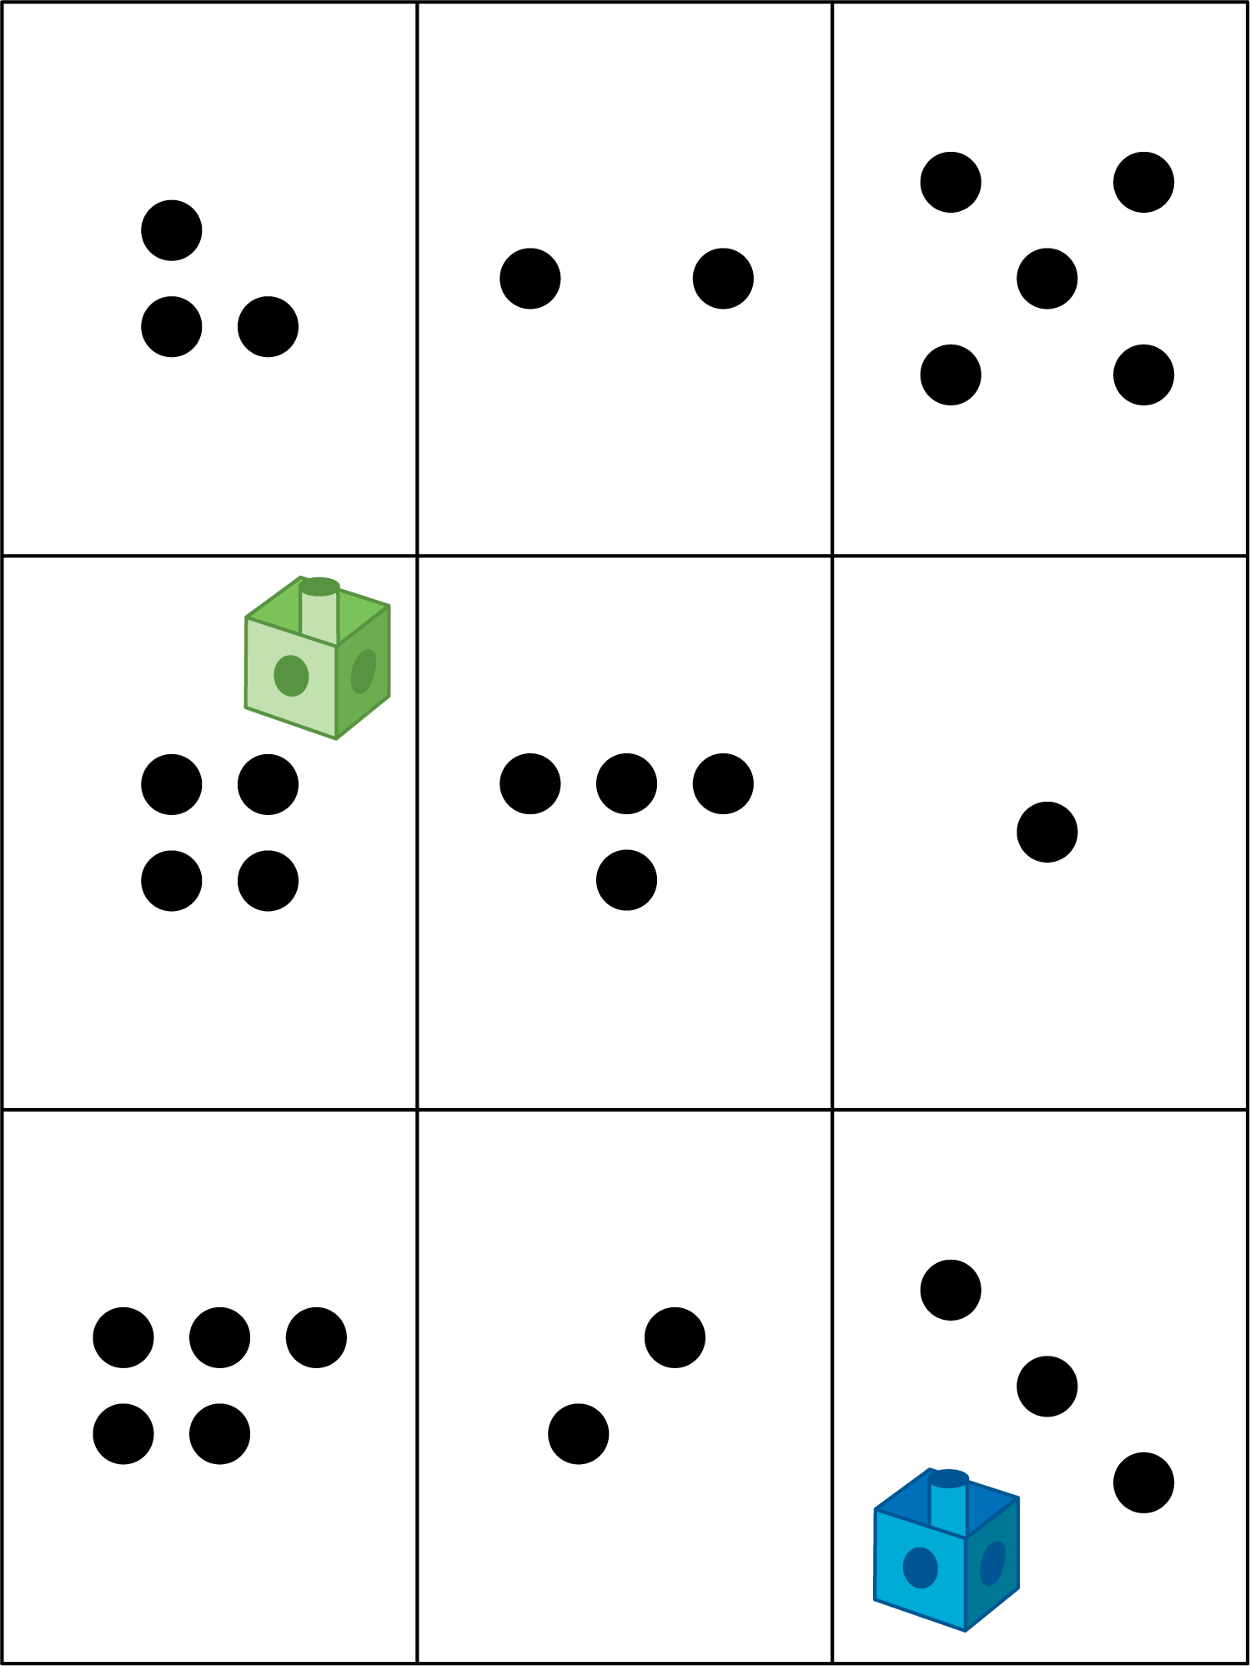

#### Images for Activity Synthesis

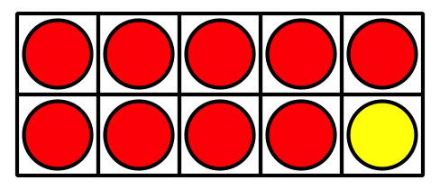





© CC BY 2021 Illustrative Mathematics®