Unit 7 Lesson 16: Represent the Classroom with Shapes

WU Choral Count: Count by 10 (Warm up)

Student Task Statement

1 Make a Model of the Classroom

Student Task Statement

2 Add to or Change the Classroom Model

Student Task Statement

3 Centers: Choice Time

Student Task Statement
Choose a center.
Build Shapes
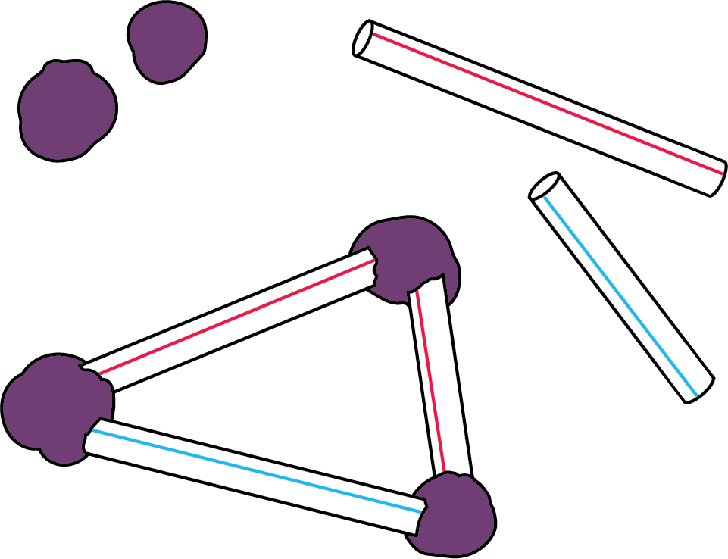
Geoblocks
Counting Collections
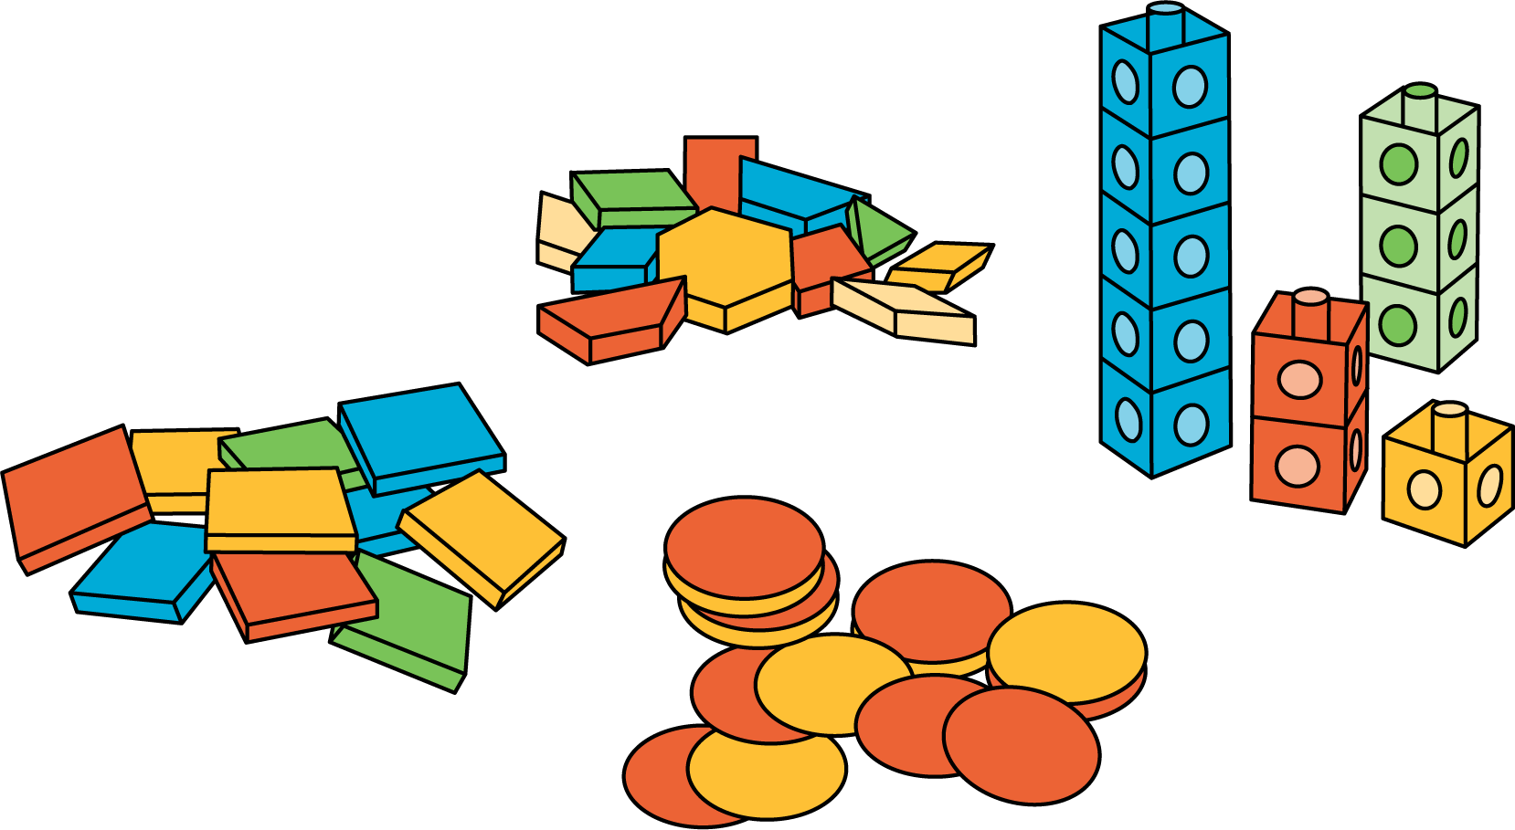
Match Mine
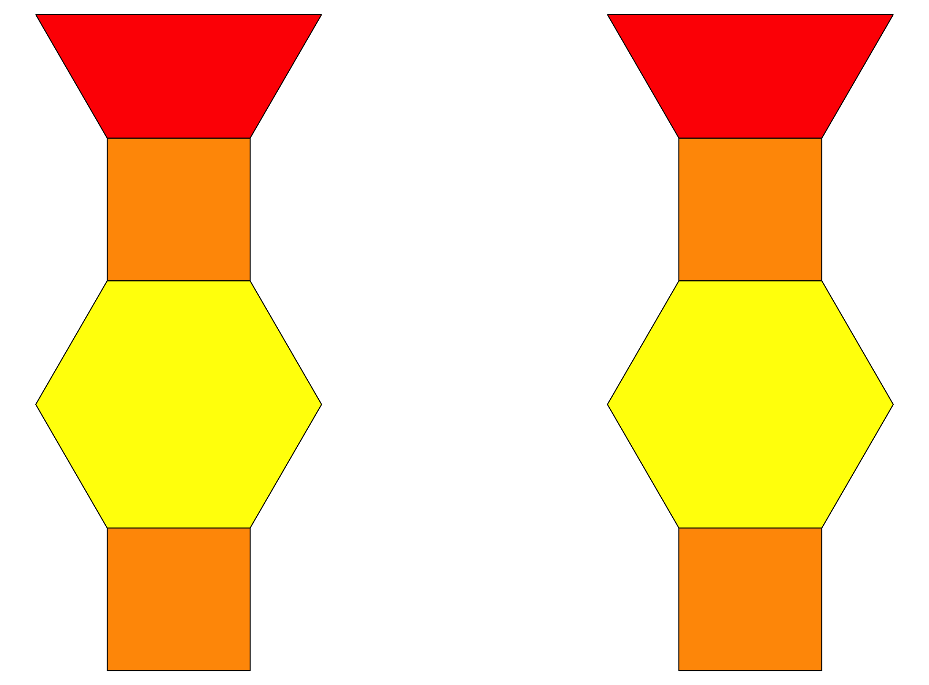
Shake and Spill
© CC BY 2021 Illustrative Mathematics®

