## Lesson 11: Equations that Show 10

* Let’s match equations to 10-frames and fingers.

### Warm-up: Notice and Wonder: Expressions for 10

What do you notice?  
What do you wonder?



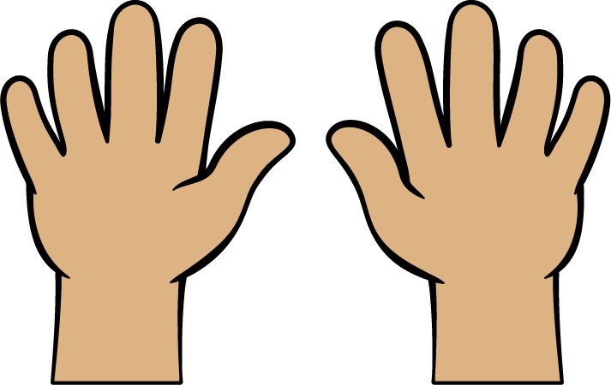



### 11.1: Match Equations and 10-frames



* 



* 



* 



* 



* 

### 11.2: Represent Equations with Fingers

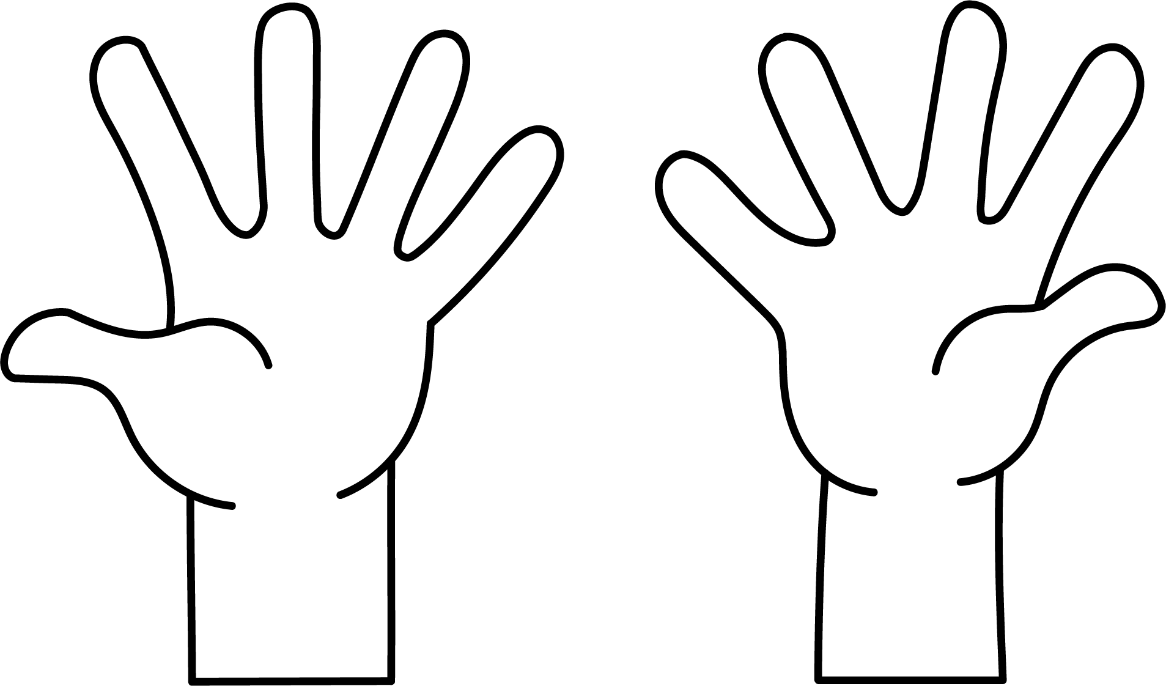











### 11.3: Centers: Choice Time

Choose a center.

Shake and Spill



Counting Collections

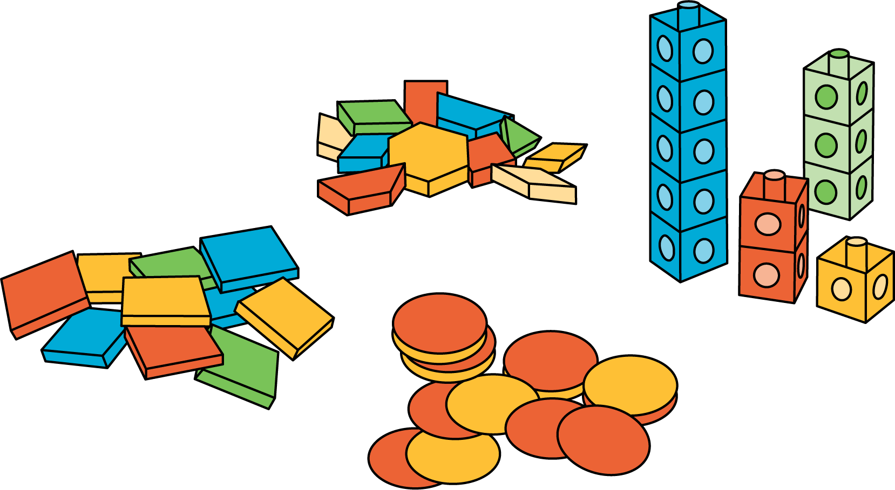

Roll and Add

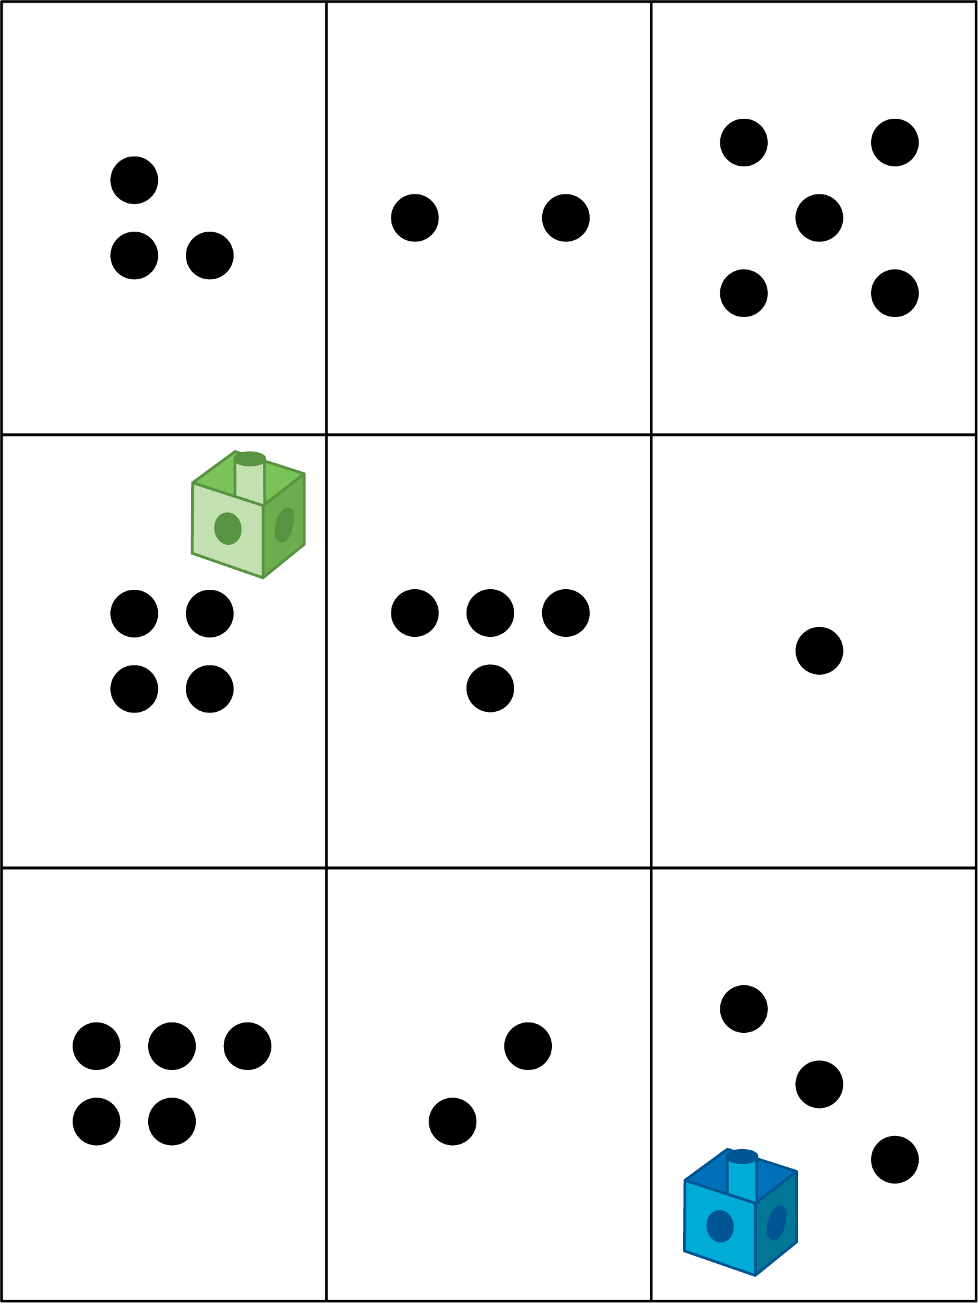



© CC BY 2021 Illustrative Mathematics®