Unit 1 Lesson 12: Congruent Polygons

1 Translated Images (Warm up)

Student Task Statement
All of these triangles are congruent. Sometimes we can take one figure to another with a translation. Shade the triangles that are images of triangle $ABC$ under a translation.
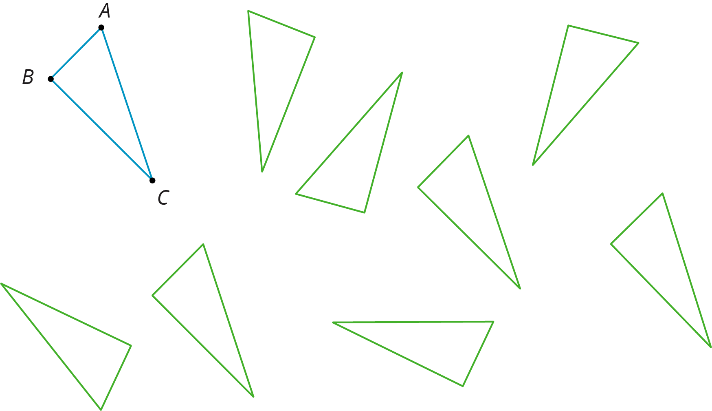

2 Congruent Pairs (Part 1)

Student Task Statement
For each of the following pairs of shapes, decide whether or not they are congruent. Explain your reasoning.

- 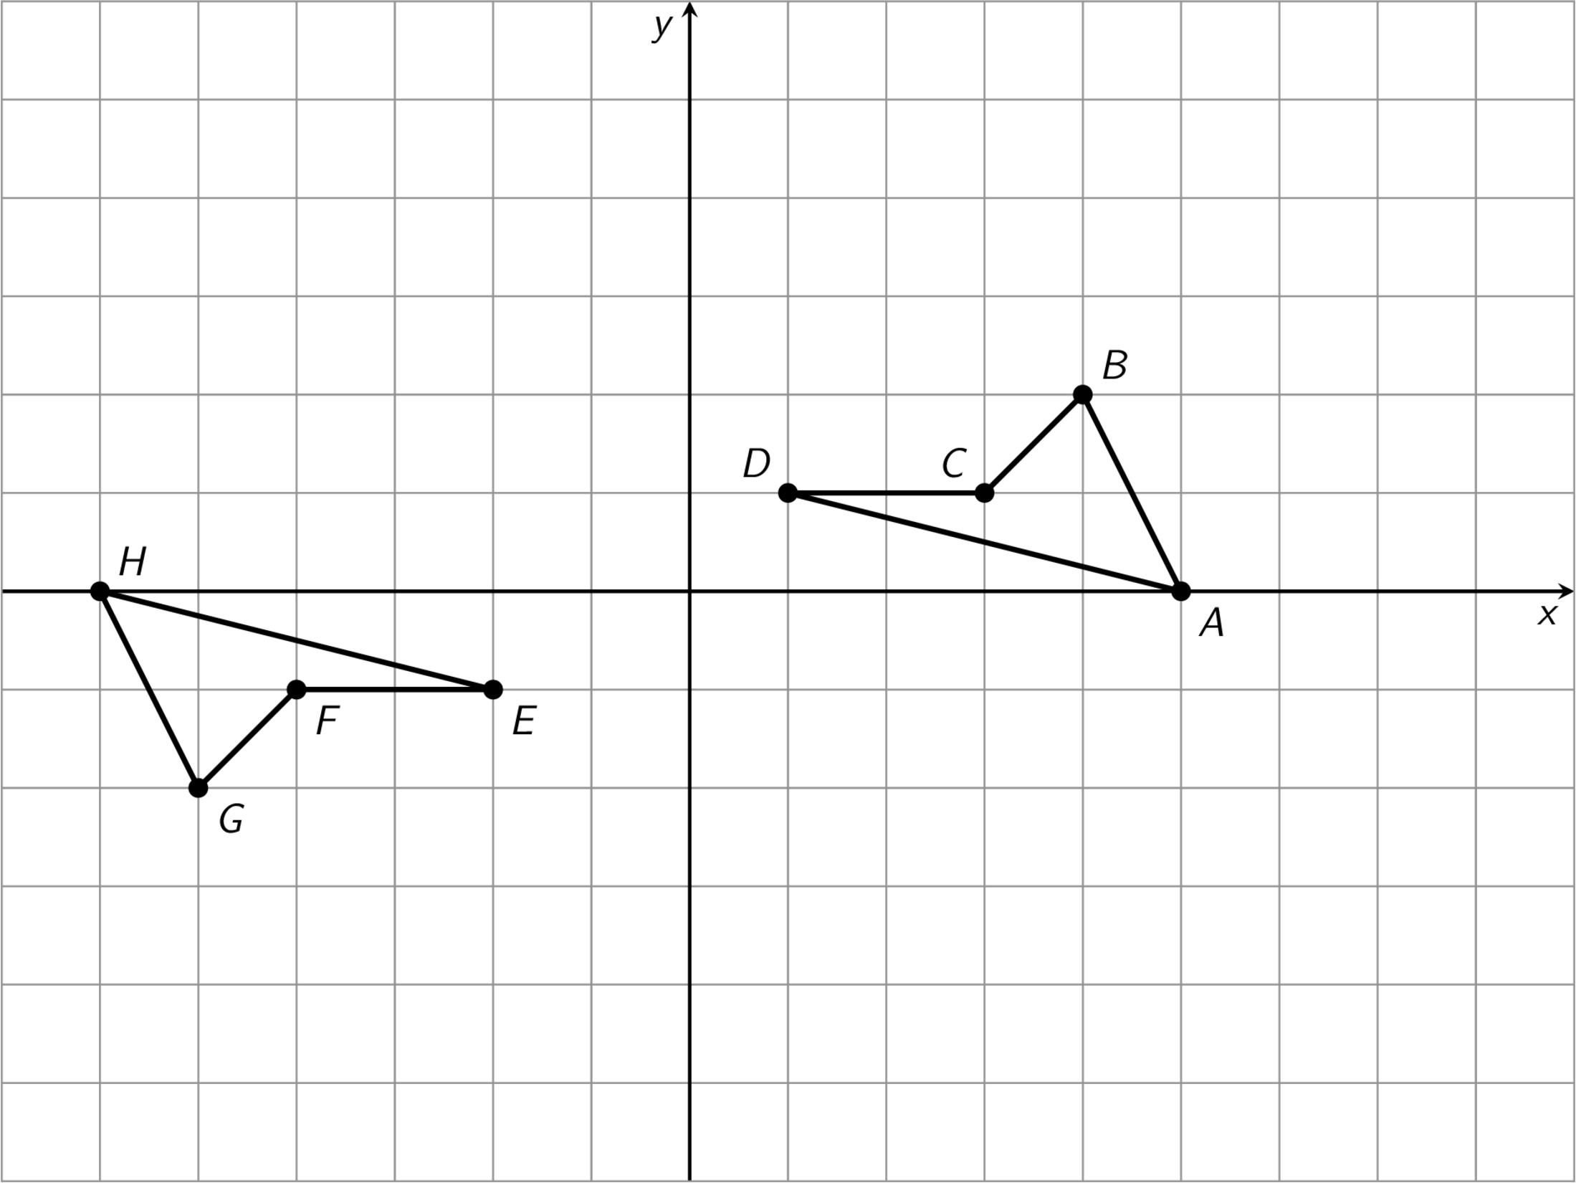

- 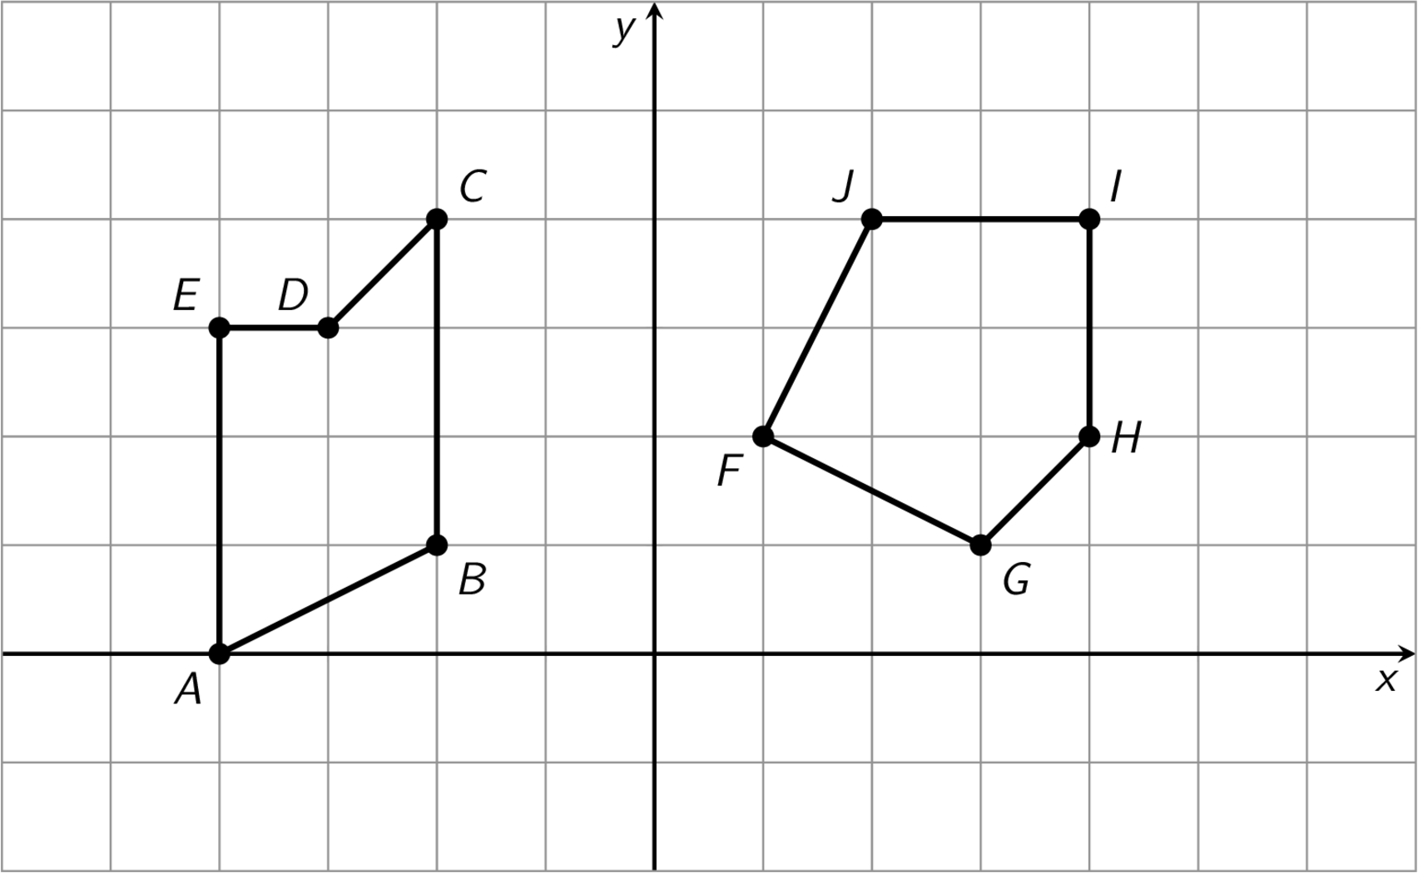

- 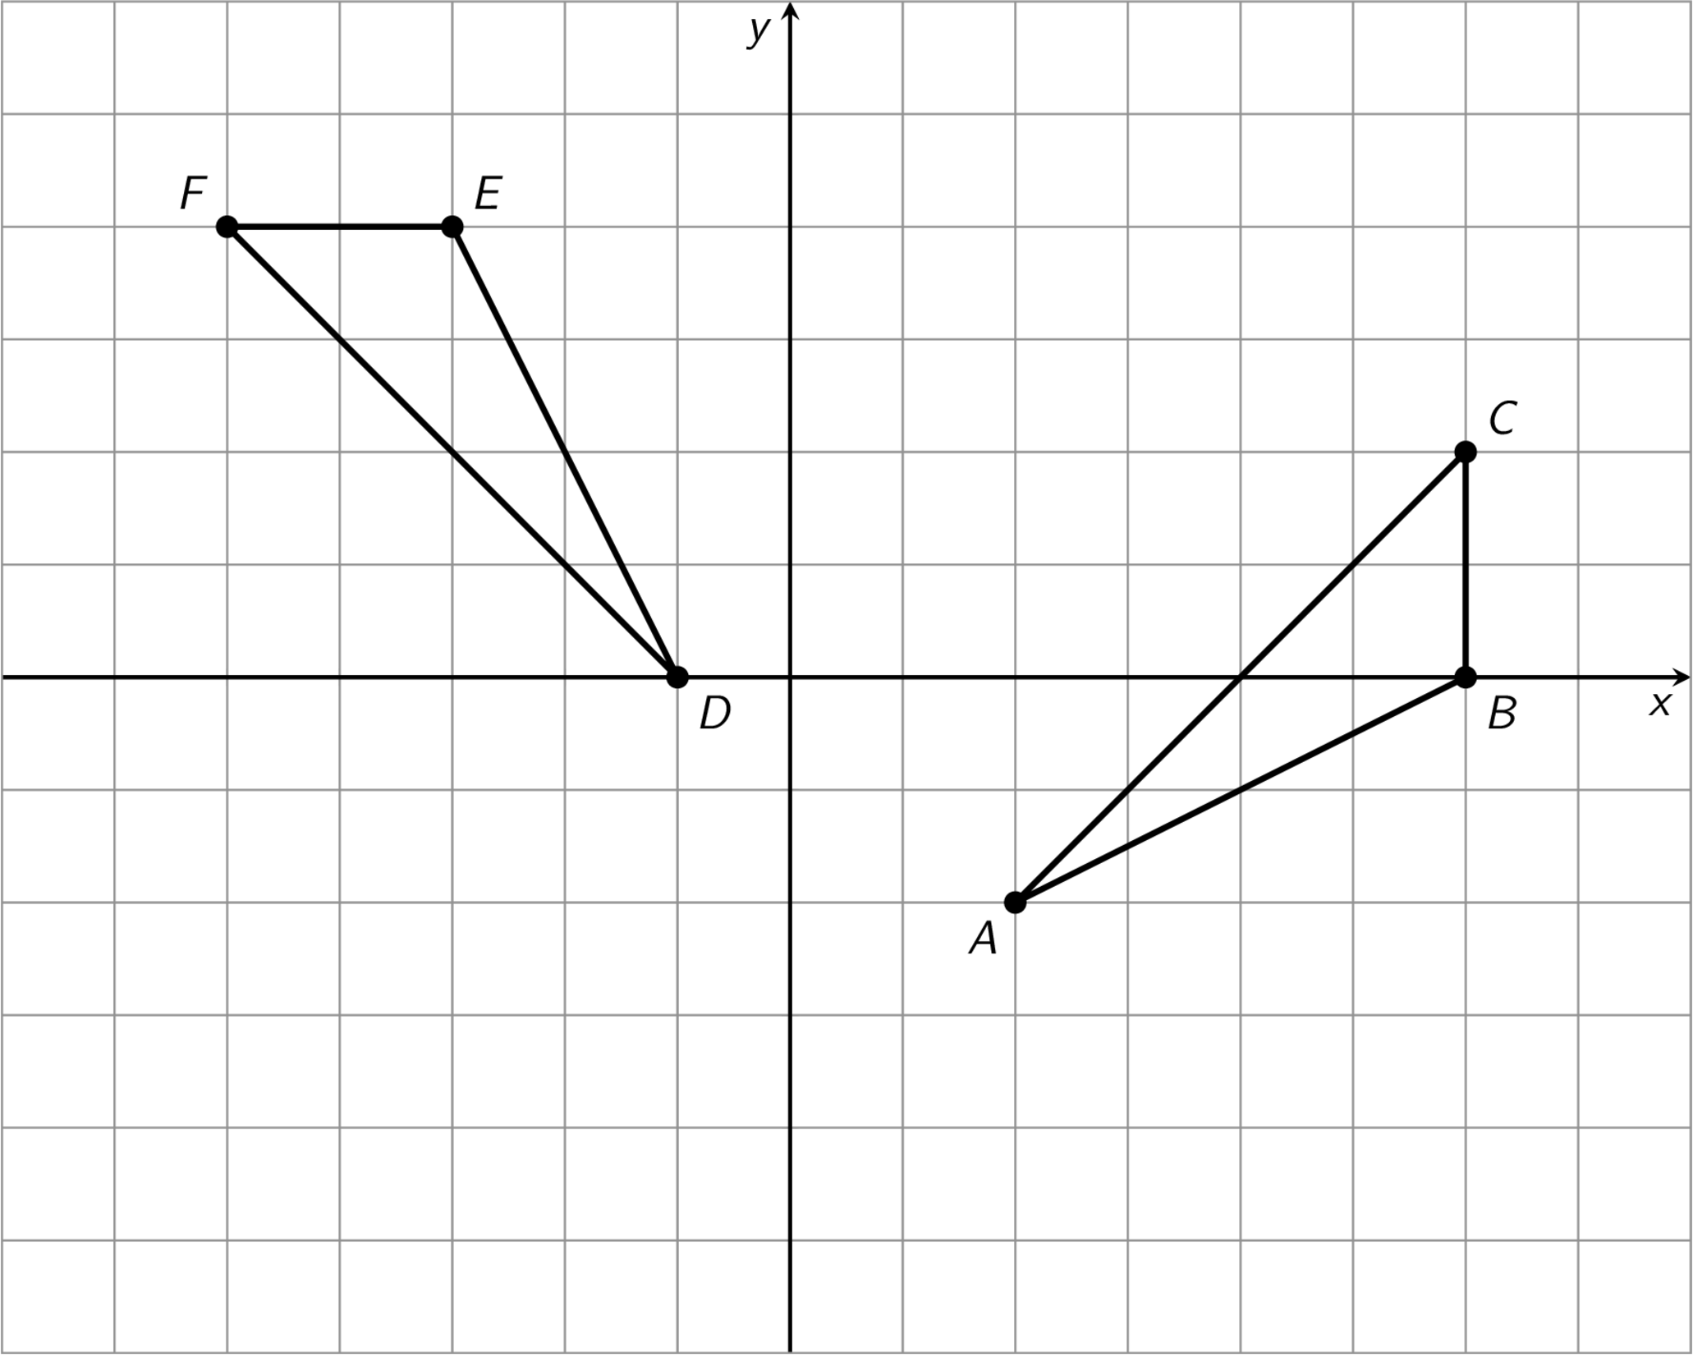

- 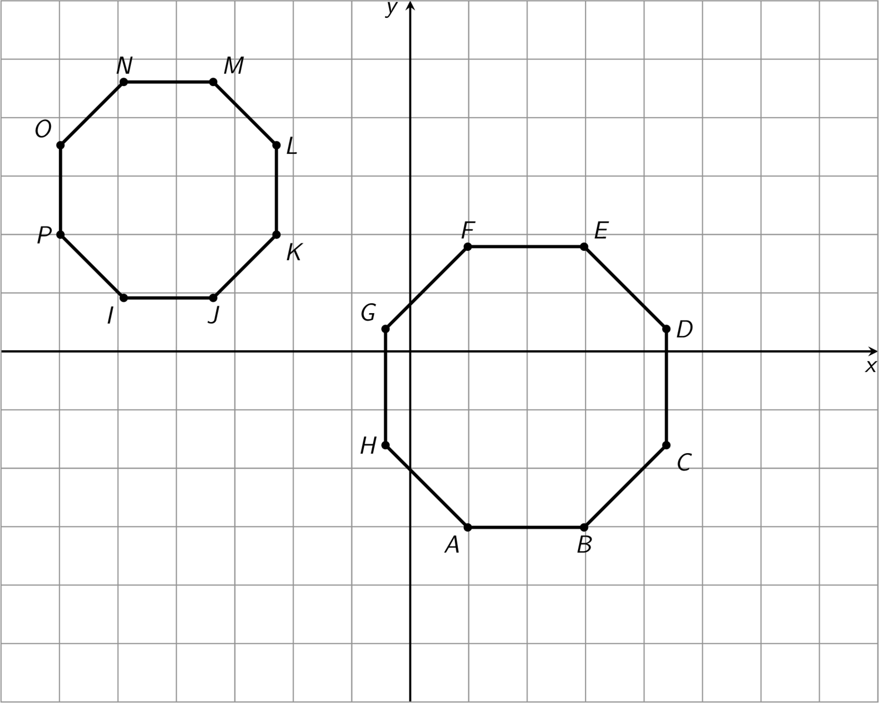

3 Congruent Pairs (Part 2)

Images for Launch
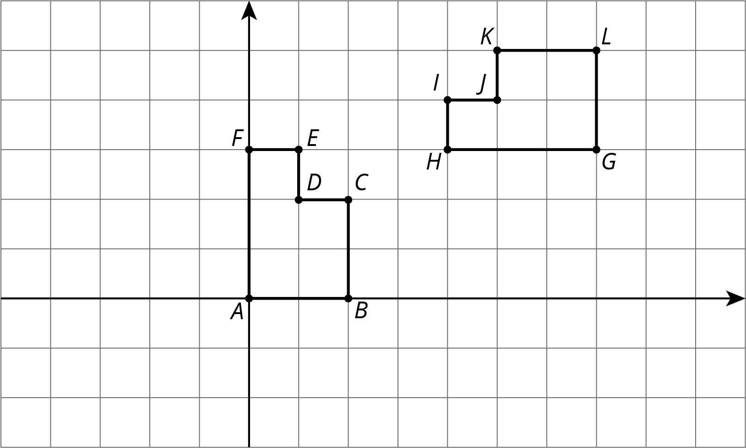

Student Task Statement
For each pair of shapes, decide whether or not Shape A is congruent to Shape B. Explain how you know.

- 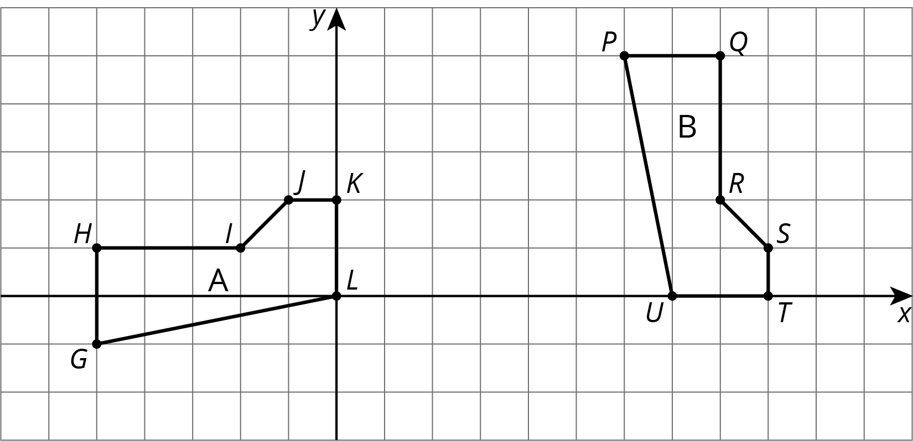

- 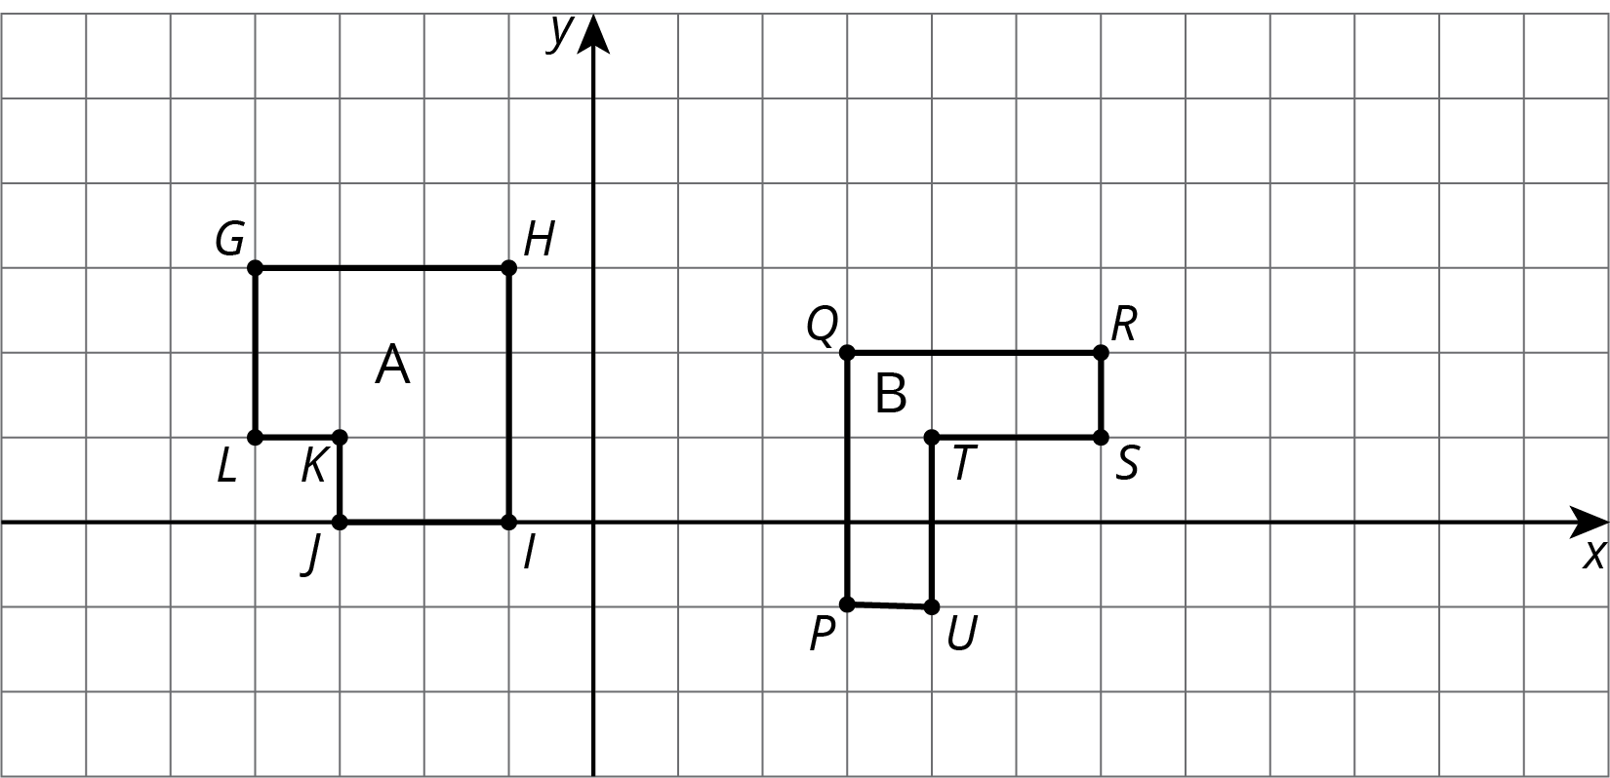

- 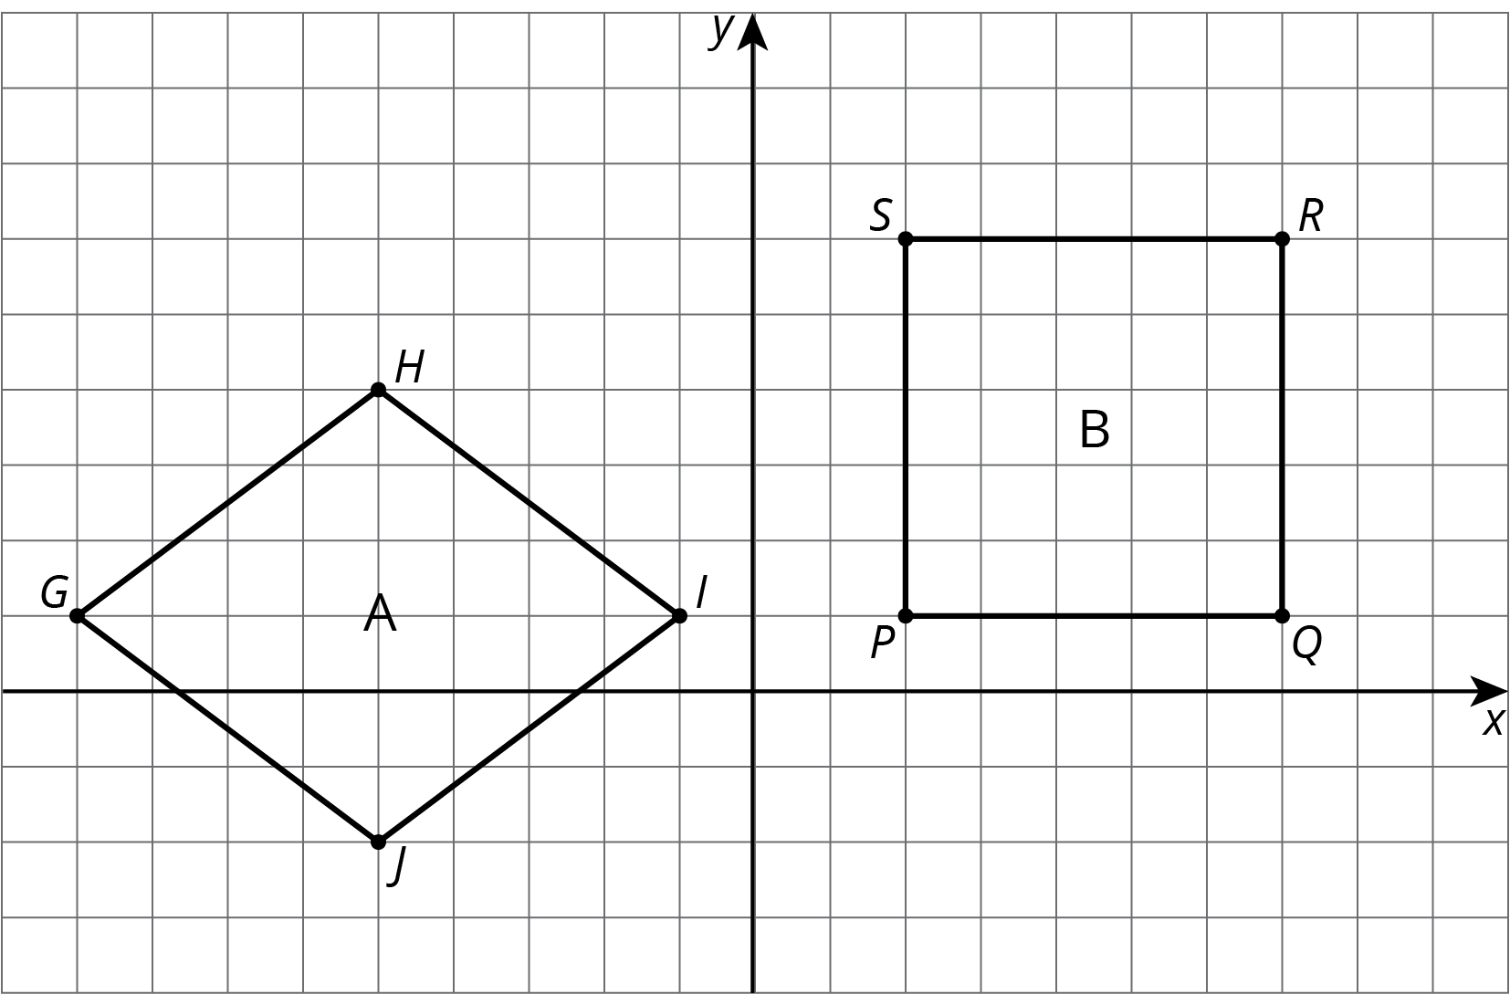

- 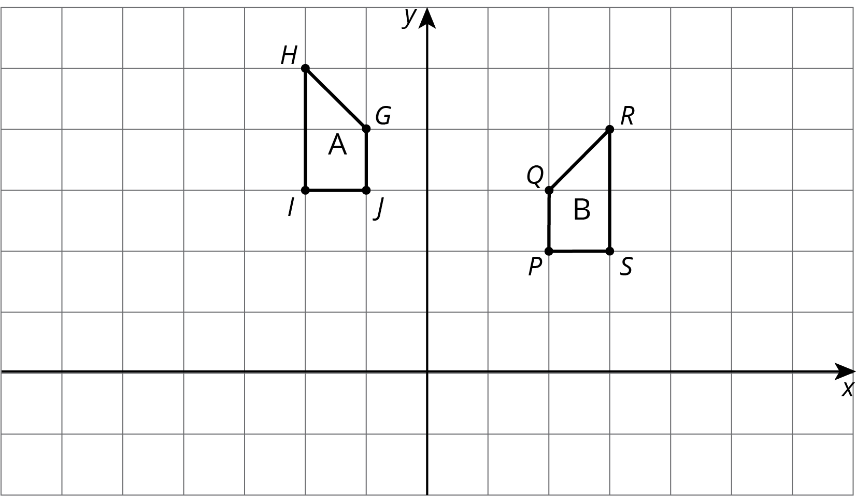

- 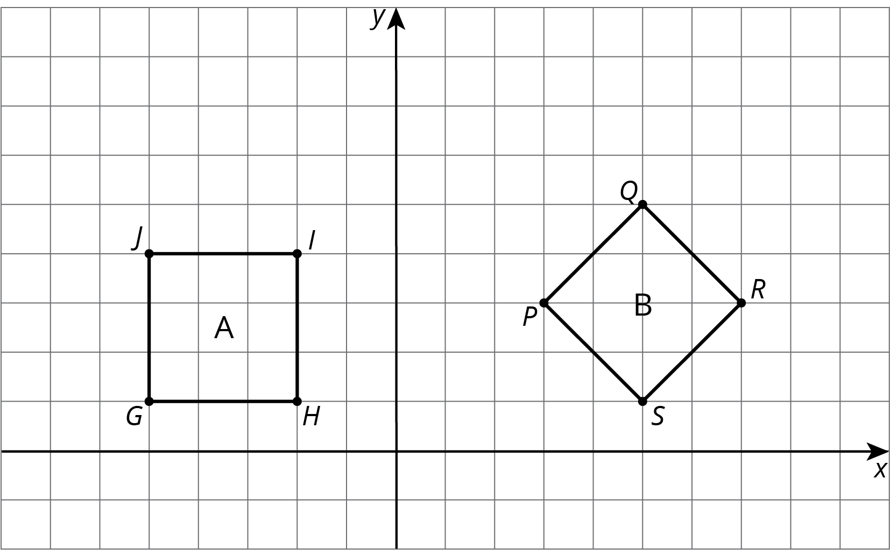

4 Building Quadrilaterals (Optional)

Student Task Statement
Your teacher will give you a set of four objects.
- Make a quadrilateral with your four objects and record what you have made.
- Compare your quadrilateral with your partner’s. Are they congruent? Explain how you know.
- Repeat steps 1 and 2, forming different quadrilaterals. If your first quadrilaterals were not congruent, can you build a pair that is? If your first quadrilaterals were congruent, can you build a pair that is not? Explain.
© CC BY Open Up Resources. Adaptations CC BY IM.

