Lesson 9: Increasing and Decreasing Functions

9.1: Comparing Values
For each pair of numbers, write $=,<$, or $>$ in the blank to make a true equation or inequality. Be prepared to share your reasoning.
- -6 $\underset{_}{​}$ -9
- $\frac{7}{3} \underset{_}{​} \frac{13}{6}$
- 5.2 $\underset{_}{​} \frac{53}{11}$
- $5(3−6) \underset{_}{​} 15−6$
- Let $f(x)=5−2x$.
  - $f(3) \underset{_}{​} f(5)$
  - $f(\text{-}3) \underset{_}{​} f(\text{-}4)$
  - $f(\text{-}1) \underset{_}{​} f(1)$

9.2: What Could It Be?
Describe $f(x)$ and $g(x)$ with a situation that could fit the given graphs. Explain your reasoning.
- 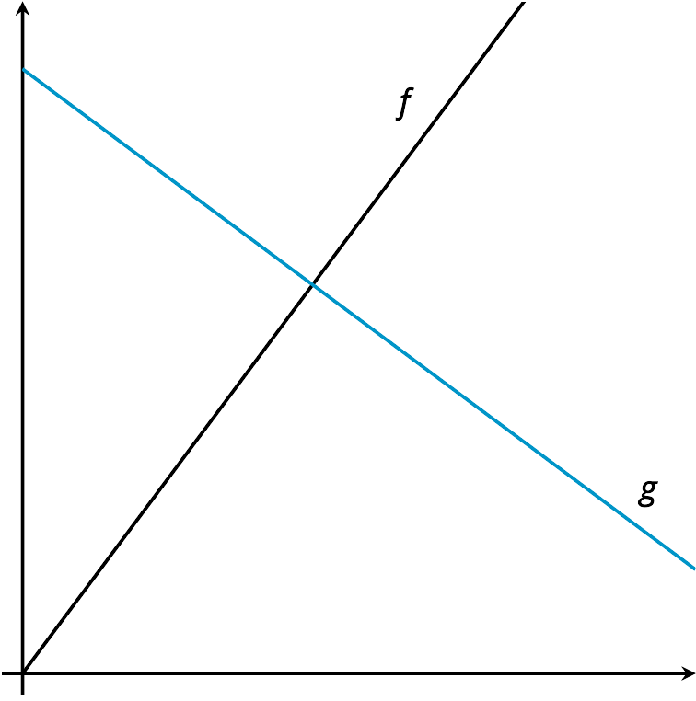
- 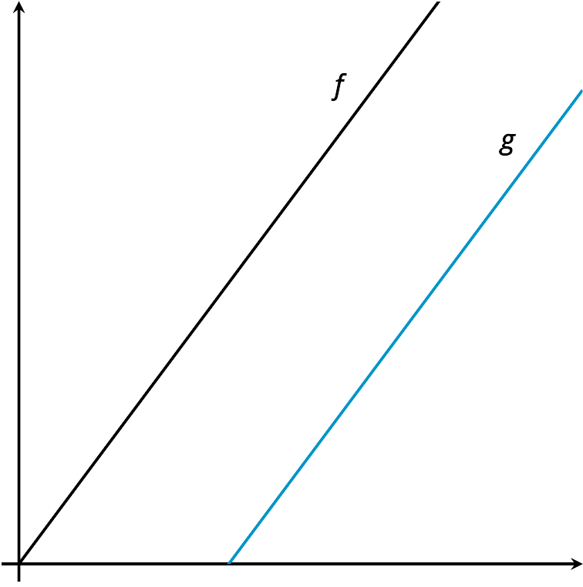
- 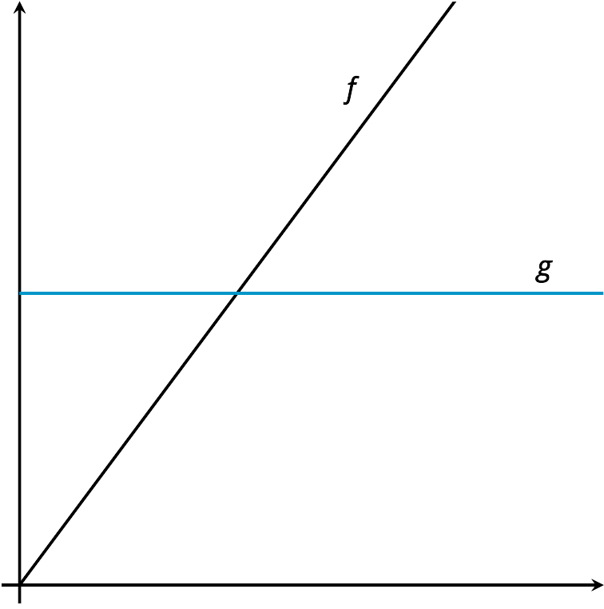
- 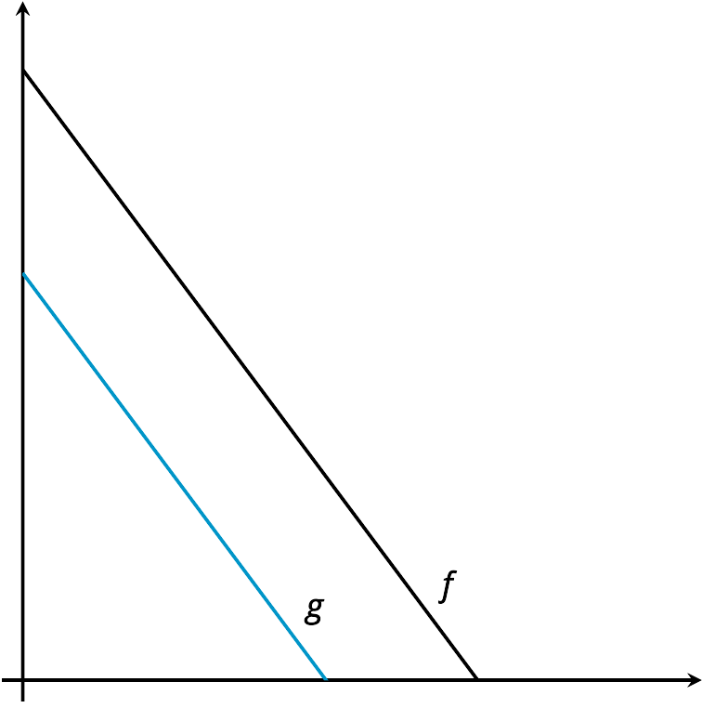

9.3: Cities, Towns, and Villages
Draw an example of a graph that shows two functions as they are described. Make sure to label the functions.
- The population of 2 cities as functions of time so that city A always has more people than city B.
- 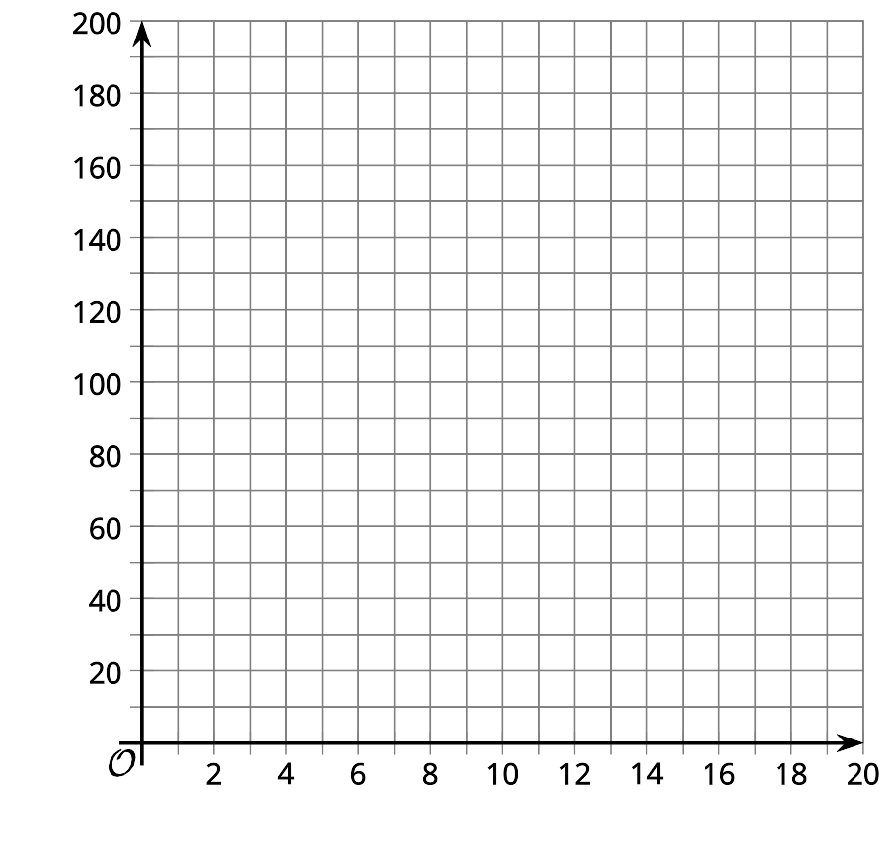
- The population of 2 towns as functions of time so that town A is larger to start, but then town B gets larger.
- 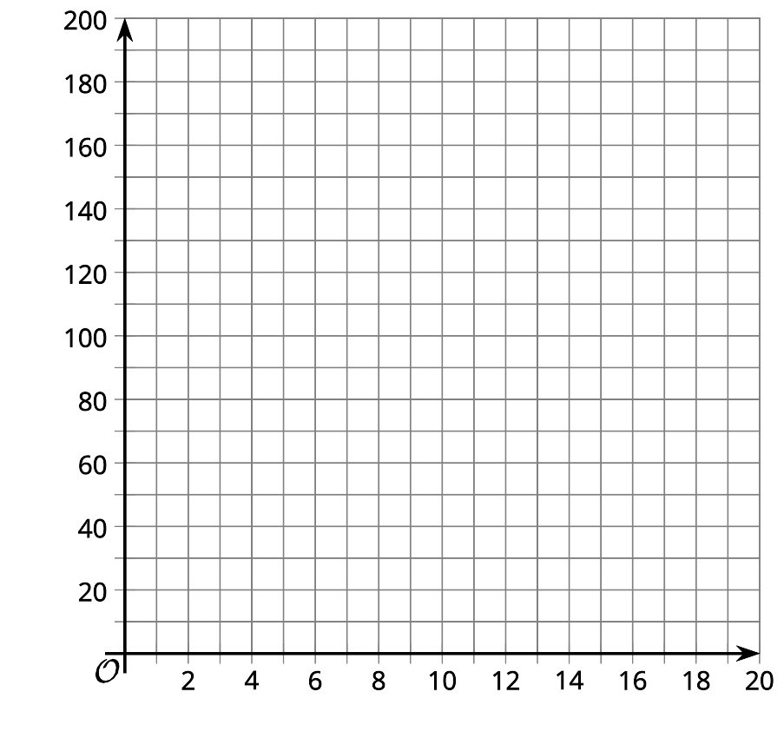
- The population of 2 villages as functions of time so that village A has a steady population and village B has a population that is initially large, but decreases.
© CC BY 2019 by Illustrative Mathematics

