Lesson 13: Multiply Fractions Game Day
- Let's multiply a fraction or whole number by a fraction.

Warm-up: Number Talk: Multiply One Third
Find the value of each expression mentally.
- $\frac{1}{3}×3$
- $\frac{1}{3}×4$
- $\frac{1}{3}×\frac{6}{3}$
- $\frac{1}{3}×\frac{1}{4}$

13.1: Fraction Multiplication Compare
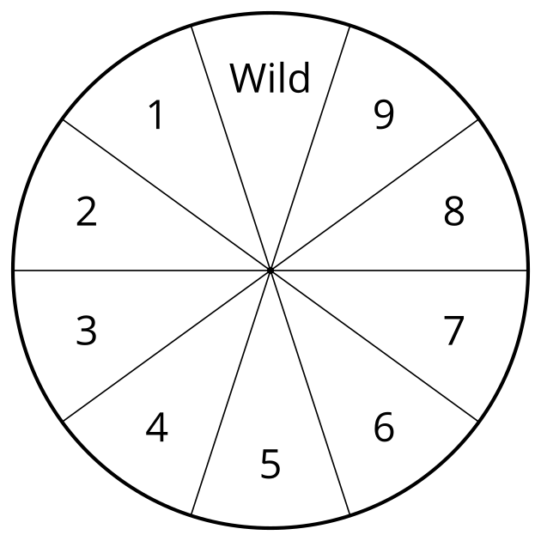
- Use the directions to play Fraction Multiplication Compare with your partner.
  - Spin the spinner.
  - Write the number you spun in one of the empty blank boxes. Once you write a number, you cannot change it.
  - Player two spins and writes the number on their game board.
  - Continue taking turns until all four blank boxes are filled.
  - Multiply your fractions.
  - The player with the greatest product wins.
  - Play again.
  - Round 1 1111111111 × 1111111111 = _
  - Round 2 1111111111 × 1111111111 = _
- What strategy do you use to decide where to write the numbers?

13.2: Fraction Multiplication Compare Round 2
- Use the directions to play Fraction Multiplication Compare with your partner.
  - Spin the spinner.
  - Write the number you spun in one of the four blank boxes.
  - Player two spins and writes the number on their game board.
  - Continue taking turns until all four blank boxes are filled.
  - Multiply your fractions.
  - The player with the smallest product wins.
  - Play again.
  - Round 1 1111111111 × 1111111111 = _
  - Round 2 1111111111 × 1111111111 = _
- What strategy did you use to choose where to write the numbers?

Section Summary
Section Summary
We played games with fractions and decimals, trying to make the largest or smallest number with given digits. Let's use the numbers 1, 3, 5, and 6. What is the smallest sum of two fractions we can make with these numbers? We want to use the smaller numbers, 1 and 3, for the numerators and the larger numbers, 5 and 6, for the denominators. This gives two possibilities, $\frac{1}{6}+\frac{3}{5}$ and $\frac{1}{5}+\frac{3}{6}$. The expression $\frac{1}{5}+\frac{3}{6}$ has the smaller value which makes sense since we want the larger numerator, which means more equal pieces, to go with the larger denominator which makes those pieces smaller.
The smallest difference we can make with these numbers is $\frac{3}{6}−\frac{1}{5}$ which is a little smaller than $\frac{3}{5}−\frac{1}{6}$. Finally, the largest product we can make is $\frac{6}{3}×\frac{5}{1}$ or $\frac{5}{1}×\frac{6}{3}$ which both have the value $\frac{30}{3}$ or 10.
© CC BY 2021 Illustrative Mathematics®

